Land use, demographic and economic projections for the Waikato region, 2018 to 2068

Executive summary
This report outlines the process undertaken and resulting data for land use, demographic and economic projections at a Statistical Area 2 (SA2) level for the Waikato Region, from a baseline in 2018 to 2068 (50 years time horizon). Projections include land use change, population dynamics (population, household, labour force) and economic development (value-added, employment). An overview is provided initially and then each projection output process is outlined.
Land Use
This section of the report provides a set of land use projections at the Statistical Area 2 (SA2) level for the Waikato Region. Projections are only provided for selected years (2025, 2035, 2045, 2055, and 2065). The land use projections were generated using the WISE model (Waikato Regional Council 2016). The land use projections were then used to support the modelling of the population and economic projections.
Prior to the land use projections being modelled the WISE model underwent a significant update. The updates improved the currency of territorial authority zoning, economic and population data and assumptions in the model. The model start date was brought forward from 2013 to 2018. After the update process a single iteration validation exercise was undertaken with territorial authorities to test the appropriateness of zoning. This involved providing initial land use outputs from WISE for 2020, 2030, 2040, 2050 and 2060, and seeking feedback on whether outcomes were plausible or appropriate given territorial authority zoning and development expectations. Adjustments were made to zoning setup based on the feedback.
The results for future land use projections indicate areas of plausible land use change. The land use figures provided by SA2 for future time steps are from a single run of the WISE model.
The changes in land use seen in the projections are in line with expected developments and zoning with increasing residential, commercial and industrial growth particularly around existing urban centres. In some cases expectations for the extent of residential development across a TA were not able to be supported by the projected population growth for a scenario.

Summary of Results: Land use baseline (2018) and projections (Medium scenario) for the Waikato Region
Land type (ha) / Year | 2018 | 2025 | 2035 | 2045 | 2055 | 2065
Residential - Lifestyle Blocks | 39400 | 40299 | 39966 | 40386 | 40451 | 42388
Residential - Low Density | 13053 | 13966 | 14586 | 15220 | 15772 | 16537
Residential – Med-High Density | 522 | 640 | 894 | 1052 | 1213 | 1278
Commercial | 2176 | 2343 | 2577 | 2785 | 2972 | 3147
Community Services | 2330 | 2542 | 2784 | 2986 | 3158 | 3314
Manufacturing | 1928 | 2047 | 2255 | 2450 | 2643 | 2833
Dairy Farming | 681263 | 689727 | 688928 | 687706 | 686820 | 685271
Sheep, Beef or Deer Farming | 515788 | 508972 | 508449 | 507519 | 502565 | 494709
Other Agriculture | 12756 | 12752 | 12959 | 12851 | 12603 | 12258
Horticulture | 3399 | 3632 | 3974 | 4283 | 4579 | 4878
Vegetable Cropping | 6300 | 6732 | 7366 | 7938 | 8483 | 9035
Other Cropping | 8395 | 8393 | 8529 | 8457 | 8294 | 8067
Forestry | 283918 | 283917 | 284065 | 285261 | 290939 | 296605

Introduction
This report describes future projections of land use, demographics and economics from a baseline in 2018 to 2068 (50 years time horizon). Future projections of land use change, population dynamics (population, household, labour force) and economic development (value-added, employment) are important to local government as an input into district, structure and infrastructure planning.
The updated WISE model now has a starting date of 2018, previously 2013, with a corresponding update of land use, population and economic data to match this start date. The other major improvement to WISE is an entire review and update of zoning to capture new council plan zones and rules that have been developed in recent district and regional plans. This also included capturing any growth strategies that identified future growth areas. Councils were also asked to identify specific areas, based on subdivision consents, where they expected growth to occur in the next 0-5 years and 5-10 years. This allowed for some better ’fine-tuning’ of the early residential growth in the WISE model.
This document outlines the processes followed to create a common set of population and economic projections data by Statistical Area 2 (SA2) for the Waikato. These outputs are aimed at providing consistency for the inputs used in a range of planning and modelling processes undertaken by Territorial Authorities (TA’s), Future Proof, Waikato Regional Transport Model (WRTM) and Waikato Integrated Scenario Explorer (WISE). To generate these outputs, it is necessary to link together outputs from three modelling processes:
- land use modelling (WISE, for future projections of land use change);
- population modelling (‘Whole of Waikato’ population model (WoW), regression analysis at SA2 level); and
- economic modelling (Economic Futures Model (EFM) and additional SA2 modelling).
The steps and methodology for these three processes are outlined below in section 2 of this report.

Process Overview
The steps undertaken in preparing the SA2 level projections and the links between the three modelling processes are outlined in Figure 1. The two steps involved:
Step1: Updating of Core Data Sets
- New population projections were developed based on new 2018 census data.
- These population projections are used in the ‘Whole-of-Waikato’ (WOW) model to provide an updated data file (territorial authority level population data) for use in economic (Economic Futures Model, EFM) and WISE modelling.
- A major update of the WISE model has been undertaken to utilise latest data sets (population, land use, zoning), and created a new start date of 2018.
- A review of data outputs from the revised WISE model was undertaken with territorial authorities to ensure setup was plausible.
- Updated sector economic data are provided from EFM into WISE

Step 2: Development of SA2 level projections
- WISE version 1.6 model is run – output data from WISE is provided to University of Waikato (land use projections by SA2) and Market Economics (land use by SA2, employment, value added and gross output) to undertake their modelling for population (see section 5) and economic (see section 6) indicators, respectively, at SA2 level.
- Regression modelling by University of Waikato produces final projection outputs for population by SA2.
- Final population projections by SA2 are provided to Market Economics to use in their modelling of economic indicators at SA2 level.
- Modelling by Market Economics produces final economic projection outputs by SA2.
The specific parts of this process are defined in the following sections for each of the three modelling processes. These provide further detail of the data used, assumptions made and processes followed.

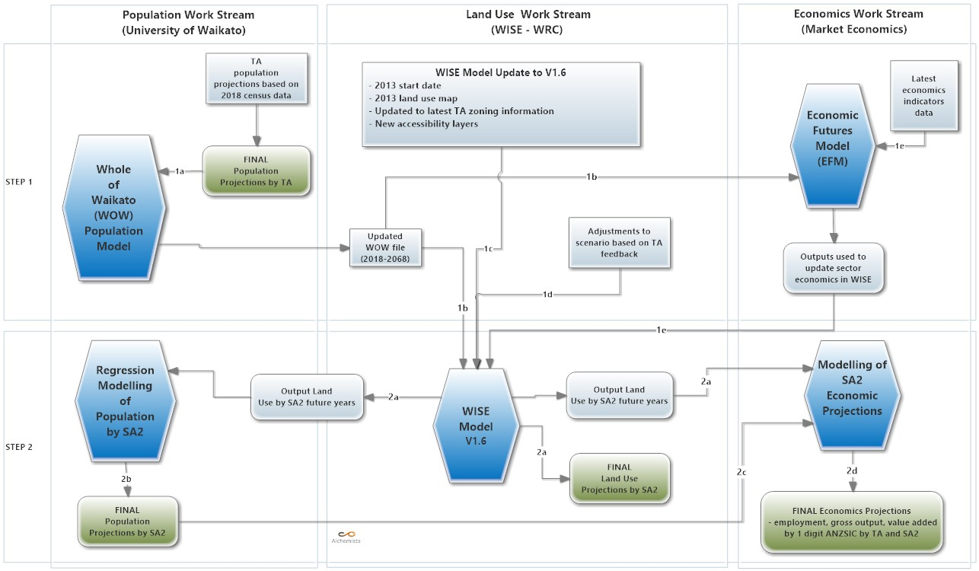
Figure 1: Work stream Process for developing updated population and economic output projections for Waikato region.

WISE Modelling – Development of Land Use Projections

Contributors:
Tony Fenton – Contractor (Alchemists Ltd) Beat Huser, Craig Briggs – Waikato Regional Council
Acknowledgements
We thank staff from all territorial authorities for their valuable input. Their participation in workshops and provision of information and local knowledge was fundamental to the development, testing and validation of the projections.
Overview
This project required WISE to produce a robust projection of future land use for the Waikato Region. This projection of land use is required to support projection modelling of population and economic outcomes.
Figure 2 shows the process that was followed to produce the land use projections. The work firstly required a significant update of the WISE model. This required a number of data updates including an update of the initial land use layer, zoning and accessability layers, underlying population database (WOW file) and economic sector data (Figure 1).
Updating these data sources is important to ensure that the model is ‘current’ and using the best available data and knowledge so that the scenario outputs are as robust as possible.
The territorial authority level population projections were updated based upon the release of the 2018 census results (Cameron and Cochrane (2021?)). Updated regional economic data was provided by Market Economics Ltd’s Economic Futures Model (EFM).

Update of WISE Model to Version 1.6
The update of the WISE model has been undertaken with the objective of keeping it current and robust for scenario modelling work in the Waikato Region. The update included moving to a new starting date of 2018. This required updating a number of key data inputs (initial land use layer, population data, economic data).

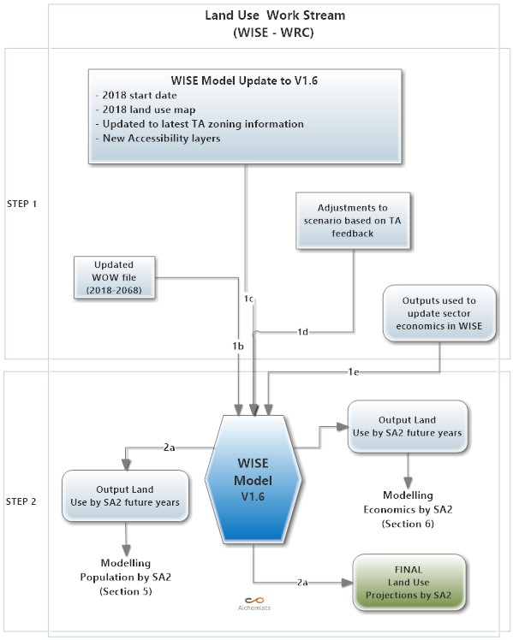
Figure 2: Process for generating up to date projections of land use for SA2 level outcomes modelling

Other data that has been updated included:
  - 2018 land use layer as the starting reference point for scenario modelling (Fenton 2020). The 2018 land use layer included a new land use class - vacant urban land. This land use class represents land that has been taken out of other productive land uses and is awaiting development for residential or other urban land uses. The draft 2018 land use map was sent to TA’s in the Region for feedback as part of a validation process
  - Accessibility layers (transport network) – These were updated again to be in line with the WRMT layers and validated against the 2018 WRAPS in main urban growth areas.
  - Zoning layers - A full review and update of zoning in the WISE model has been undertaken. This has required an evaluation of all the zoning across the region and rules in plans that relate to them (Waikato Regional Council, 2020). This provided a series of ‘zoning matrix’ tables for each territorial authority which outlines the zoning and restrictions to be setup in the WISE model. The second part of updating zoning involved sourcing the latest zoning spatial shape files from the territorial authorities. These were then matched to the ‘zoning matrix’ tables and converted into “grid” files that can be imported into WISE. These files are then loaded and matched to their respective rules information from the ’zoning matrix’ tables to determine how each area will respond to land use changes when modelled.
  - For a full description of the current technical status of the WISE V1.6 model and specifics of updated components refer to the technical specifications document (Waikato Regional Council, 2021).
After initial setup of updated data in the WISE model a calibration process was undertaken to ensure that the settings and parameters are stable and produce the expected behaviour based on economic demands and productivities and these interactions between land uses.

Validation of WISE Model and Adjustments to the Projections Scenario
After the updated WISE V1.6 model had been setup an initial set of land use maps from the baseline at 2018 into the future was created. These were provided to the territorial authorities for time steps of 2020, 2030, 2040, 2050 and 2060 for their validation. This process was to check the plausibility of the modelling and territorial authorities were asked to identify any changes that were not expected given their current zoning and planning documents.
This validation checking process identified a number of outcomes that were considered implausible and the WISE model was adjusted to improve model results.

Results: Land Use Projections by SA2
Process Methodology
After setting up of the WISE V1.6 model and further validation based on territorial authority feedback the resulting ‘reference’ scenario was run and land use projections for the following years were captured as ‘geotiff’ files: 2018, 2025, 2035, 2045, 2055, 2065.
For each of these time steps the ‘geotiff’ file is then analysed in GIS software (Tabulate Area / Cross Tabulate process) against the Statistics New Zealand 2020 SA2 layer.
This provides a database file for each time step that contains areas of each land use modelled in WISE by SA2’s within the Waikato region. This data is then converted to hectares from (square metres) and loaded into a template spreadsheet that creates easy to view summaries of the data (see Waikato Regional Council Doc # 3492343).
Projection Results
A time step summary of this land use data for each time step, by territorial authority in the region is provided in Table 1. This provides a summary of the most relevant 13 land uses (out of a total of 25 land use classes).
Land type (ha) / Year | 2018 | 2025 | 2035 | 2045 | 2055 | 2065
Residential - Lifestyle Blocks | 39400 | 40299 | 39966 | 40386 | 40451 | 42388
Residential - Low Density | 13053 | 13966 | 14586 | 15220 | 15772 | 16537
Residential – Med-High Density | 522 | 640 | 894 | 1052 | 1213 | 1278
Commercial | 2176 | 2343 | 2577 | 2785 | 2972 | 3147
Community Services | 2330 | 2542 | 2784 | 2986 | 3158 | 3314
Manufacturing | 1928 | 2047 | 2255 | 2450 | 2643 | 2833
Dairy Farming | 681263 | 689727 | 688928 | 687706 | 686820 | 685271
Sheep, Beef or Deer Farming | 515788 | 508972 | 508449 | 507519 | 502565 | 494709
Other Agriculture | 12756 | 12752 | 12959 | 12851 | 12603 | 12258
Horticulture | 3399 | 3632 | 3974 | 4283 | 4579 | 4878
Vegetable Cropping | 6300 | 6732 | 7366 | 7938 | 8483 | 9035
Other Cropping | 8395 | 8393 | 8529 | 8457 | 8294 | 8067
Forestry | 283918 | 283917 | 284065 | 285261 | 290939 | 296605
Table 1: Land Use Projection (Medium growth) by Region - 2018 to 2068 (ha’s) – for selected land uses

