Waikato Economic Projections
2021 Update
29th April 2021

Waikato Economic Projections
2021 Update

Prepared for
Waikato Regional Council

Document reference: EW042.19/Report
Date of this version: 29th April 2021
Report author(s): Dr Pascal Cheon & Dr Garry McDonald
Director approval: Dr Garry McDonald
www.me.co.nz

Disclaimer: Although every effort has been made to ensure accuracy and reliability of the information contained in this report, neither Market Economics Limited nor any of its employees shall be held liable for the information, opinions and forecasts expressed in this report.

Contents
1 Introduction 2
2 Projections of economic outcomes by SA2 4
2.1 Methodology 4
2.2 Data for the SA2 Projections 6
2.3 Model Specification 6
3 Regional Level Commentary 8
3.1 Employment 8
3.2 Value Added 8
4 TA Level Commentary 11
4.1 Employment 11
4.2 Value Added 14
4.3 Projected within each TA 16
4.3.1 Hamilton City 16
4.3.2 Waipa District 18
4.3.3 Waikato District 21
4.3.4 Taupō District 24
4.3.5 Matamata-Piako District 27
4.3.6 Thames-Coromandel District 29
4.3.7 South Waikato District 31
4.3.8 Hauraki District 33
4.3.9 Waitomo District 35
4.3.10 Ōtorohanga District 38
4.4 Projections within each Statistical Area 2 41
5 Conclusion 43

Introduction
Employment and value added are the key economic indicators projected. Annual employment and value added projections are developed at the Statistical Area 2 (SA2) level from 2018 to 2068. The Australian New Zealand Industry Classification (ANZSIC) at the 1-Digit industry level is used for the industrial classification of the projections. This level of detail equates to a very large database of 229,900 projection datapoints each for employment and value added. This was to allow investigation of patterns of industry and spatial change across the whole region, as well as changes in economic structure within the SA2s themselves. Additionally, three sets of projections are produced covering low, medium, and high economic growth futures.

The projections are computed based on least squares regression. The regression is carried out based on (1) change in future land use patterns as derived from the Waikato Integrated Scenarios Explorer (WISE) Spatial Decisions Support System, (2) historical employment trends taken from StatsNZ’s Buinsess Directory, and (3) independent population projections produced by Assoc. Prof. Michael Cameron at the Univesity of Waikato.

It should be noted that the projections are only an estimate based on the available data. The relatively smooth growth projections of the region mask the changes that can be significantly volatile within smaller SA2 areas, as industries evolve, respond to local conditions (particularly land use change constraints), and move between areas or elsewhere. For this reason, it is important to acknowledge that the results presented are projections and not predictions – it is not possible to predict the future. The medium, high, and low projections give a range of projections that are plausible, having been developed under a limited set of assumptions. The projections produced have a higher degree of uncertainty in the long run than in the short run. In this report, we use the high growth projection series as an exemplar for reporting. This series is based on both high population and economic growth. Looking back at the previous WISE projections, the high growth projection series has performed best in describing growth over the preceding 10 years.

It should be noted that these projections have been developed through the collaborative effort of several organisations. This includes Waikato Regional Council, the Territorial Authorities (TAs) of the Waikato Region, the University of Waikato, and independent economic and GIS consultants. The projections are fully compatible with those produced at the regional level by WISE. The use of WISE represents a ‘step change’, but also ‘test-bed’, within New Zealand for the use of state-of-the-art technology in the development of these projections. WISE is unique in its depth of coverage of socio-economic and environmental wellbeing through an integration of existing demographic, land use, economics, and environment models. This integrated systems-based approach provides unique insights into the key trade-offs (supply versus demand) faced within the Waikato region.

Projections of economic outcomes by SA2
The methodology used to generate the economic projections is outlined below in five steps. This is followed by more detailed information on the selection of regression models and underpinning data applied as a part of the methodology.

Methodology
Step 1: Update the WISE economic model final demand projections
A key driver of the WISE economic model is final demand projections covering domestic consumption, international exports, interregional exports, gross fixed capital formation, and net changes in stocks. The following methods and data were used for updating:
- Domestic consumption projections: These are derived from Assoc. Prof. Michael Cameron’s population model by age-sex projections at a regional level. Adjustments, as outlined in the WISE technical specifications report, are made for the different consumption characteristics of different age-sex cohorts.
- International exports, Gross Fixed Capital Formation, and Net Changes in Stocks. These are derived econometrically from time series data supplied by StatsNZ for international trade and capital expenditure. Particular attention was given to ensuring that these projections reflect prevailing dynamics in key Waikato agriculture and aligned processing industries.
- Update of the Waikato Region multi-regional input-output table to 2018. This table, which is based on StatsNZ’s inter-industry study for the New Zealand economy for 2016, underpins the WISE economic model. Full technical documentation of this update is available from Market Economics Ltd upon request.
Step 2: Update the WISE economic model – for investments and aspirations
Workshops with local government GIS, policy advisors and analysts were held to determine likely major investments and growth aspirations over the next 30-40 years. This ensured that investments and aspirations were captured in WISE geographically (through road network additions and zoning areas and rules) through time.
Step 3: Run the WISE model – producing land use estimates for the SA2 modeling
Under this step, the WISE model was run. Figure 1 illustrates how WISE final demand projections are used to drive WISE. Specifically, these projections along with the multi-regional input-output model contained within WISE, sets demand for primarily non-residential land use types contained within WISE. The WISE land use model then allocates this demand (based on zoning, suitability, accessibility, and spatial interactions rules) to land use types at a 100m x 100m grid cell resolution. Since land is a scare resource, with many competing uses, the WISE land use model may not sufficiently allocate land to fulfil demand. This typically only happens for the larger competing land use types such as livestock farming, dairy farming, forestry, other farming, and horticulture. The WISE economic model, in turn, accounts for this lack of land supply and reduces the economic output produced by those economic sectors, along with key down-stream industries, using the impacted land use types.
Figure 1 WISE Economic Model
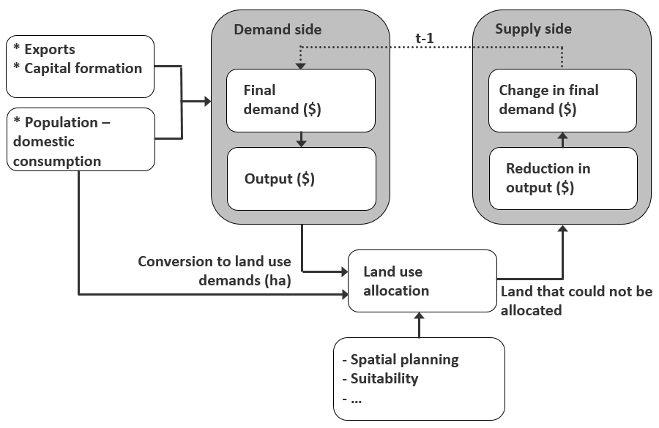Step 5: SA2 Economic projections
This step of the methodology involves deriving employment and value added projections using least squares regression, by 48 IO industries, for each SA2 within Waikato Region – further details are provided in Sections 2.2 and 2.3 below. These projections provide bottom-up estimates of employment at the SA2 level – which enables us to determine where industry employment will be allocated (i.e. across which SA2 areas). We, in turn, scale these, at an industry level, to the annual (top-down) projection estimates generated from the WISE model. This ensures that the bottom up SA2 estimates at the industry level sum exactly to their top-down regional equivalents. The economic regression models produce estimates of total employment by 48 industries, which are, in turn, aggregated to the 1 Digit ANZSIC level (19 industries) for each SA2. The estimates of employment are then converted to estimates of value added, by applying a value added-to-employment ratio for each industry and adjusting for estimated growth in productivity (i.e. value added per worker) over time.

Data for the SA2 Projections
For the least-squares regression model, a set of historical and projection data was utilised, containing both dependent and independent variables. The modeling derives a set of parameters that will enable unknown dependent variables to be derived, based on estimates of future independent variables. Below is a brief description of the historic and future datasets.
- Employment - Historical employment data (2006 to 2020) is obtained from StatsNZ’s Business Directory. This data, originally measured in Employment Counts (ECs), is translated to Modified Employment Counts (MECs) measure. MECs are Employment Counts (ECs) adjusted to include estimates of working proprietors.
- Land Use – The land use projections (2018 to 2068) by type are obtained from WISE covering the period 2018 to 2068. The land use data is disaggregated by 24 land types by SA2.
- Population – Historical population data by SA2 was obtained from the StatsNZ’s Census of Population and Dwellings (2006, 2013, 2018) and projections (2018 to 2068) supplied by Assoc. Prof. Michael Cameron of the University of Waikato.

Model Specification
The least-squares regression is considered to compute the projections based on the historical and projection data detailed in Section 2.2. One of the most ubiquitous challenges in producing these projections is dealing with the random error present in the data. In least squares regression analysis, this challenge can be addressed by computing p-values of the regression coefficients. The p-values represent the probability of a test statistic being at least as unusual as the one computed, given a null hypothesis being true. In this case, this is the null hypothesis corresponds to the coefficients being zero. This means that low p-values indicate that it would be rare to get a result as unusual as this if the coefficients were really zero. This test is often considered to “measure” the performance of the model against the error present in the data.
In our approach, we considered three regression models. Under the first approach the projection was determined using the historical employment data, land use projection data, and population projection data as the primary independent variables. Under the second approach the projection was determined by considering the said independent variables, as well as the 1-year lagged employment time series data. The main idea of this was to incorporate the latest trend of the employment into the projection. These two approaches were modelled in such a way that the trivial model is selected if all the non-trivial models fails the p-value test. To consider a non-trivial model in these cases, we implemented a third approach in which the model picks the projection series with the “best possible” p-value.
Ultimately, the selection of the model depends on reviewing the p-values. Over 84% of the projection series (6,954 projection series (non-zero SA2 x 1-Digit ANZSIC combinations) each covering 50 years (2018 to 2068) were generated from selection of one of the three regression models. The remaining 17% of projection series, which performed poorly (as defined by the p-values) were generated using several ad hoc models. In reviewing these poorer performing projections, we note these generally occur where significant levels of fluctuation in historical employment year-to-year from 2006 to 2020 – thus making any projection difficult. In these cases, we applied one of four models to set the projection series (16% of projection series): (1) set the projection values to the last year of known employment (2020) (9%), (2) index the projection values to the average of the last four years of known employment (2017 to 2020) (4%), (3) index growth to population growth at the TA level (1%), and (4) index growth of the industry growth rate as generated from the regional-level WISE model (2%).

Regional Level Commentary
In this chapter, we dicuss the regional level economic projections under a high growth scenario (ie. as based on high population and employment growth). We use the high growht projection as an exemplar. Looking back at previous projections, the high projection series has performed best in describing growth over the preceding 10 years. We note however that this was a period of extraordinary growth in population and economic growth terms in New Zealand’s history.

Employment
In 2018, there were 226,681 people employed in Waikato Region. It is projected to increase to 299,864 MECs by 2038. By 2068, the figure is projected to be 363,978 MECs. From 2018, this is 137,298 additional MECs or 60.6% growth.
Employment projections in the nineteen ANZSIC industries (excluding Owner Occupied Dwellings) for Waikato Region are shown in Figure 2. In 2018, Agriculture, Forestry and Fishing is the dominant industry in terms of employment 25,267 MECs or 11.1% of the Waikato Region workforce. This is followed by Manufacturing with 11.1% of total employment. In 2068, the two industries with the highest numbers employed for the region are Manufacturing and Construction with the relative shares of total regional employment of 11.6% and 10.1%, respectively. Financial and Insurance Services has the highest projected growth rate in employment, with 118% more workers employed in the industry by 2068 compared to 2018. In the projection scenario considered for this report, there are no industries that are projected to decline in the number of people employed from the 2018 base.

Value Added
Value added for Waikato Region was estimated at $₂₀₁₈20.2 billion in 2018, and projected to reach $₂₀₁₈28.9 billion in 2038 and $₂₀₁₈42.6 billion in 2068 (including Owner Occupied Dwellings (OODs)). This is an increase of approximately 110% by 2068, from 2018 levels.
Value added projections in the nineteen ANZSIC industries (excluding OODs) are presented in Figure 3. Manufacturing is the biggest industry (13.3% of total) in terms of value added or contribution to the region’s value added (excluding OODs) in 2068. The value added of the industry is projected to grow from $₂₀₁₈2.6 billion to $₂₀₁₈5.3 billion in the 50-year period. The second biggest industry in 2068 is projected to be Agriculture, Foresty and Fishing. This industry starts out as the biggest industry with $₂₀₁₈2.8 billion and is projected to be $₂₀₁₈4.7 billion or 11.9% of region total (excluding OODs). Construction is the third largest industry in value added terms in 2068 with $₂₀₁₈3.5 billion contributing 8.8% of the region total (excluding OODs), growing from $₂₀₁₈1.6 billion in 2018. It should be noted that the value added of all industries are projected to grow.
Figure 2 Waikato Region Employment under a High Growth Scenario, 2018 to 2068
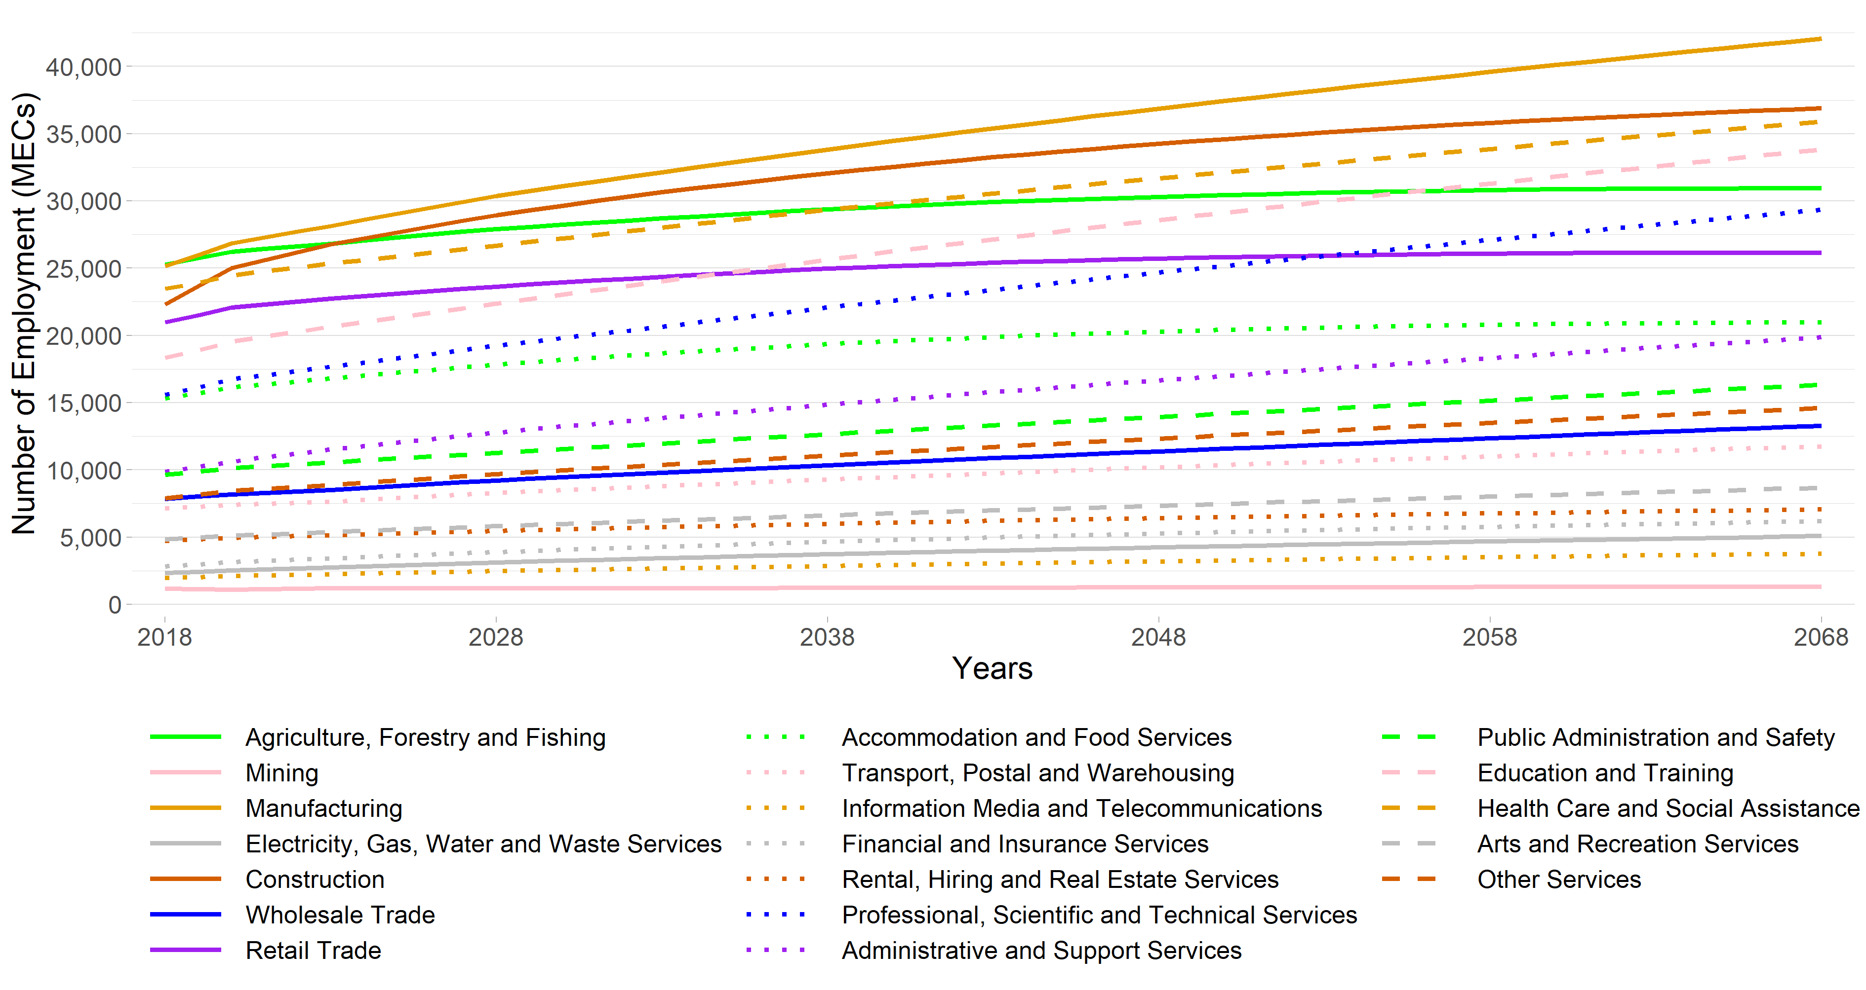Note: The employment figures for 2018 through to 2020 are actuals derived from StatsNZ’s 2020 Business Directory.

Figure 3 Waikato Region Value Added $₂₀₁₈million under a High Growth Scenario, 2018 to 2068
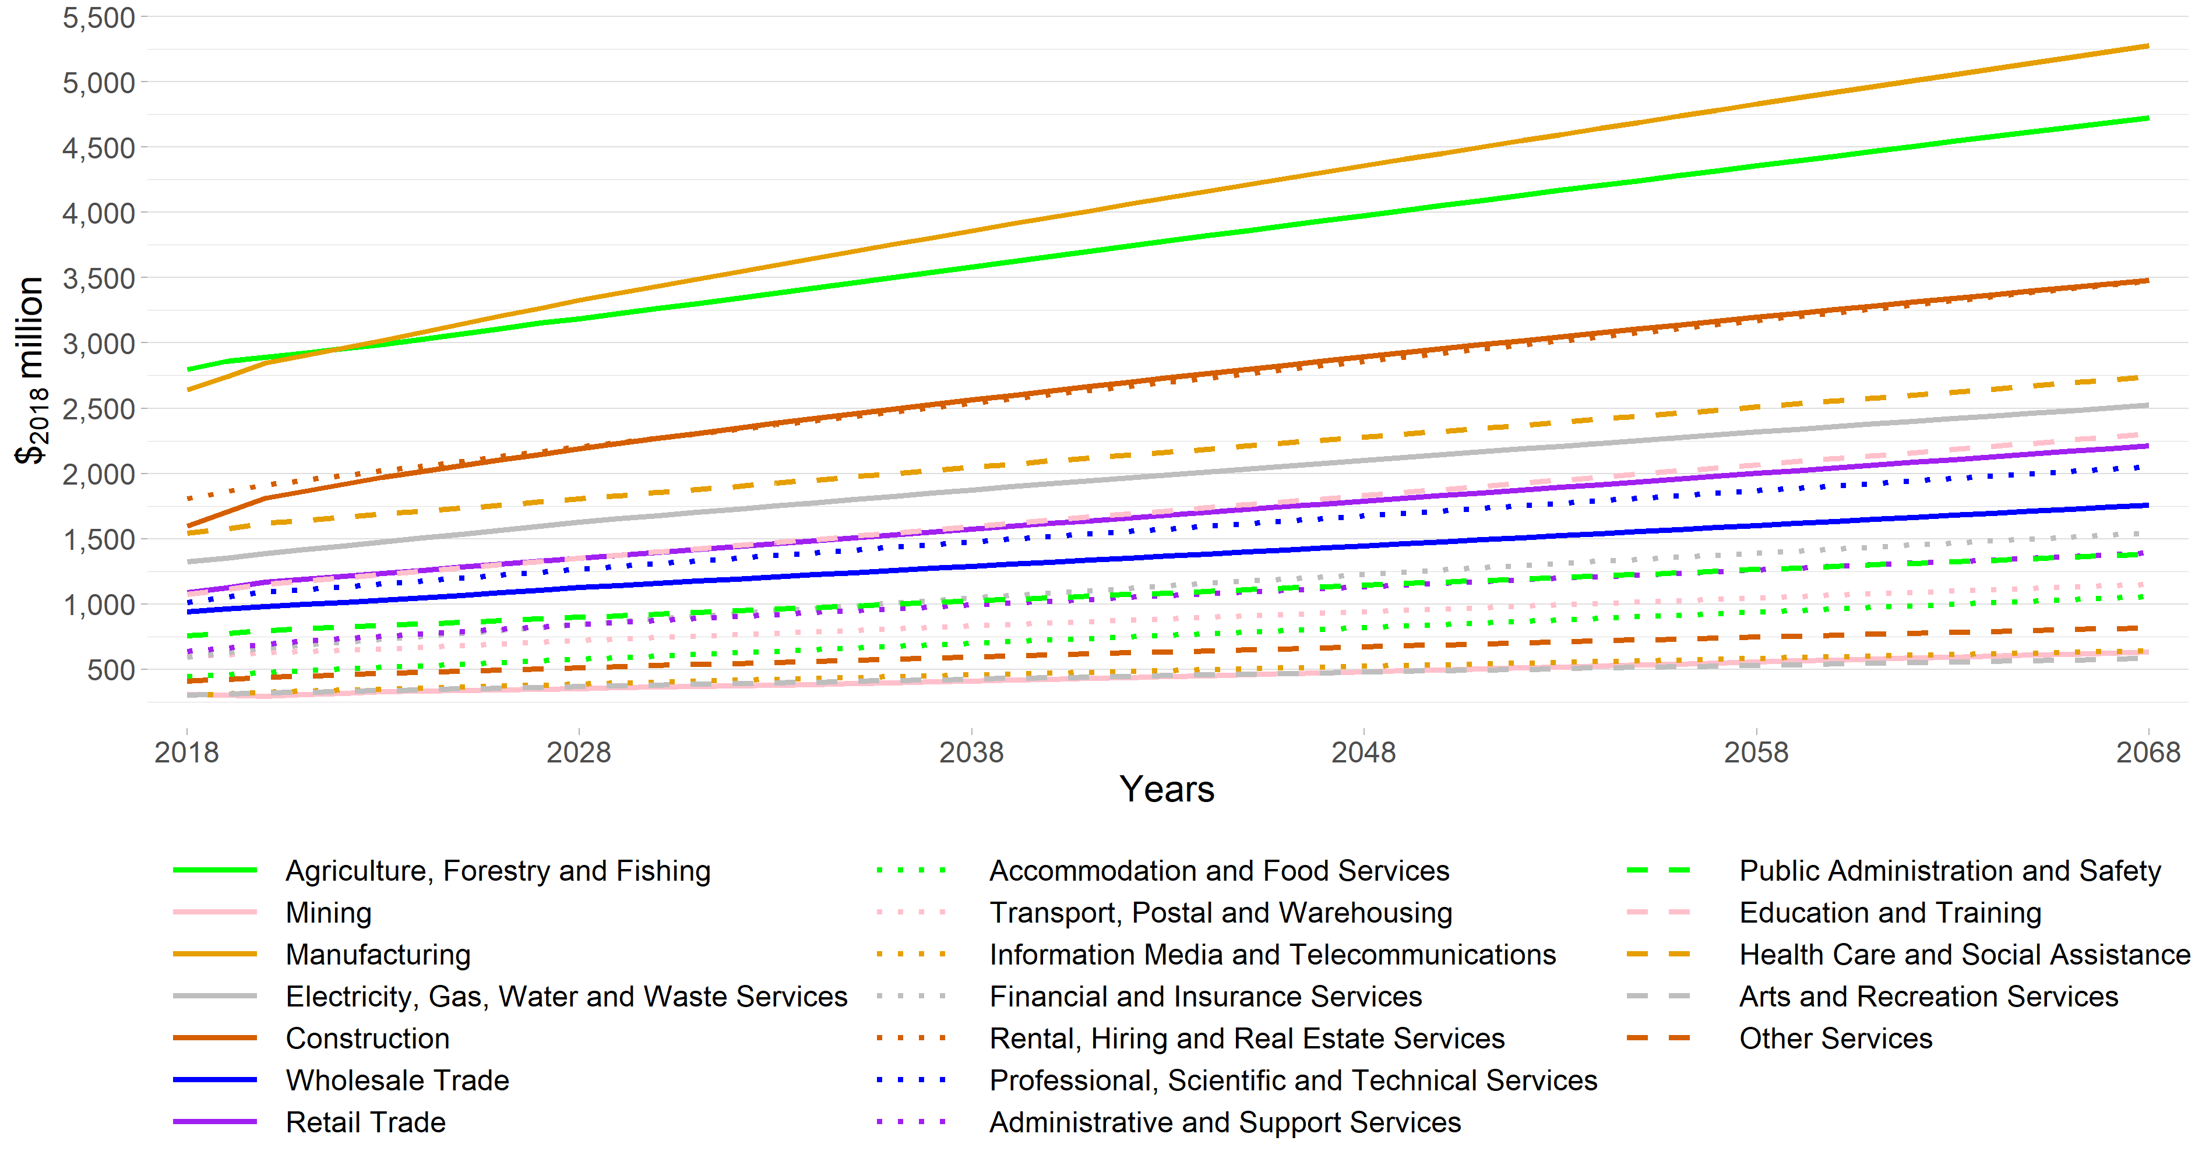Note: The value added figures for 2018 to 2020 are estimates based on MEResearch’s multi-regional input-output table for the financial year ending March 2018 as derived from the latest available StatsNZ Inter-Industry Study of the New Zealand economy.

TA Level Commentary
In this chapter, we discuss the TA level economic projections. We also present some projections at the SA2 level as an illustration of the level of detail for which the results are available. The Waikato Regional Council, along with all of its constituent TAs, have been provided with a spreadsheet version of the results which may be queried in detail.

Employment
Table 1 shows the numbers of MECs in each TA, with projected changes from 2018 to 2038 and 2068, and the compounded annual growth rate for that periods 2018-2038 and 2018-2068. The urban Hamilton City is the dominant centre of employment for the region, with over 40% of the region’s employment (MECs). In terms of employment, Hamilton City is at least four times larger than Waikato District and Waipa District which are the second and third largest TAs, respectively. Hamilton city is projected to have the highest absolute growth in MECs by 2068, with an increase of over 70,000 MECs. Of the more rural districts, Matamata-Piako District is projected to have the biggest growth in employment out to 2068.

Table 1 Total Growth in Employment by Territorial Authority Under a High Growth Scenario, 2018 to 2038, and 2018 to 2068
Territorial Authority | Actual MECs in 2018 | Projected MECs in 2038 | Compounded Annual Growth Rate (2018-2038) | Projected MECs in 2068 | Compounded Annual Growth Rate (2018-2068)
Hamilton City | 100,394 | 137,385 | 1.58% | 171,013 | 1.07%
Waipa District | 23,735 | 31,218 | 1.38% | 38,789 | 0.99%
Waikato District | 23,833 | 34,462 | 1.86% | 43,858 | 1.23%
Taupō District | 18,938 | 23,220 | 1.02% | 26,116 | 0.65%
Matamata-Piako District | 17,889 | 21,887 | 1.01% | 24,647 | 0.64%
Thames-Coromandel District | 12,966 | 16,175 | 1.11% | 19,275 | 0.80%
South Waikato District | 9,751 | 11,942 | 1.02% | 13,498 | 0.65%
Hauraki District | 7,239 | 9,063 | 1.13% | 10,513 | 0.75%
Waitomo District | 5,352 | 6,561 | 1.02% | 7,417 | 0.66%
Ōtorohanga District | 4,739 | 6,110 | 1.28% | 6,849 | 0.74%
Rotorua District (part in Waikato) | 2,219 | 2,213 | -0.01% | 2,451 | 0.20%
Total | 227,055 | 300,235 | 1.41% | 364,425 | 0.95%
Notes: MECs = Modified Employment Counts. This is a measure of the number of employees within an industry based on Statistic New Zealand’s Employment Count measure but modified to take account estimates of the number of working proprietors within each industry.
For a few TAs in Waikato Region, Agriculture, Forestry and Fishing is one of the dominant industries in employment terms: Waipa District, Waikato District, South Waikato District, Hauraki District, Waitomo District, and Ōtorohanga District. There are only four TAs in which Agriculture, Forestry and Fishing is not one of the dominant industries. These TAs are Hamilton City, which employs most of its workforce in Health Care and Social Assistance; in Taupō District, Accommodation and Food Services is the dominant industry; in Matamata-Piako District, Manufacturing is the dominant industry; in Thames-Coromandel District, Retail Trade and Accommodation and Food Services are the dominant industries.
The employment by industry projections in the ten Waikato Region TAs are presented in Figure 4. This enables a comparison of the main employment trends in each TA and projected changes. The employment data presented between 2018 and 2020 is actual data, whereas the data from 2021 to 2068 is projected from the modelling. This comparable graphic clearly shows the TAs where there are one or two dominant industries (e.g., Waikato District and Ōtorohanga District District), and those with more diversified industry employment (e.g., Taupō District and Thames-Coromandel District). We refer to the Section 3.3 for a more detailed discussion on the TA-level projections.

Figure 4 Projected Employment by Industry in Waikato Region’s Territorial Local Authorities under a High Growth Scenario, 2018 to 2068
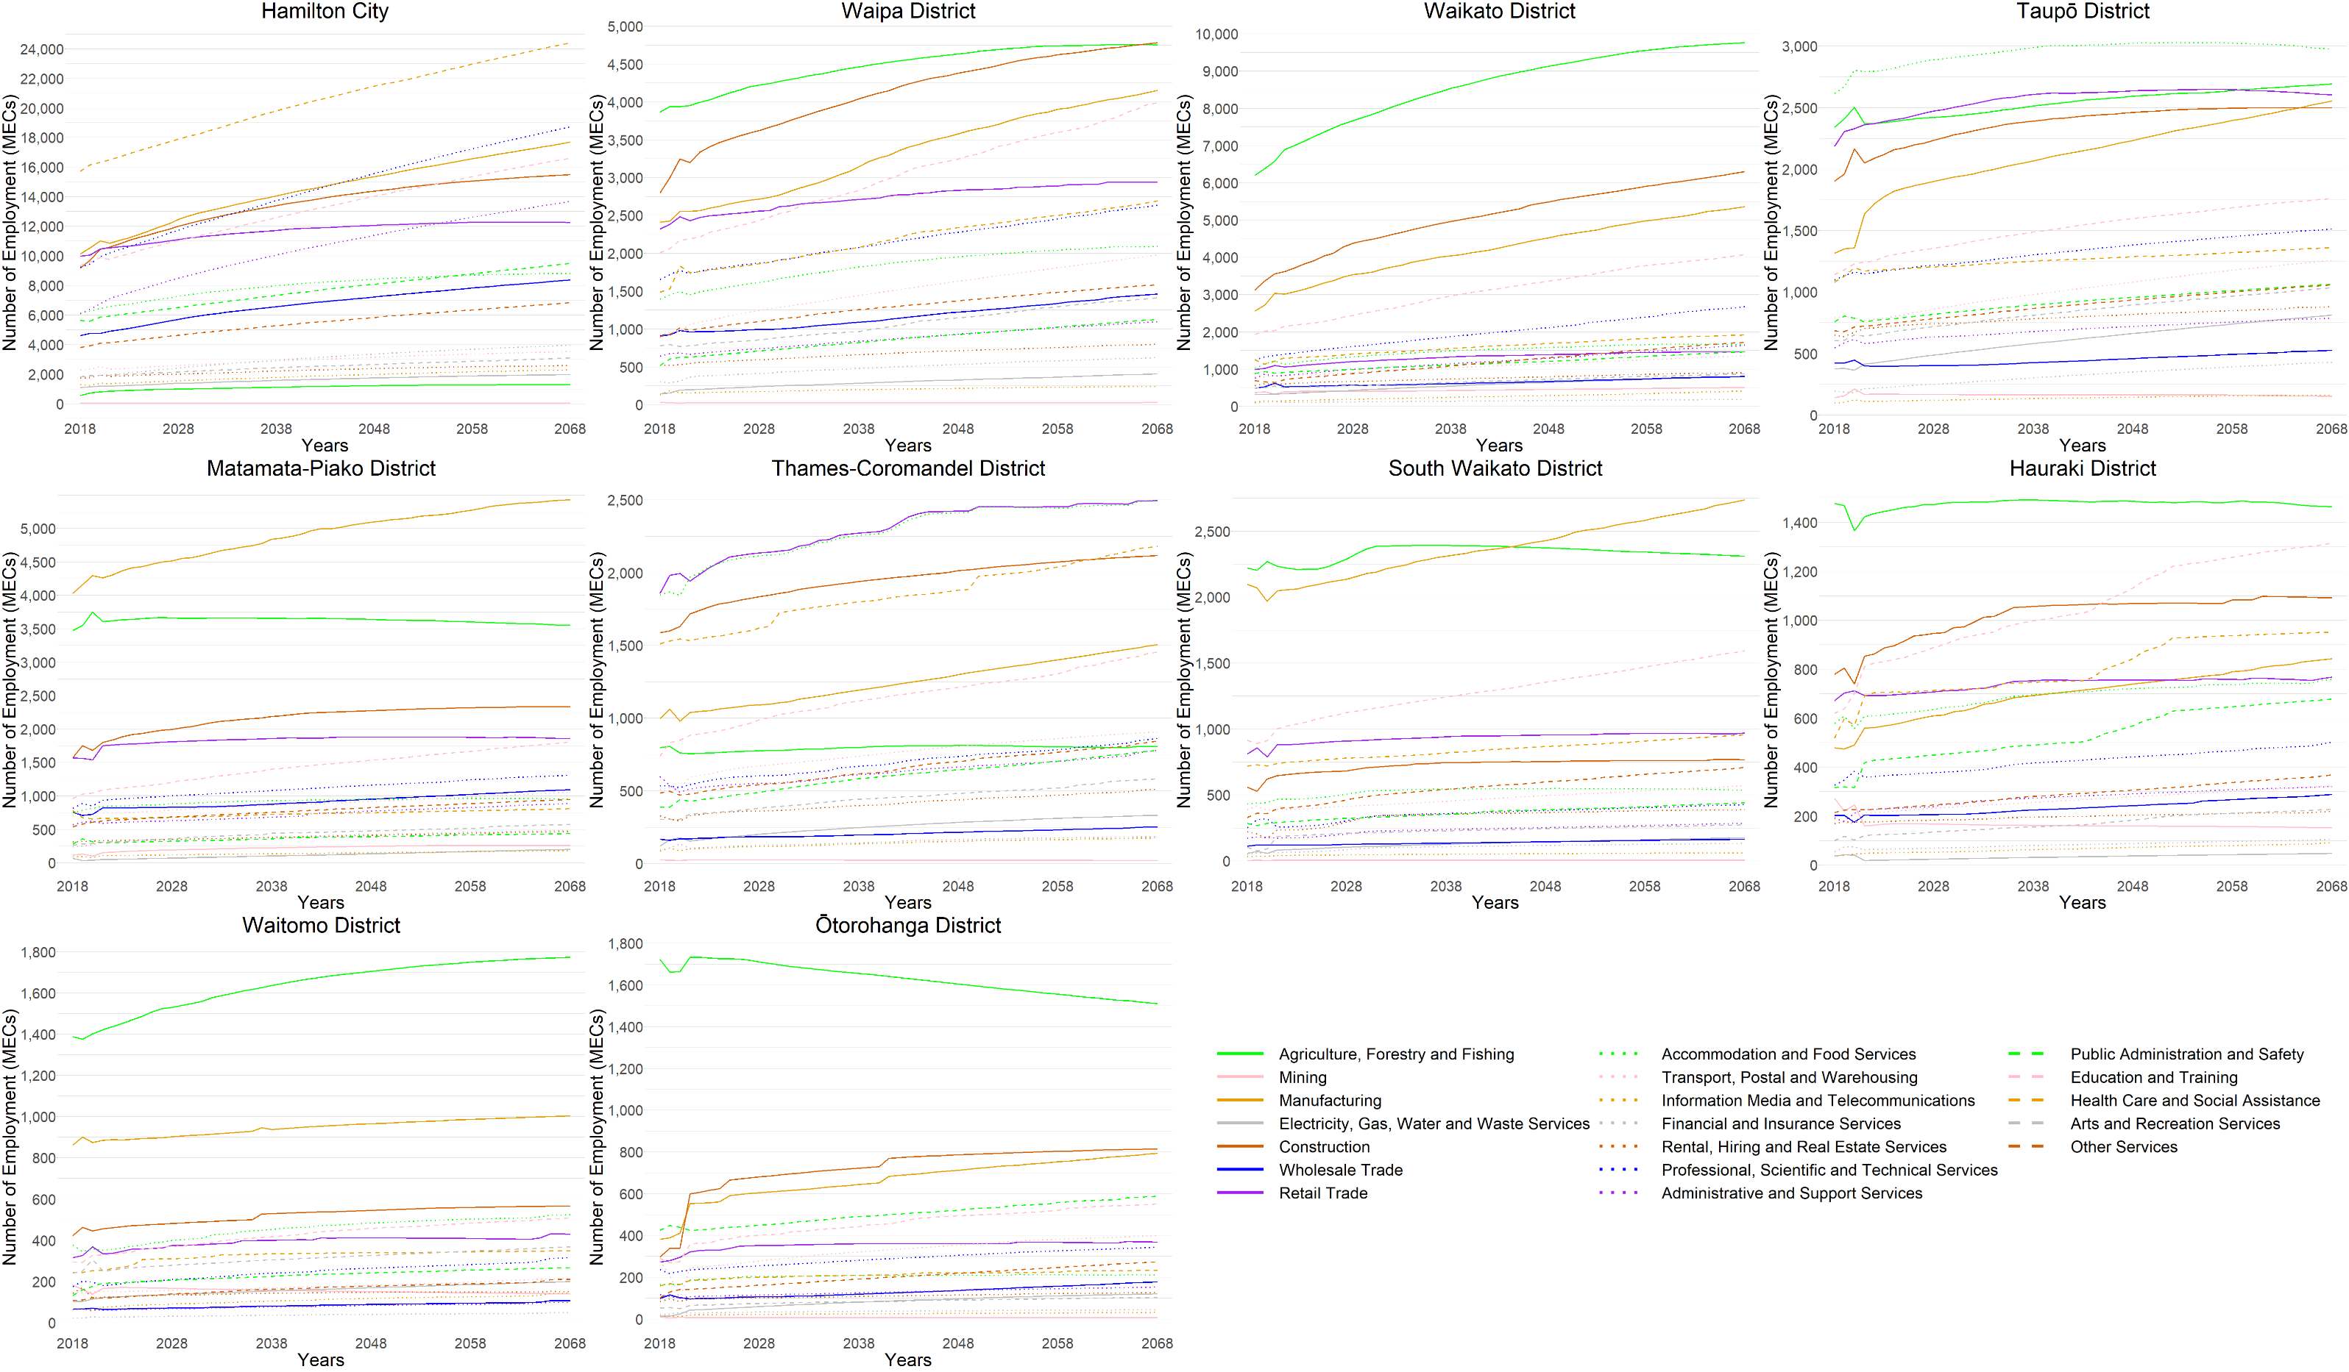Note: The vertical scale on each line charts varies. The employment figures for 2018 through to 2020 are actuals derived from StatsNZ’s 2020 Business Directory.

Value Added
Table 2 shows the relative size of each TA in terms of value added contribution, in 2018, 2038, and in 2068. It also shows the compound annual growth rates for each TA between 2018 and 2038, and then between 2018 and 2068. There are higher growth rates in value added within the next twenty years in all the TAs, in comparison to the following period from 2018 to 2068. Table 2 shows that Waikato District has the highest compounded annual growth rate, with South Waikato District the lowest (excluding the part of Rotorua District that is in Waikato Region).
Table 2 Total Growth in Value Added by Territorial Authority under a High Growth Scenario, 2018 to 2038, and 2018 to 2068
Territorial Authority | Actual VA in 2018 ($₂₀₁₈m) | Projected VA in 2038 ($₂₀₁₈m) | Compounded Annual Growth Rate (2018-2038) | Projected VA in 2068 ($₂₀₁₈m) | Compounded Annual Growth Rate (2018-2068)
Hamilton City | 8,448 | 12,477 | 1.97% | 17,209 | 1.43%
Waipa District | 2,056 | 2,974 | 1.86% | 4,225 | 1.45%
Waikato District | 2,199 | 3,461 | 2.29% | 5,063 | 1.68%
Taupō District | 1,862 | 2,484 | 1.45% | 3,276 | 1.14%
Matamata-Piako District | 1,742 | 2,347 | 1.50% | 3,148 | 1.19%
Thames-Coromandel District | 983 | 1,338 | 1.55% | 1,860 | 1.28%
South Waikato District | 1,026 | 1,348 | 1.37% | 1,746 | 1.07%
Hauraki District | 676 | 889 | 1.38% | 1,186 | 1.13%
Waitomo District | 557 | 743 | 1.45% | 995 | 1.17%
Ōtorohanga District | 436 | 611 | 1.70% | 791 | 1.20%
Rotorua District (part in Waikato) | 224 | 248 | 0.50% | 318 | 0.70%
Total | 20,209 | 28,919 | 1.81% | 39,816 | 1.37%
Note: The estimates of value added in this table exclude the contribution of Owner Occupied Dwellings, which is only available at a regional level and estimated to be $₂₀₁₈1,652m in 2018 and $₂₀₁₈2,866m by 2068.
The value added projections for each industry (excluding OODs) in the ten Waikato Region TAs are presented in Figure 5. This enables a comparison of the main value added trends in each TA and projected changes. Note, the scales (in monetary terms) differ for each TA and, as can also be seen from Table 2 above, the level of economic activity across the TAs has a wide range, from Hamilton City with a value added of over $₂₀₁₈8.4 billion to Ōtorohanga District with $₂₀₁₈436 million.
Figure 5 Projected Value Added by Industry in each of Waikato Region’s Territorial Local Authorities under a High Growth Scenario, 2018 to 2068
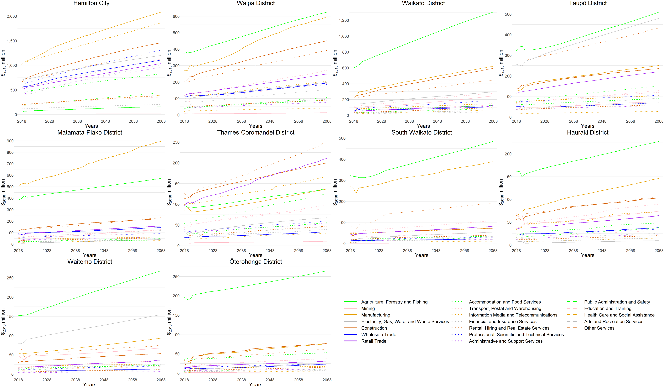Note: The vertical scale on each line charts varies. The value added figures for 2018 to 2020 are estimates based on MEResearch’s multi-regional input-output table for the financial year ending March 2018 as derived from the latest available StatsNZ Inter-Industry Study of the New Zealand economy.

Projected within each TA

Hamilton City
Hamilton City is the dominant TA in terms of economic activity in Waikato Region. With a value added contribution of $₂₀₁₈8.4 billion (excluding OODs) in 2018 and a workforce of close to 100,400 MECs, it dwarfs the other TA economies. Unsurprisingly with its relative size, it has a diversified industry structure.
The employment projections of each nineteen ANZSIC industries are presented in Figure 6. The biggest industry in 2018 employment terms is, and is projected to continue to be, Health Care and Social Assistance. With 15,713 MECs in 2018, 15.7% of Hamilton City’s employees are in this industry. Manufacturing is the second biggest (10,116 MECs or 10.1%) followed by Retail Trade (9,985 MECs or 10.0%) and Education and Training (9,334 MECs or 9.3%).
Figure 6 Hamilton City Employment under a High Growth Scenario, 2018 to 2068
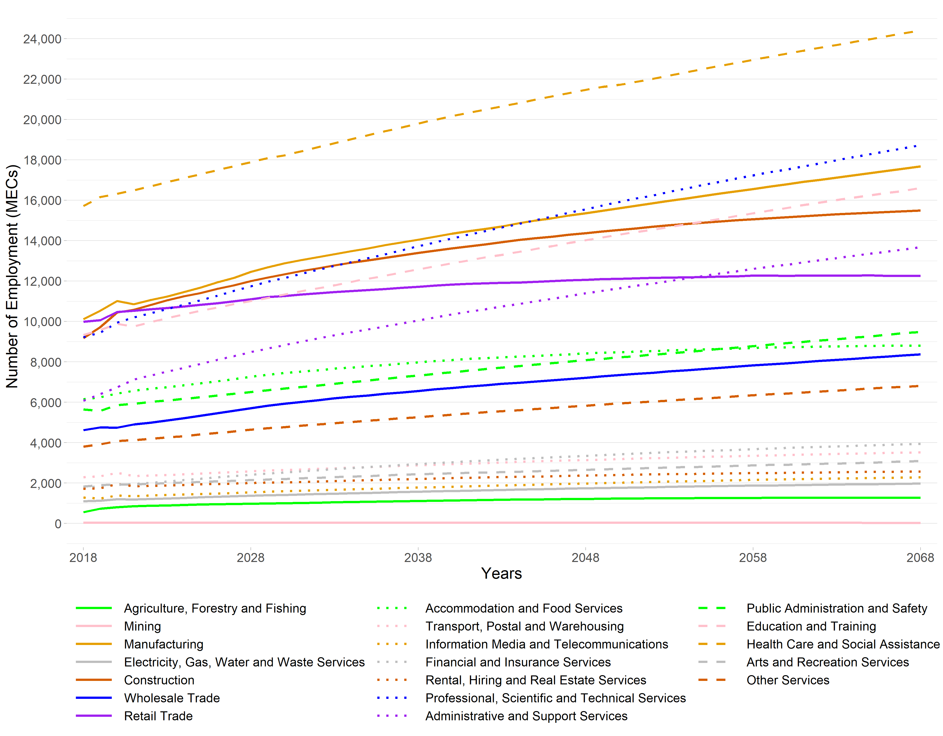Note: The employment figures for 2018 through to 2020 are actuals derived from StatsNZ’s 2020 Business Directory.
The projections for each TA can be explored by SA2. We extracted an example of an urban centre SA2 within Hamilton City for illustrative purposes. This is shown in Figure 7.
Figure 7 Hamilton East SA2 Employment under a High Growth Scenario, 2018 to 2068
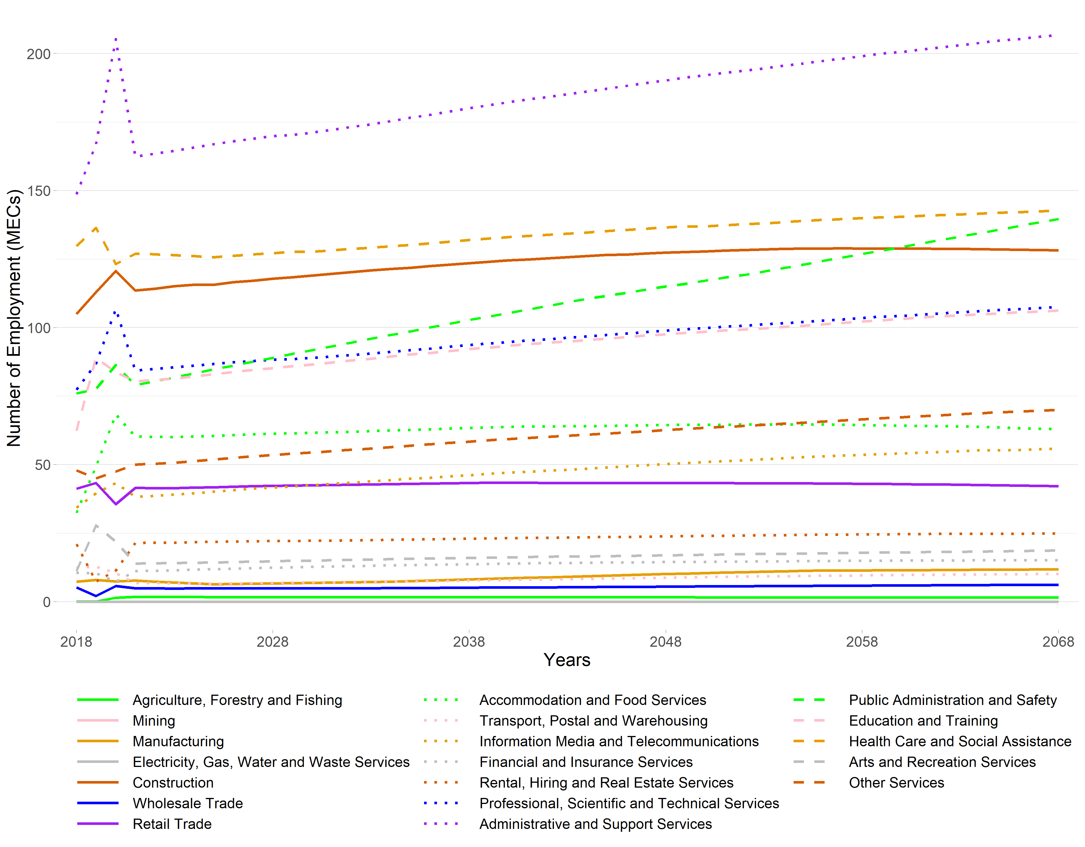Note: The employment figures for 2018 through to 2020 are actuals derived from StatsNZ’s 2020 Business Directory.
The value added projections of each of the nineteen ANZSIC industries are presented in Figure 8. In terms of value added, Manufacturing is the dominant industry for most of the period between 2018 and 2068. Manufacturing starts as the second biggest industry in 2018 employment terms behind Health Care and Social Assistance, but it catches up quickly growing from $₂₀₁₈1.01 billion in 2018 to $₂₀₁₈2.08 billion in 2068, contributing 12.1% of the TA’s total value added (excluding OODs). Health Care and Social Assistance starts with the value added of $₂₀₁₈1.03 billion and is projected to grow to $₂₀₁₈1.87 billion.
In 2018, Manufacturing is followed by Electricity, Gas, Water and Waste services ($₂₀₁₈700 million) and Rental, Hiring and Real Estate Services ($₂₀₁₈659 million). The value added of all industries in Hamilton City are projected to increase out to 2068, indicating a persistently growing economy.

Figure 8 Hamilton City Value Added under a High Growth Scenario, 2018 to 2068
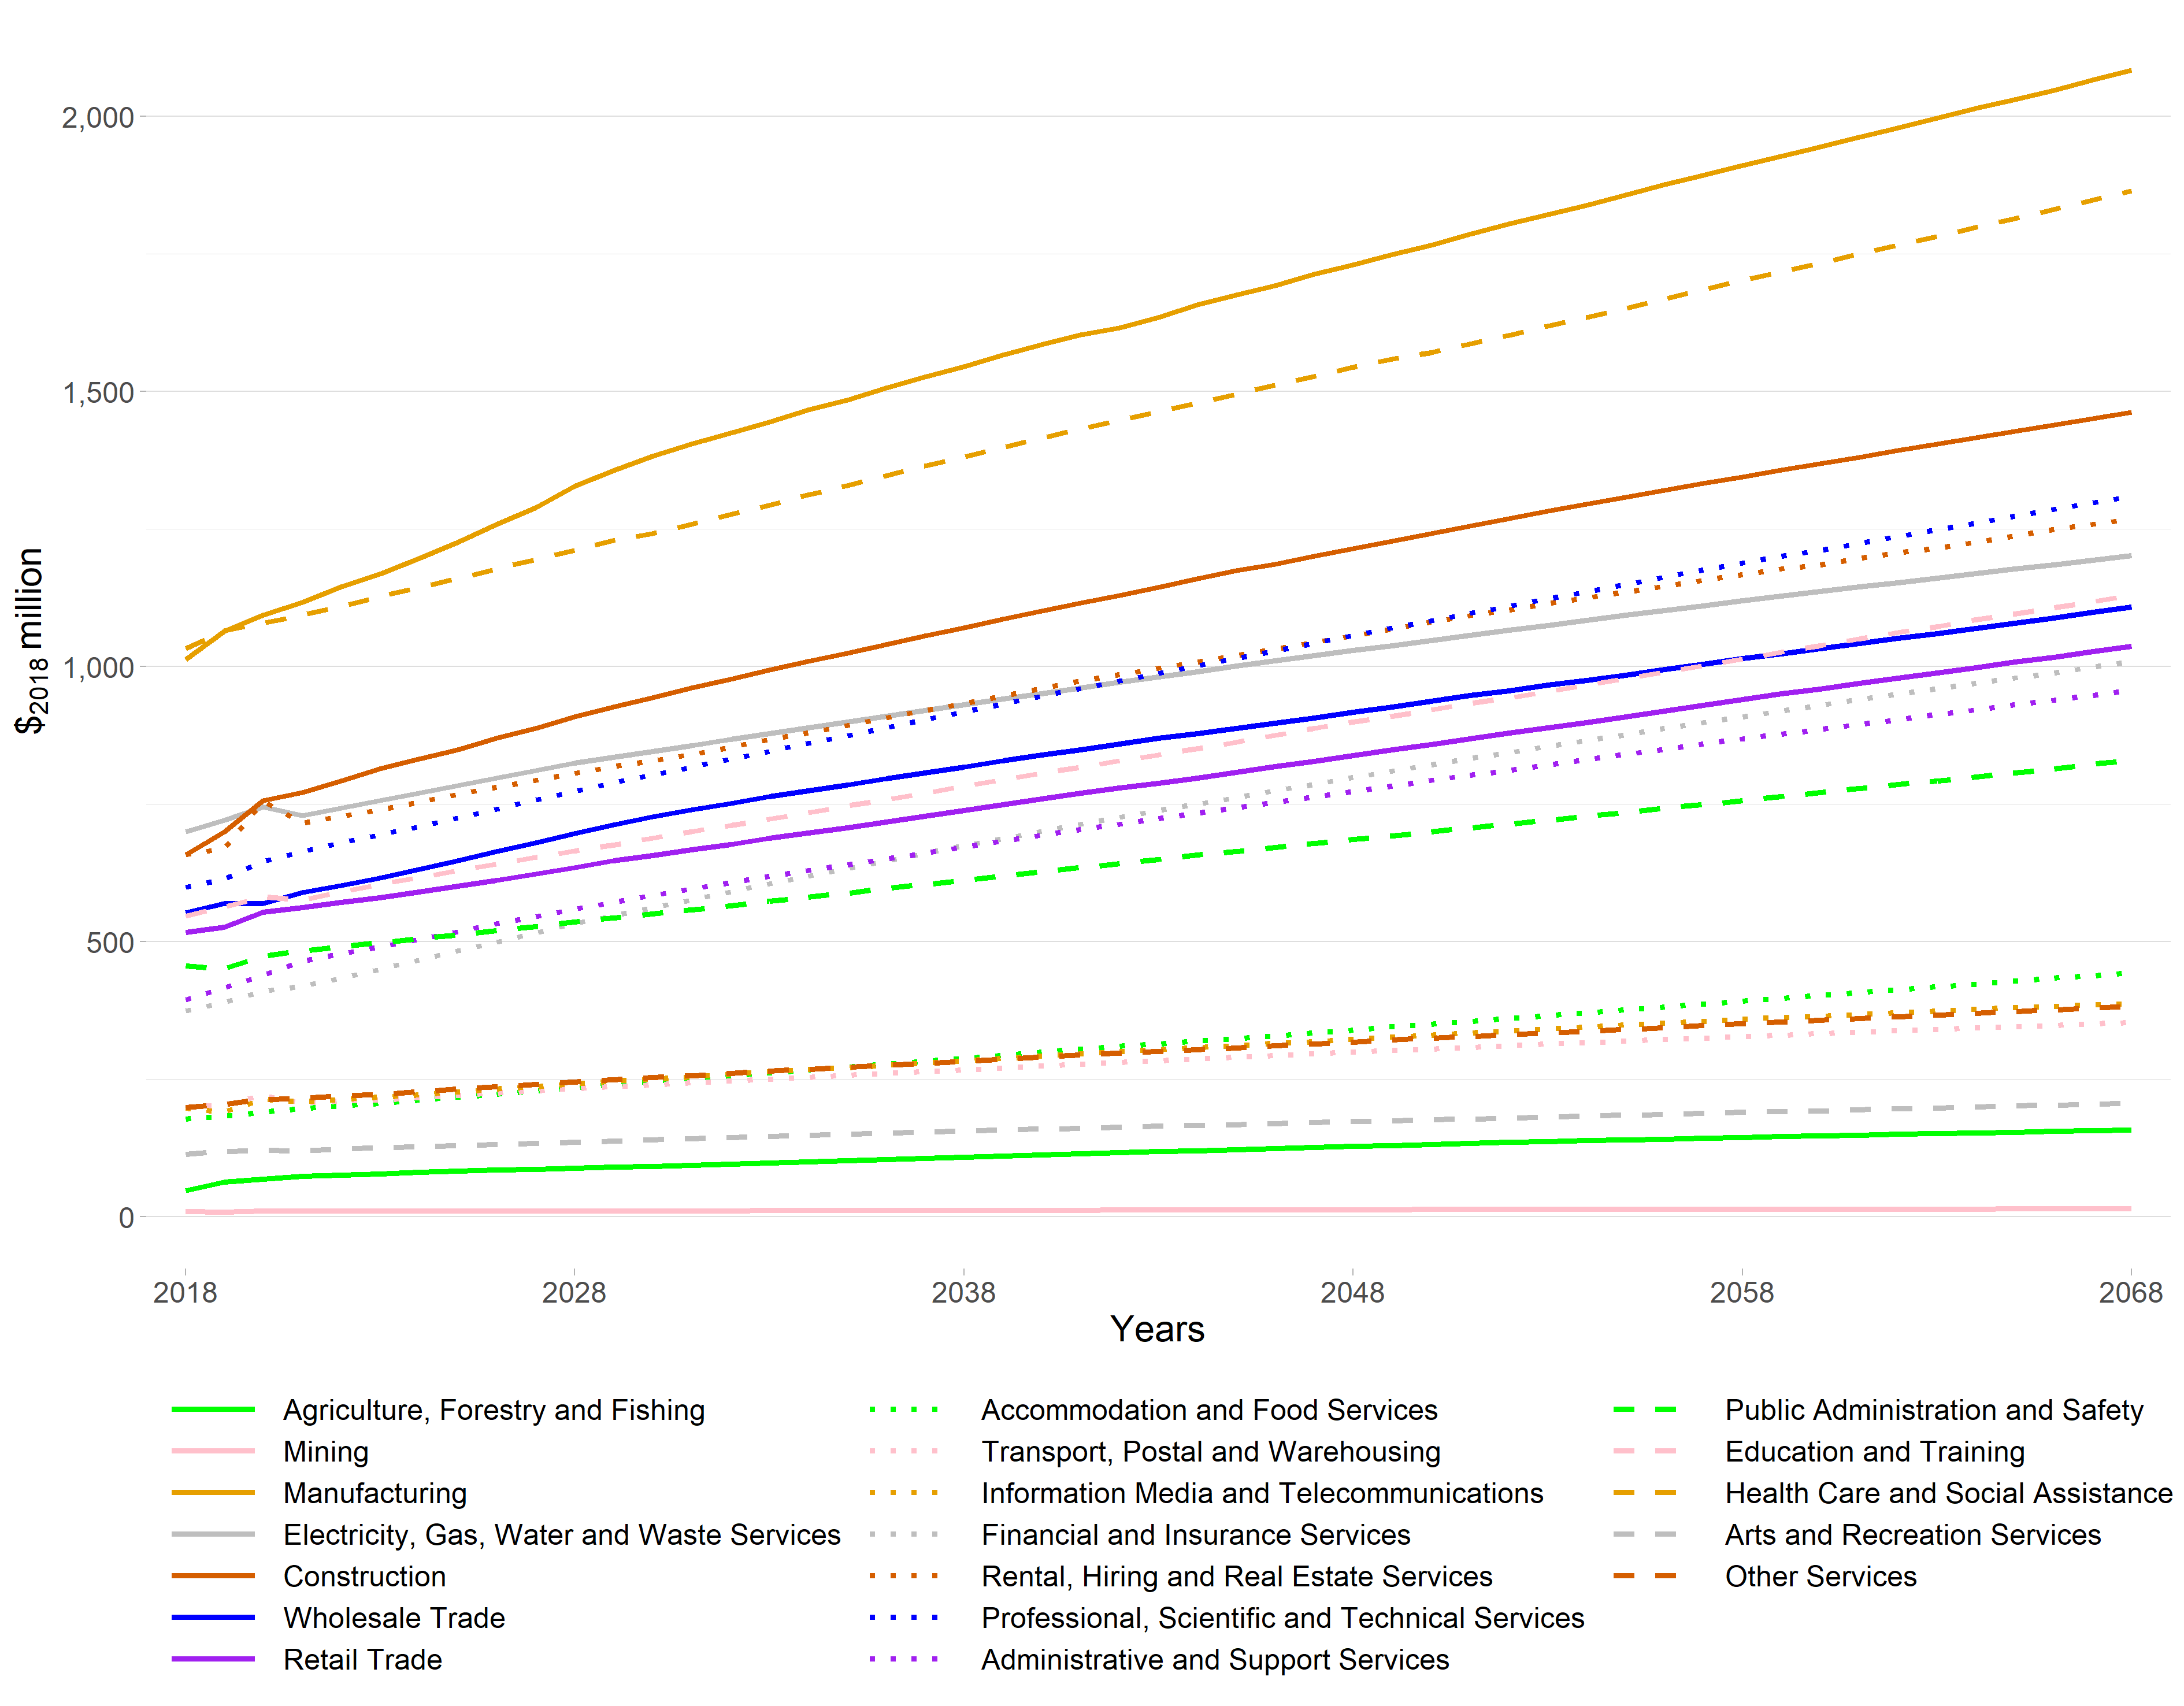Note: The value added figures for 2018 to 2020 are estimates based on MEResearch’s multi-regional input-output table for the financial year ending March 2018 as derived from the latest available StatsNZ Inter-Industry Study of the New Zealand economy.

Waipa District
Waipa District is the third largest TA in Waikato Region in terms of economic activity (as measured in value added terms), just behind Waikato District.
The employment projections of each nineteen ANZSIC industries are presented in Figure 9. Waipa District is initially dominated by Agriculture, Forestry and Fishing, with 3,867 MECs out of a 23,735 MEC total (16.3%) in 2018. Construction is the industry that employs the second greatest number of people (2,797 MECs in 2018, or 11.8% of total employed), followed closely by Manufacturing (2,412 MECs or 10.2%). The MECs in Construction eventually surpasses Agriculture, Forestry and Fishing. By 2068, it is projected that these three industries will have 12.3%, 12.3%, and 10.7%, respectively. Retail Trade, Education and Training, Professional, Scientific and Technical Services, and Health Care and Social Assistance are also some of considerable industries in the district in terms of employment.
The somewhat smooth growth rates at a TA level mask more volatile projections at the SA2 level, with projected changes to the industry structure. We include employment projections for Fencourt, with actual data up to 2020, and modelled data out to 2068. This is an example of a quite diversified SA2, with numerous industries. The projections are shown in Figure 10.

Figure 9 Waipa District Employment under a High Growth Scenario, 2018 to 2068
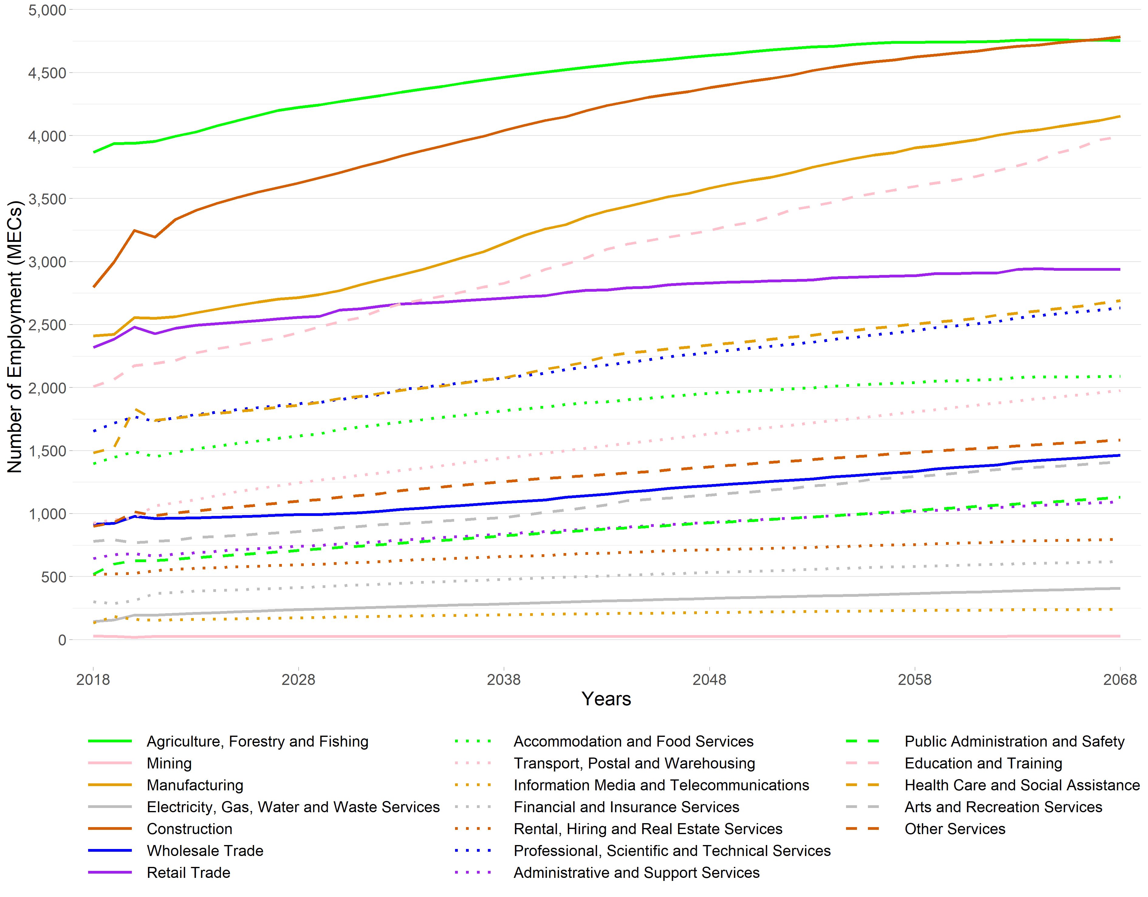Note: The employment figures for 2018 through to 2020 are actuals derived from StatsNZ’s 2020 Business Directory.

Figure 10 Fencourt SA2 Employment under a High Growth Scenario, 2018 to 2068
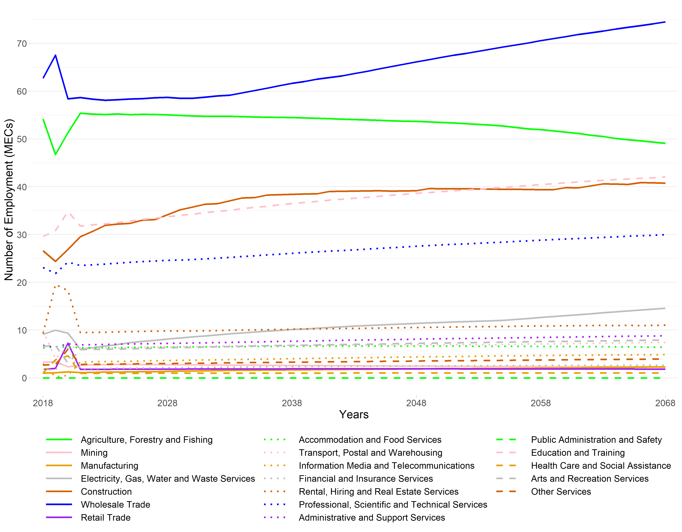Note: The employment figures for 2018 through to 2020 are actuals derived from StatsNZ’s 2020 Business Directory.
In terms of economic contribution to the district’s value added, Agriculture, Forestry and Fishing is consistently the greatest contributor, with $₂₀₁₈375 million in 2018. Manufacturing ($₂₀₁₈269 million) is the second largest value added industry in the district in 2018. Construction contributed $₂₀₁₈200 million in 2018 followed by Rental, Hiring and Real Estate Services contributing $₂₀₁₈199 million.
The projected changes of industry’s value added to 2068 are presented in Figure 11. All the industries are showing positive projections. Manufacturing is a stand-out, increasing from $₂₀₁₈269 million to $₂₀₁₈598 million. It almost catches up to Agriculture, Forestry and Fishing of which the VA is projected to grow from $₂₀₁₈375 million to $₂₀₁₈626 million.

Figure 11 Waipa District Value Added under a High Growth Scenario, 2018 to 2068
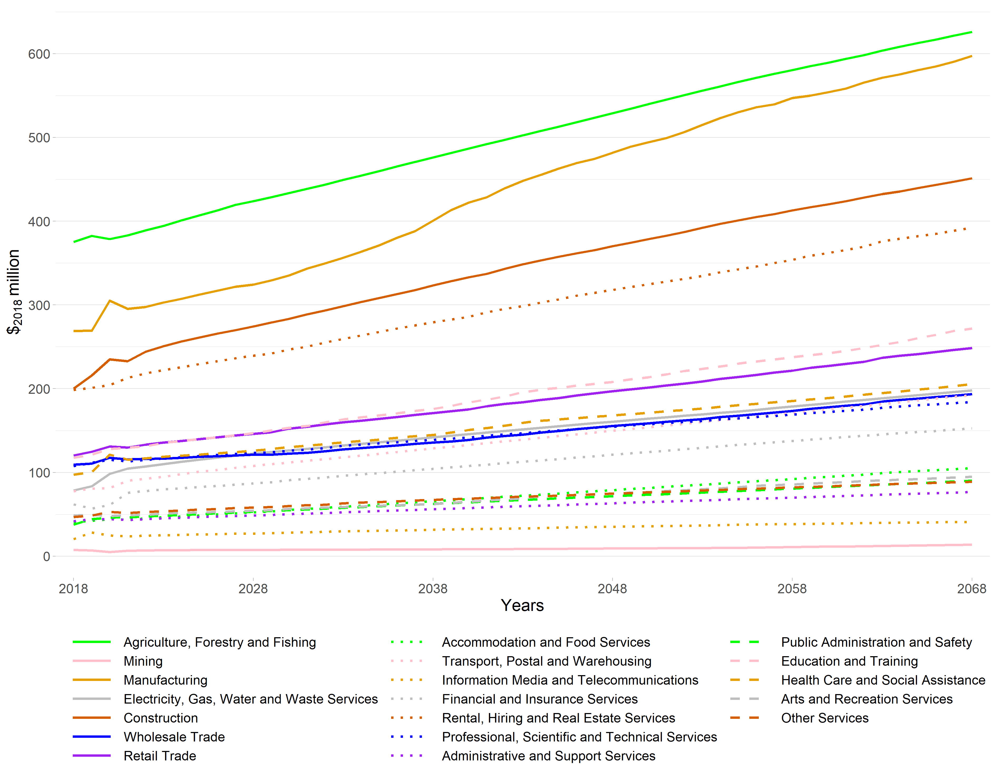Note: The value added figures for 2018 to 2020 are estimates based on MEResearch’s multi-regional input-output table for the financial year ending March 2018 as derived from the latest available StatsNZ Inter-Industry Study of the New Zealand economy.

Waikato District
The employment projections of each nineteen ANZSIC industries are presented in Figure 12. Waikato District is dominated by Agriculture, Forestry and Fishing, with 6,202 of the 23,833 people employed, situated in this sector in 2018. This is 26.0% of the district’s MECs. Agriculture, Forestry and Fishing is projected to grow to 9,763 MECs by 2068. Construction is the second largest in terms of employment, with 3,124 MECs employed in 2018. Manufacturing and Education and Training are the third and fourth largest industries in terms of employment in 2018, with 2,557 and 1,926 MECs respectively.

Figure 12 Waikato District Employment under a High Growth Scenario, 2018 to 2068
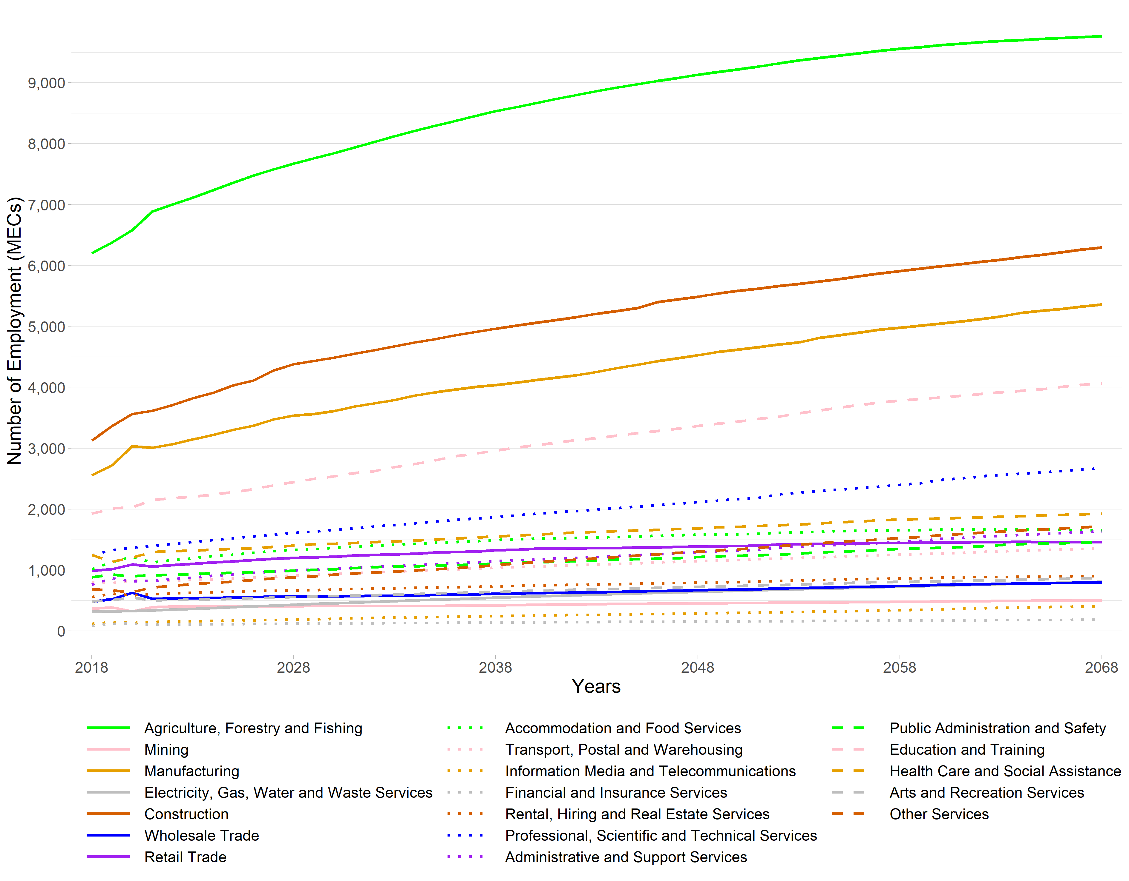Note: The employment figures for 2018 through to 2020 are actuals derived from StatsNZ’s 2020 Business Directory.
We selected an SA2 within Waikato District that is highly dependent on one industry. In this case, Pōkeno is clearly dependent on Manufacturing. This is shown in the employment projections presented in Figure 13. The modelled projection returns a steep increase in employment initially before stabilising. However, caution is warranted in reporting at a SA2 level, as there is much uncertainty at the level of accuracy of projections at this resolution.
The value added projections of each nineteen ANZSIC industries are presented in Figure 14. Agriculture, Forestry and Fishing is estimated to have contributed $₂₀₁₈600 million to Waikato District, or 27.3% of the $₂₀₁₈2.20 billion total (excluding OODs) in 2018. Agriculture, Forestry and Fishing also has a great projected total growth in terms of value added, reaching $₂₀₁₈1.30 billion by 2068. The contribution of Manufacturing to the district’s economy is also set to rise, increasing by 174% from $₂₀₁₈226 million in 2018 to $₂₀₁₈619 million by 2068. The contribution of Information Media and Telecommunications to the district’s economy had the highest growth rate, with $₂₀₁₈18.1 million in 2018 and projected to reach $₂₀₁₈69.7 million in 2068.
Figure 13 Pōkeno SA2 Employment under a High Growth Scenario, 2018 to 2068
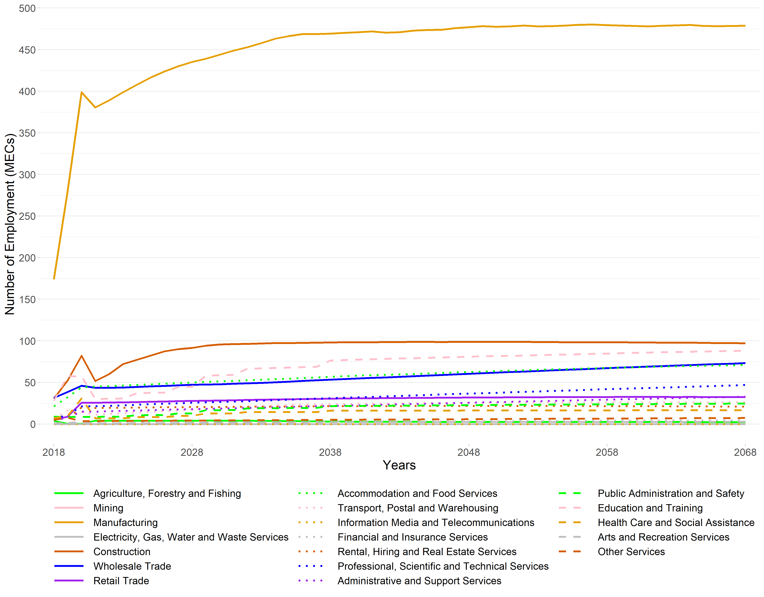Note: The employment figures for 2018 through to 2020 are actuals derived from StatsNZ’s 2020 Business Directory.
Figure 14 Waikato District Value Added under a High Growth Scenario, 2018 to 2068
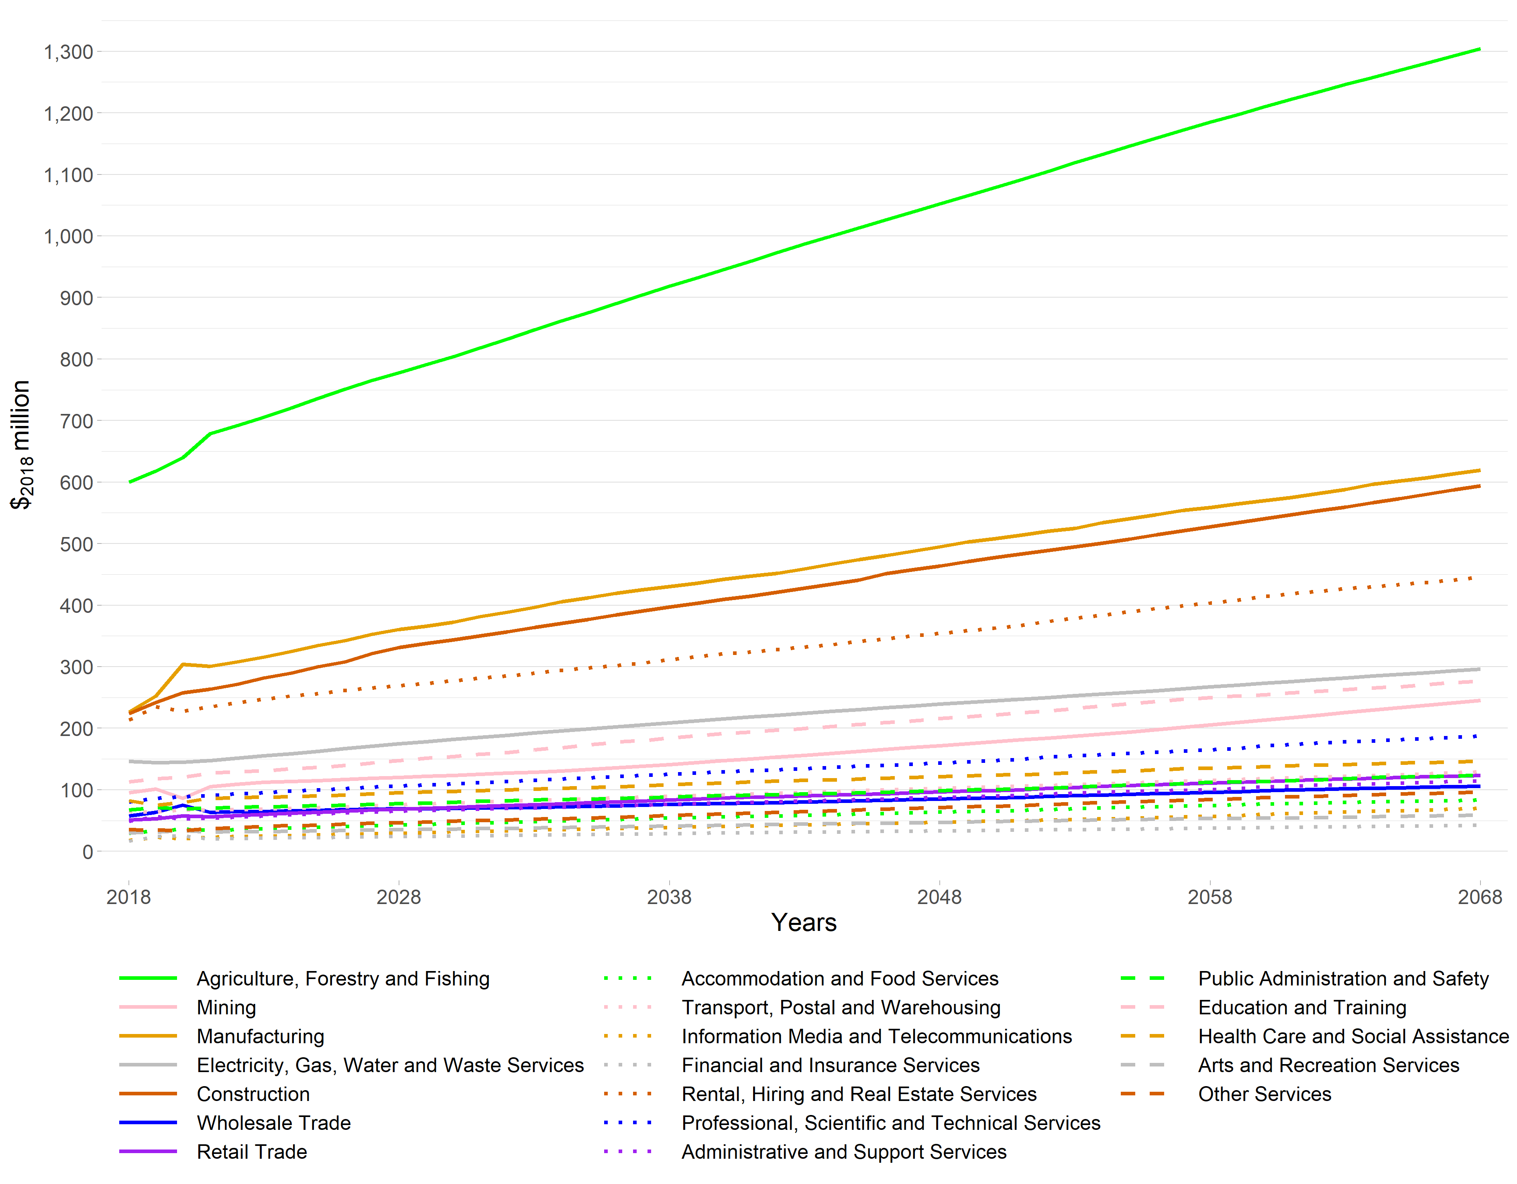Note: The value added figures for 2018 to 2020 are estimates based on MEResearch’s multi-regional input-output table for the financial year ending March 2018 as derived from the latest available StatsNZ Inter-Industry Study of the New Zealand economy.

Taupō District
Taupō District is the fourth largest in Waikato Region, in terms of economic activity, with a value added contribution of $₂₀₁₈1.86 billion (excluding OODs) in 2018, and 18,938 associated workers or MECs.
The employment projections of each nineteen ANZSIC industries are presented in Figure 15. The figure shows that Taupō District’s workforce is relatively smaller to that of some other districts. This is shown with the district’s dominant industry, Accommodation and Food Services, with 2,617 MECs in 2018 (13.8%).
The projection also indicates that Taupō District is also a service centre, for more rural outlying districts. These characteristics are illustrated by the dominance of service industries such as Accommodation and Food Services. Furthermore, we observe that Taupō District economy is diversified, reflecting the importance of tourism.
Retail Trade and Construction are ranked third and fourth in employment terms in 2018, with 2,185 and 1,902 MECs respectively in 2018. There are no industries that are declining in this period.
Once again, economic activities within individual SA2s can be tracked. We extracted one SA2, Acacia Bay. See Figure 16 for the employment projections in this SA2.
Figure 15 Taupō District Employment under a High Growth Scenario, 2018 to 2068
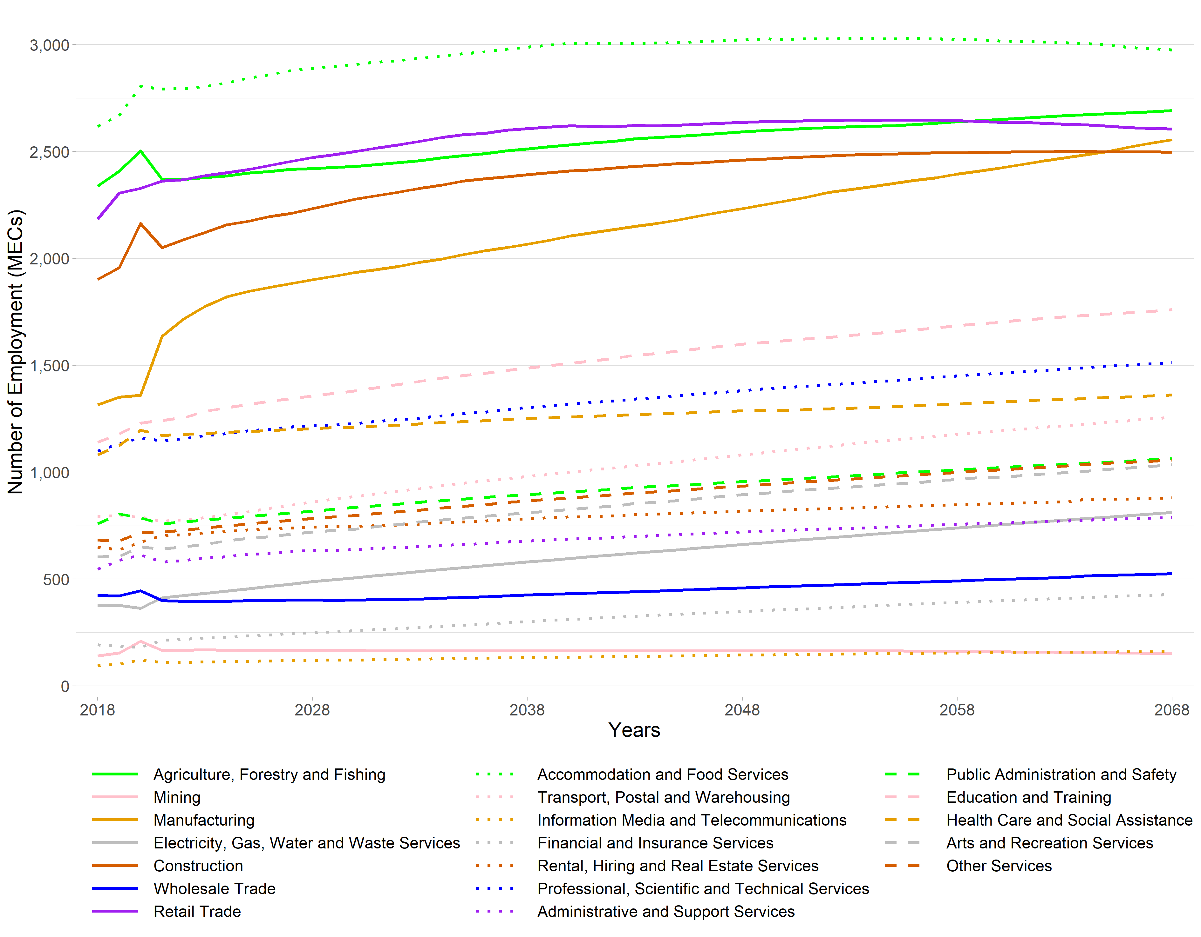Note: The employment figures for 2018 through to 2020 are actuals derived from StatsNZ’s 2020 Business Directory.
The value added projections of each nineteen ANZSIC industries are presented in Figure 17. Agriculture, Forestry and Fishing is the largest in terms of contribution to the economy for Taupō District. Its contribution of $₂₀₁₈323 million in 2018, followed by Electricity, Gas, Water and Waste services ($₂₀₁₈256 million) and Rental, Hiring and Real Estate ($₂₀₁₈249 million). The three industries are all projected to grow to $₂₀₁₈510 million, $₂₀₁₈480 million, and $₂₀₁₈433 million, respectively.

Figure 16 Acacia Bay SA2 Employment under a High Growth Scenario, 2018 to 2068
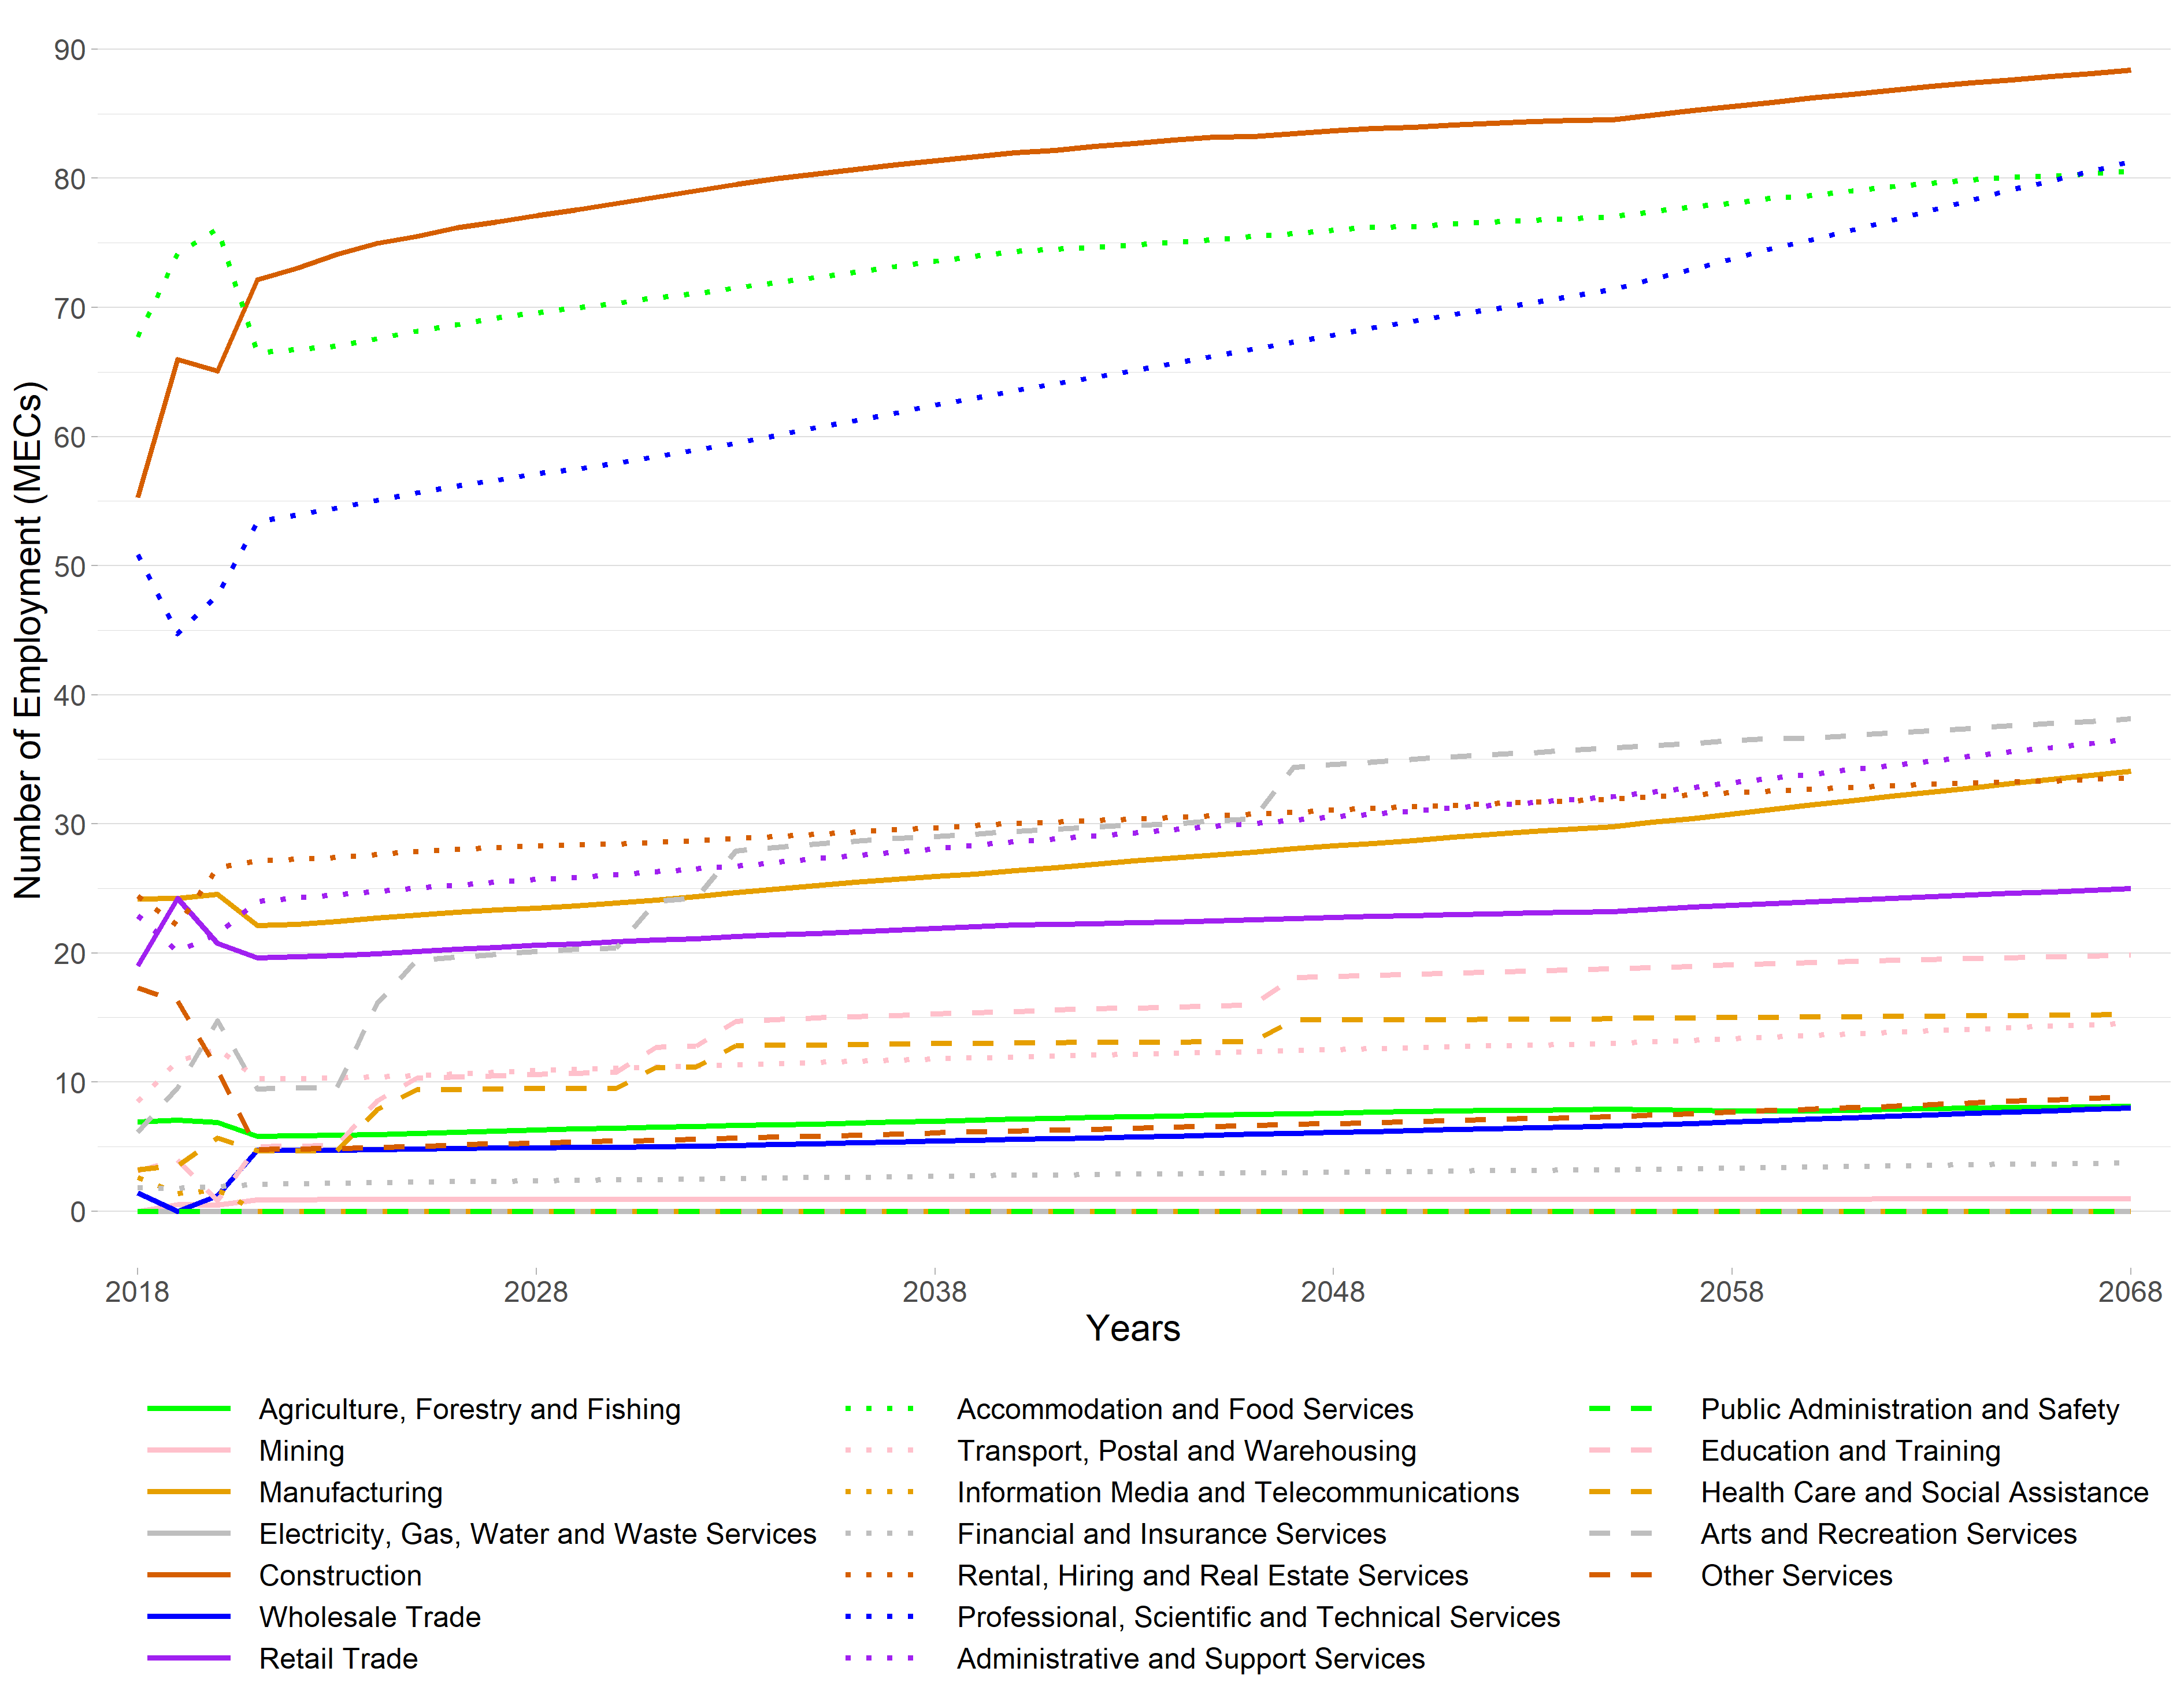Note: The employment figures for 2018 through to 2020 are actuals derived from StatsNZ’s 2020 Business Directory.
Figure 17 Taupō Value Added under a High Growth Scenario, 2018 to 2068
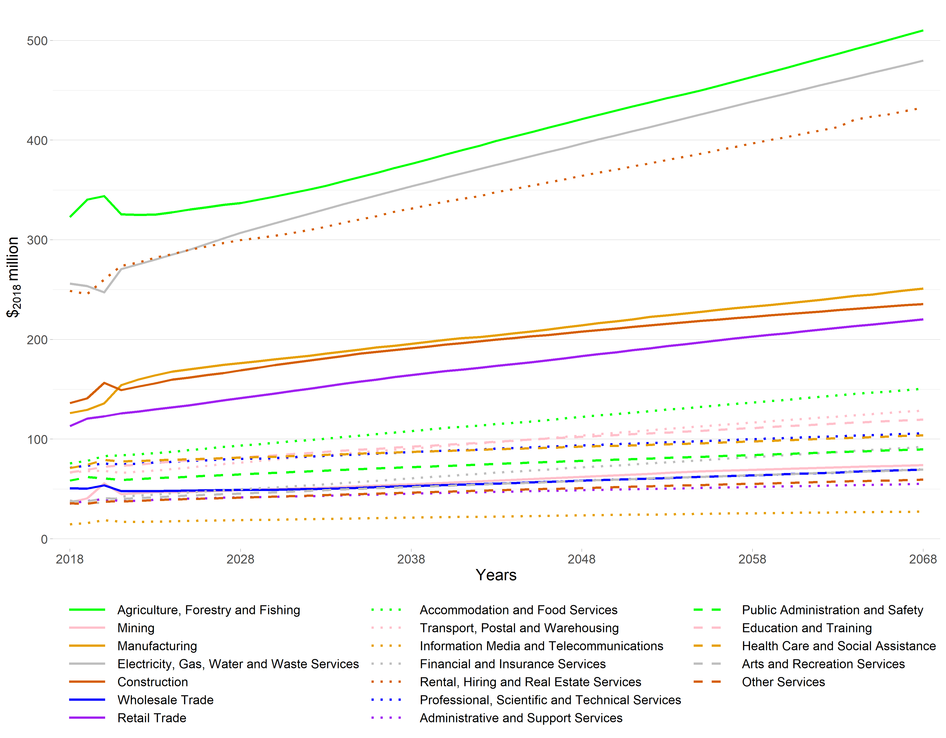Note: The value added figures for 2018 to 2020 are estimates based on MEResearch’s multi-regional input-output table for the financial year ending March 2018 as derived from the latest available StatsNZ Inter-Industry Study of the New Zealand economy.

Matamata-Piako District
Matamata-Piako District is one of the districts in Waikato Region of which the economy is not dominated by Agriculture, Forestry and Fishing. Manufacturing is the dominant industry in the district and is projected to remain the largest industry in employment, above Agriculture, Forestry and Fishing in the 50-year period.
The employment projections of each nineteen ANZSIC industries are presented in Figure 18. It should also be noted that a considerable amount of manufacturing within Waikato Region is linked to agricultural production directly, in the form of meat, dairy and food processing. In 2018, there were 4,030 MECs in Manufacturing and 3,473 MECs in Agriculture, Forestry and Fishing, out of the district’s total of 17,889 employees. These two industries employ just under half (41.9%) of Matamata-Piako’s employees.
Construction is the third largest, in terms of numbers employed, with 1,574 MECs in 2018. This industry is projected to increase to 2,332 MECs in 2068. Retail Trade was the fourth largest employer in 2018. It had 1,567 MECs in 2018 and is projected to increase to 1,857 by 2068.
Figure 18 Matamata-Piako District Employment under a High Growth Scenario, 2018 to 2068
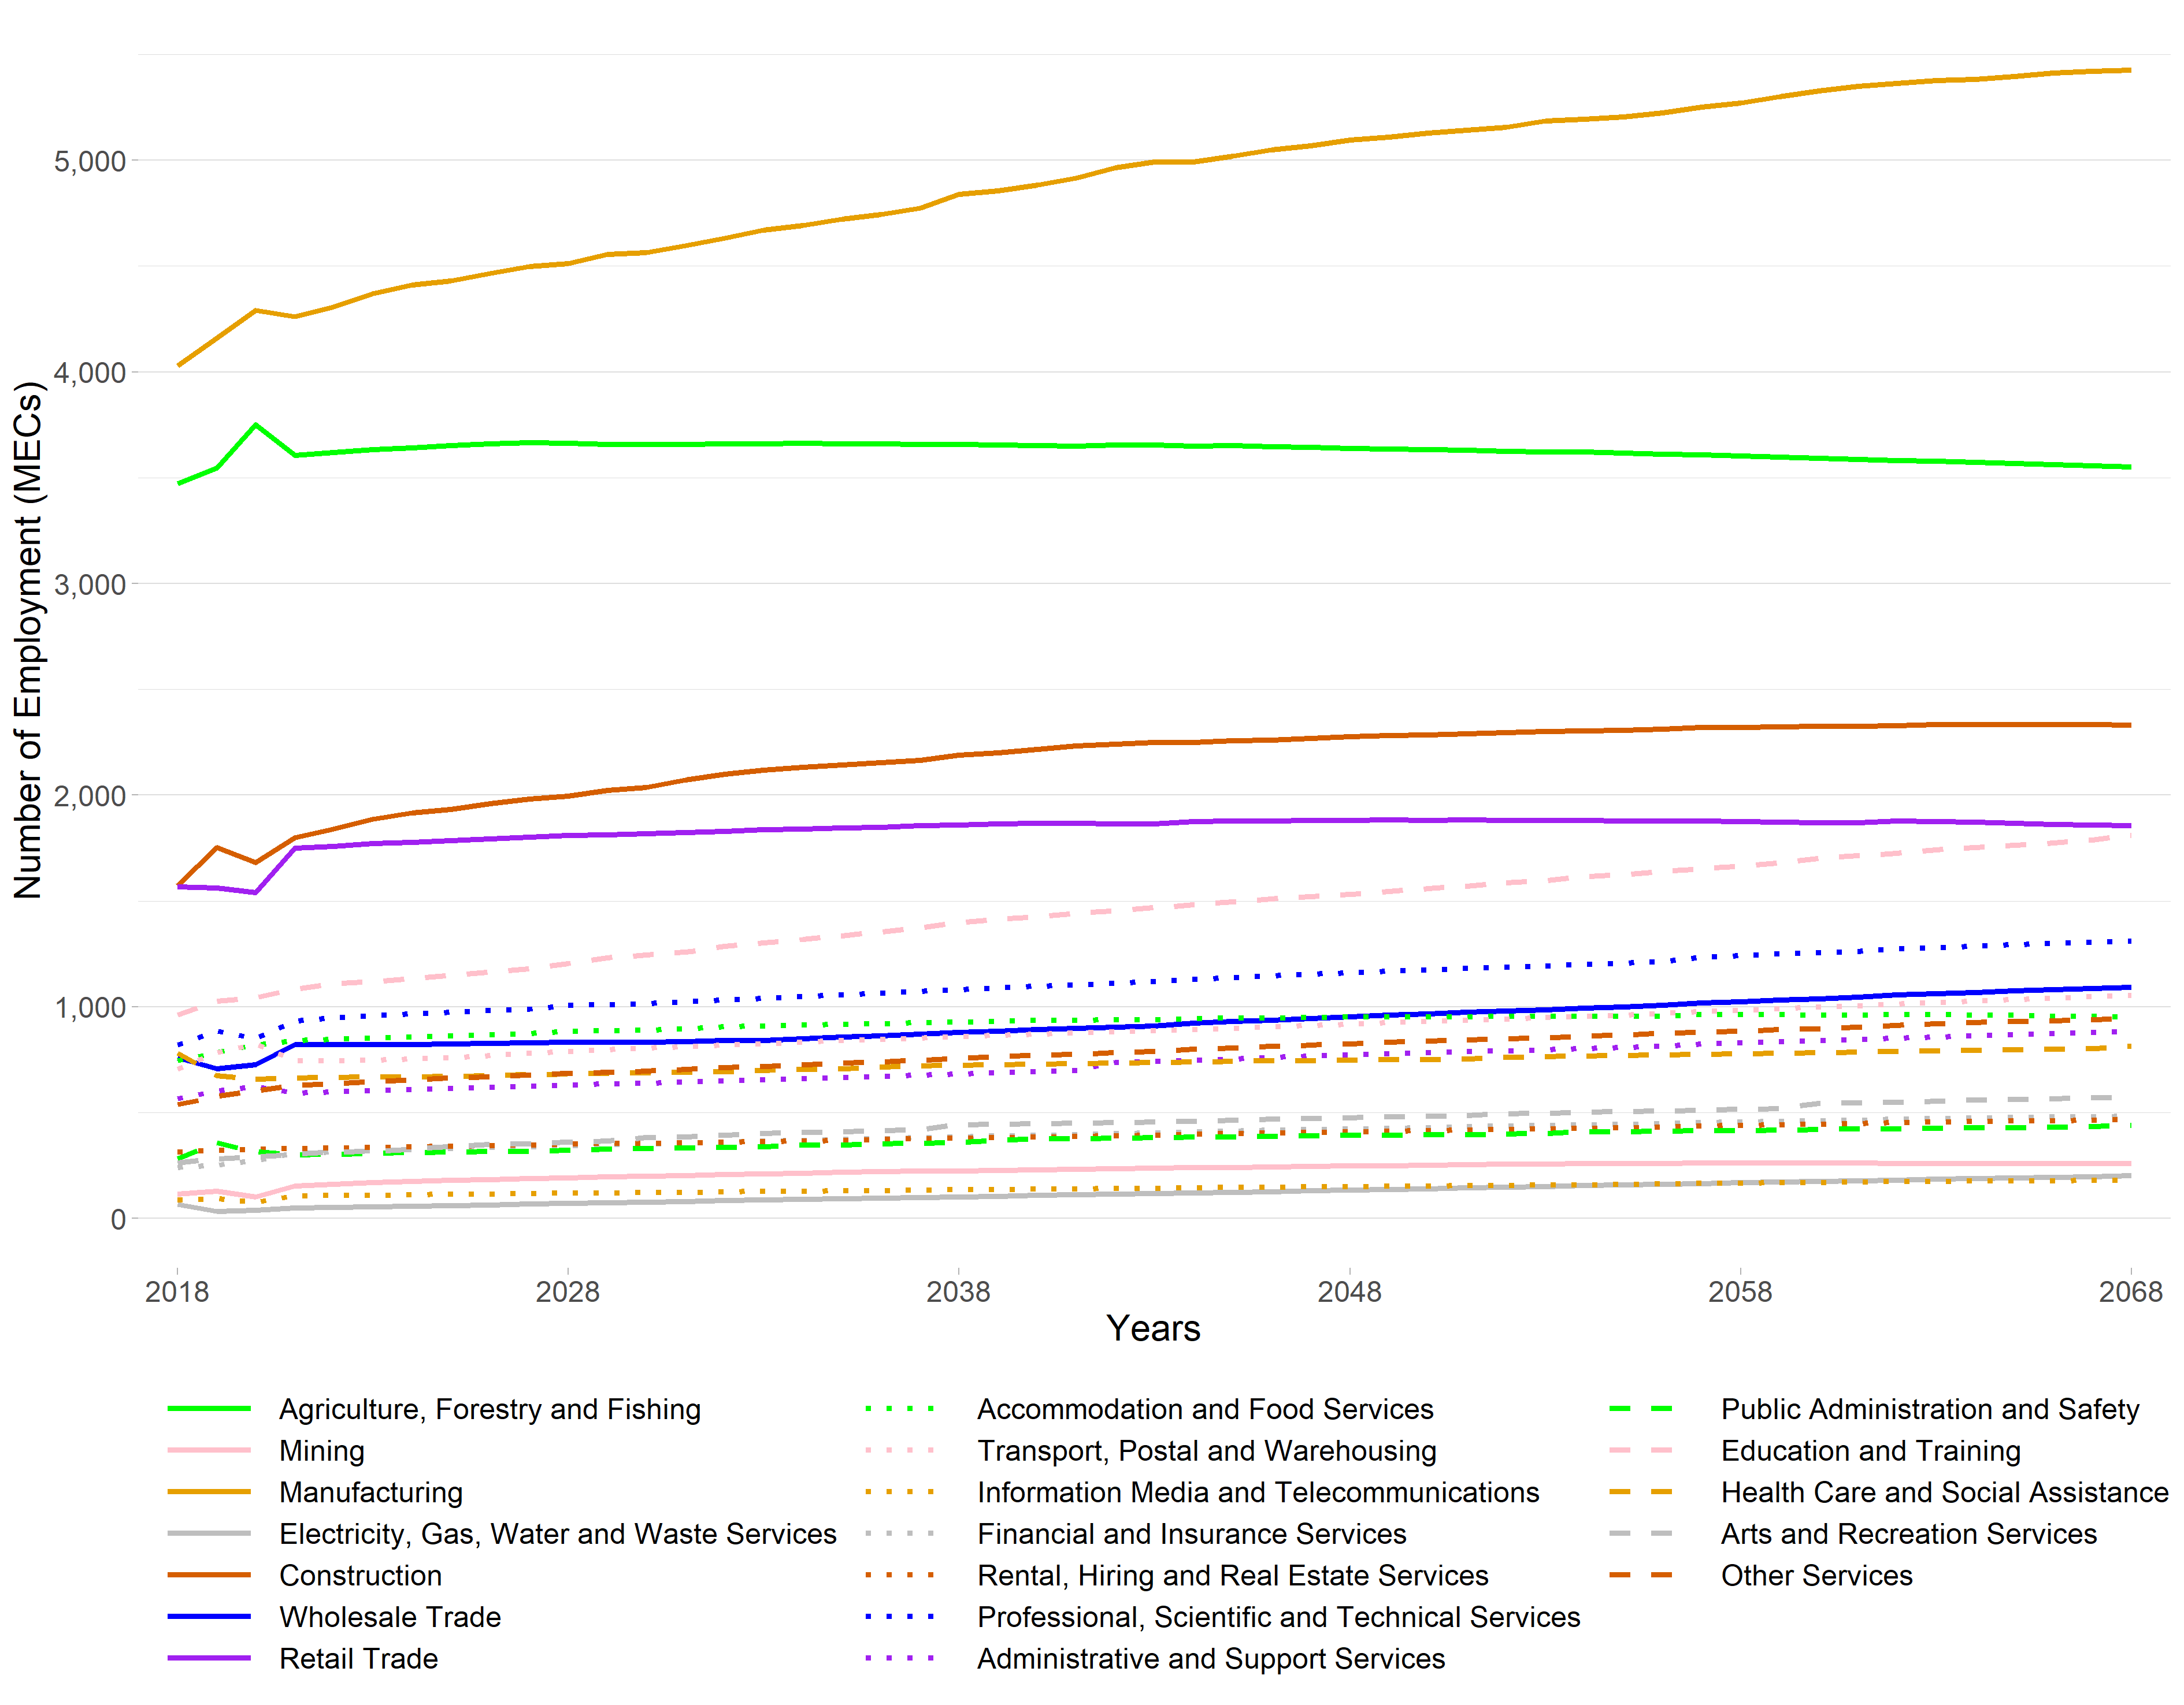Note: The employment figures for 2018 through to 2020 are actuals derived from StatsNZ’s 2020 Business Directory.
The value added projections of each nineteen ANZSIC industries are presented in Figure 19. The contribution of Manufacturing to the value added of the district is on an upward trend. Manufacturing contributed $₂₀₁₈506 million to the economy in 2018 (29.0% of the district’s total value added excluding OODs) and is projected to increase to $₂₀₁₈894 million in 2068. The Agriculture, Forestry and Fishing contribution to the district’s value added was $₂₀₁₈384 million in 2018, and this is projected to increase by an additional 48.9% by 2068, to $₂₀₁₈572 million. The other major industry that shows significant relative growth above other industries is Mining, projected to increase from $₂₀₁₈29.7 million to $₂₀₁₈126 million.

Figure 19 Matamata-Piako Value Added under a High Growth Scenario, 2018 to 2068
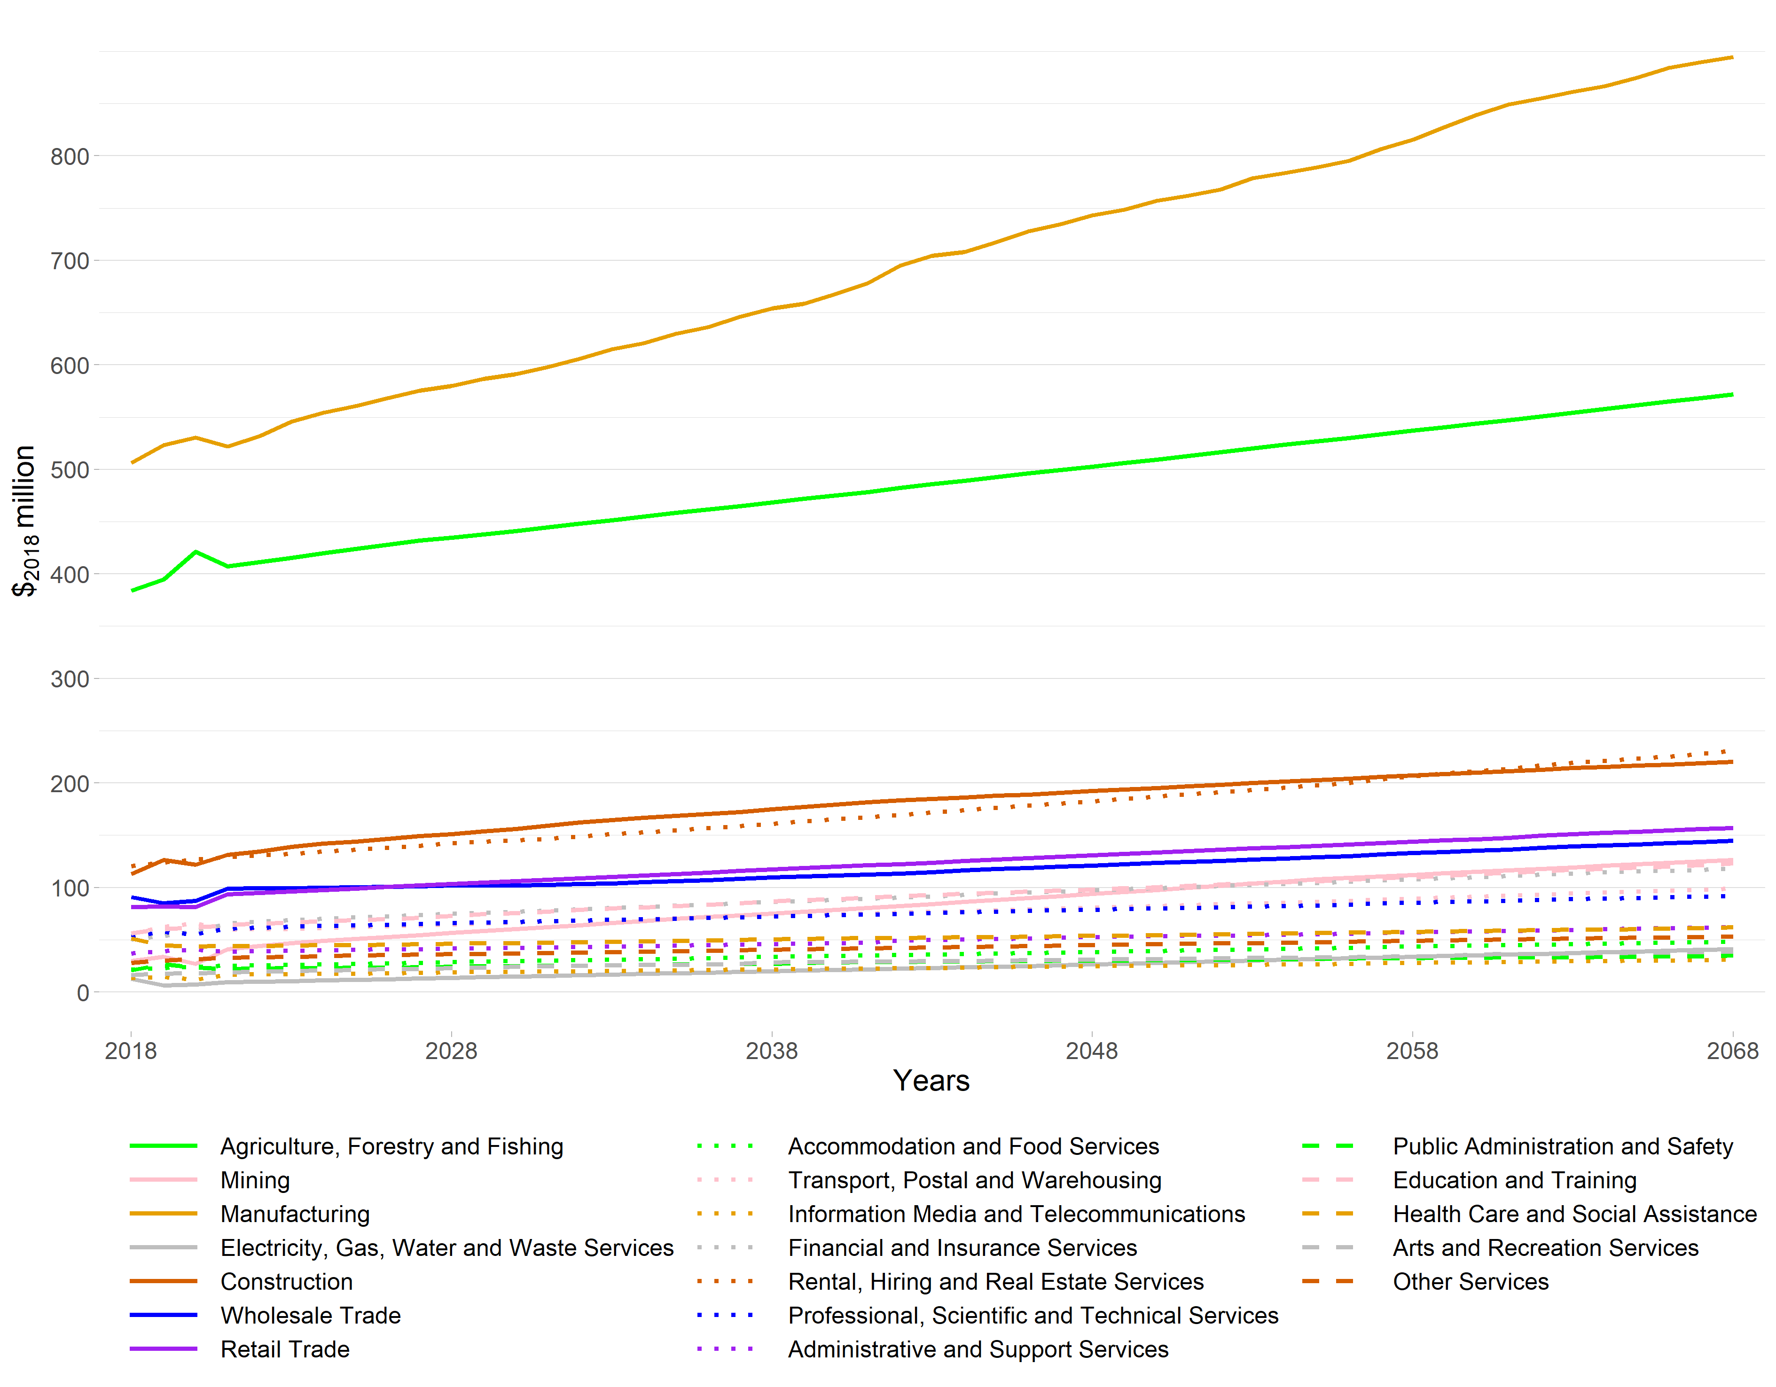Note: The value added figures for 2018 to 2020 are estimates based on MEResearch’s multi-regional input-output table for the financial year ending March 2018 as derived from the latest available StatsNZ Inter-Industry Study of the New Zealand economy.

Thames-Coromandel District
Thames-Coromandel District has a diversified industry structure, with four industries employing over 1,000 MECs in 2018.
The employment projections of each nineteen ANZSIC industries are presented in Figure 20. Retail trade is the largest employer in the TA with 1,857 MECs and is projected to grow to 2,494 MECs in 2068. The second largest industry in 2018, Accommodation and Food Services, is also projected to grow from 1,846 MECs to 2,500 MECs by 2068. Electricity, Gas, Water and Waste Services is projected to grow the most relatively with 176% growth rate in the 50-year period, from 120 MECs to 332 MECs.

Figure 20 Thames-Coromandel District Employment under a High Growth Scenario, 2018 to 2068
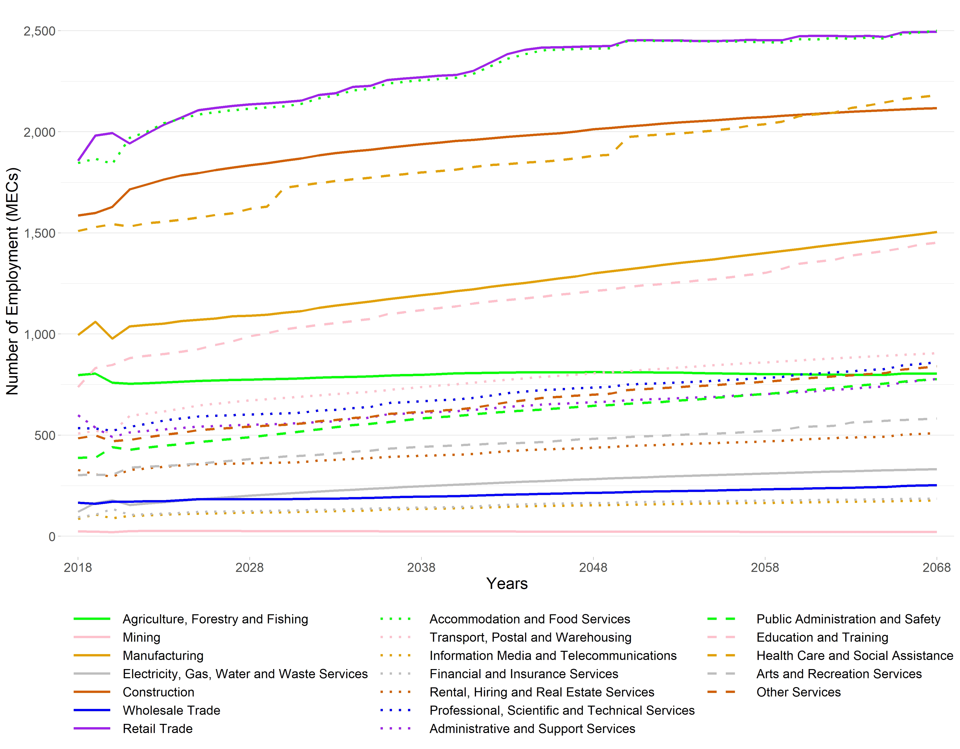Note: The employment figures for 2018 through to 2020 are actuals derived from StatsNZ’s 2020 Business Directory.
The value added projections of each nineteen ANZSIC industries are presented in Figure 21. Although Rental, Hiring and Real Estate Services is not the greatest employer, it contributes the greatest dollar amount to Thames-Coromandel District’s economy with $₂₀₁₈126 million in 2018. This trend is projected to remain consistent for the most of the 50-year period. Similarly, Construction, although third in terms of employment in 2018, is second in terms of contribution to value added ($₂₀₁₈114 million in 2018), reflecting difference in labour intensities of production across sectors.

Figure 21 Thames-Coromandel District Value Added under a high Growth Scenario, 2018 to 2068
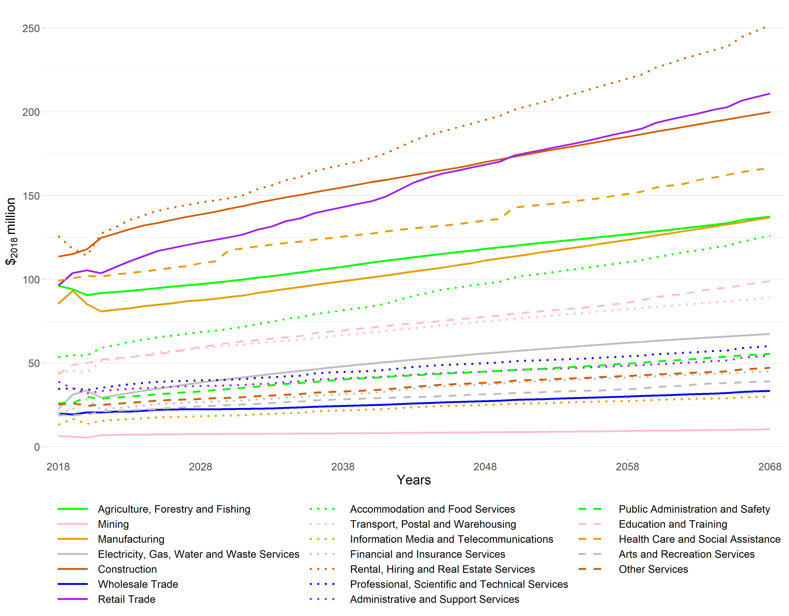Note: The value added figures for 2018 to 2020 are estimates based on MEResearch’s multi-regional input-output table for the financial year ending March 2018 as derived from the latest available StatsNZ Inter-Industry Study of the New Zealand economy.

South Waikato District
South Waikato District has approximately 4% of Waikato Region’s workforce in 2018.
The employment projections of each nineteen ANZSIC industries are presented in Figure 22. Being a rural district, Agriculture, Forestry and Fishing dominates the economy in terms of employment, alongside Manufacturing. In 2018, there were 2,220 MECs employed in Agriculture, Forestry and Fishing. This is projected to increase to 2,311 by 2068. Manufacturing is projected to increase from 2,096 MECS in 2018 to 2,736 MECs by 2068, overtaking Agriculture, Forestry and Fishing. Education and Training was the third largest in terms of employment in 2018, with 914 MECs, followed closely by Retail Trade with 809 MECs. Education and Training is projected to increase to 1,592 MECs by 2068 and Retail Trade increases by 7.17% from 968 MECs. Electricity, Gas, Water and Waste Services exhibits the most substantial relative growth, increasing by 213% from 56 MECs to 175 MECs.

Figure 22 South Waikato District Employment under a High Growth Scenario, 2018 to 2068
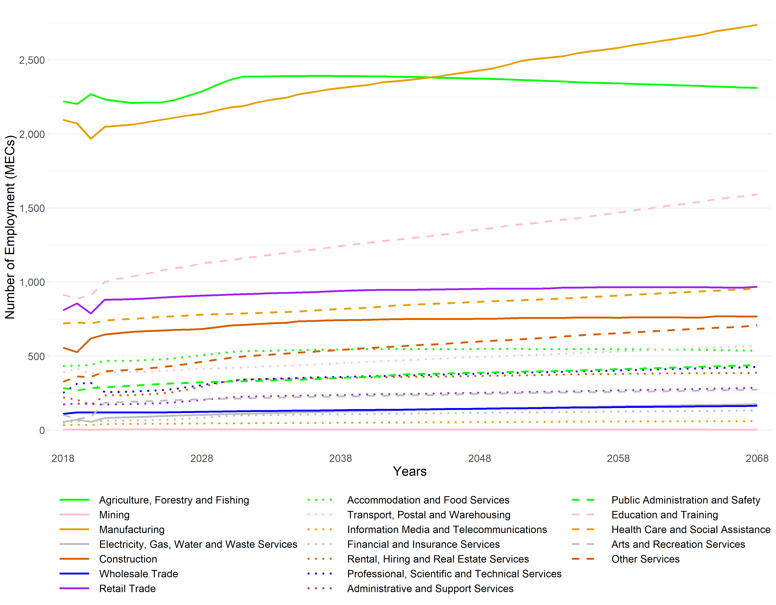Note: The employment figures for 2018 through to 2020 are actuals derived from StatsNZ’s 2020 Business Directory.
The value added projections of each nineteen ANZSIC industries are presented in Figure 23. Unsurprisingly, Agriculture, Forestry and Fishing contributes the most to South Waikato District in terms of value added. This trend is consistent in the 50-year period, with both Manufacturing and Agriculture, Forestry and Fishing projected to increase their value added contributions. Agriculture, Forestry and Fishing contributed $₂₀₁₈323 million to the district economy in 2018, with Manufacturing contributing $₂₀₁₈273 million. These values are projected to increase to $₂₀₁₈484 million and $₂₀₁₈388 million, respectively by 2068 reflecting increase in productivity over time. These two industries together contribute to 58.1% of the region’s value added (excluding OODs) in 2018. The value added contribution of Financial and Insurance Services value added is projected have the highest relative growth in this period.

Figure 23 South Waikato District Value Added under a High Growth Scenario, 2018 to 2068
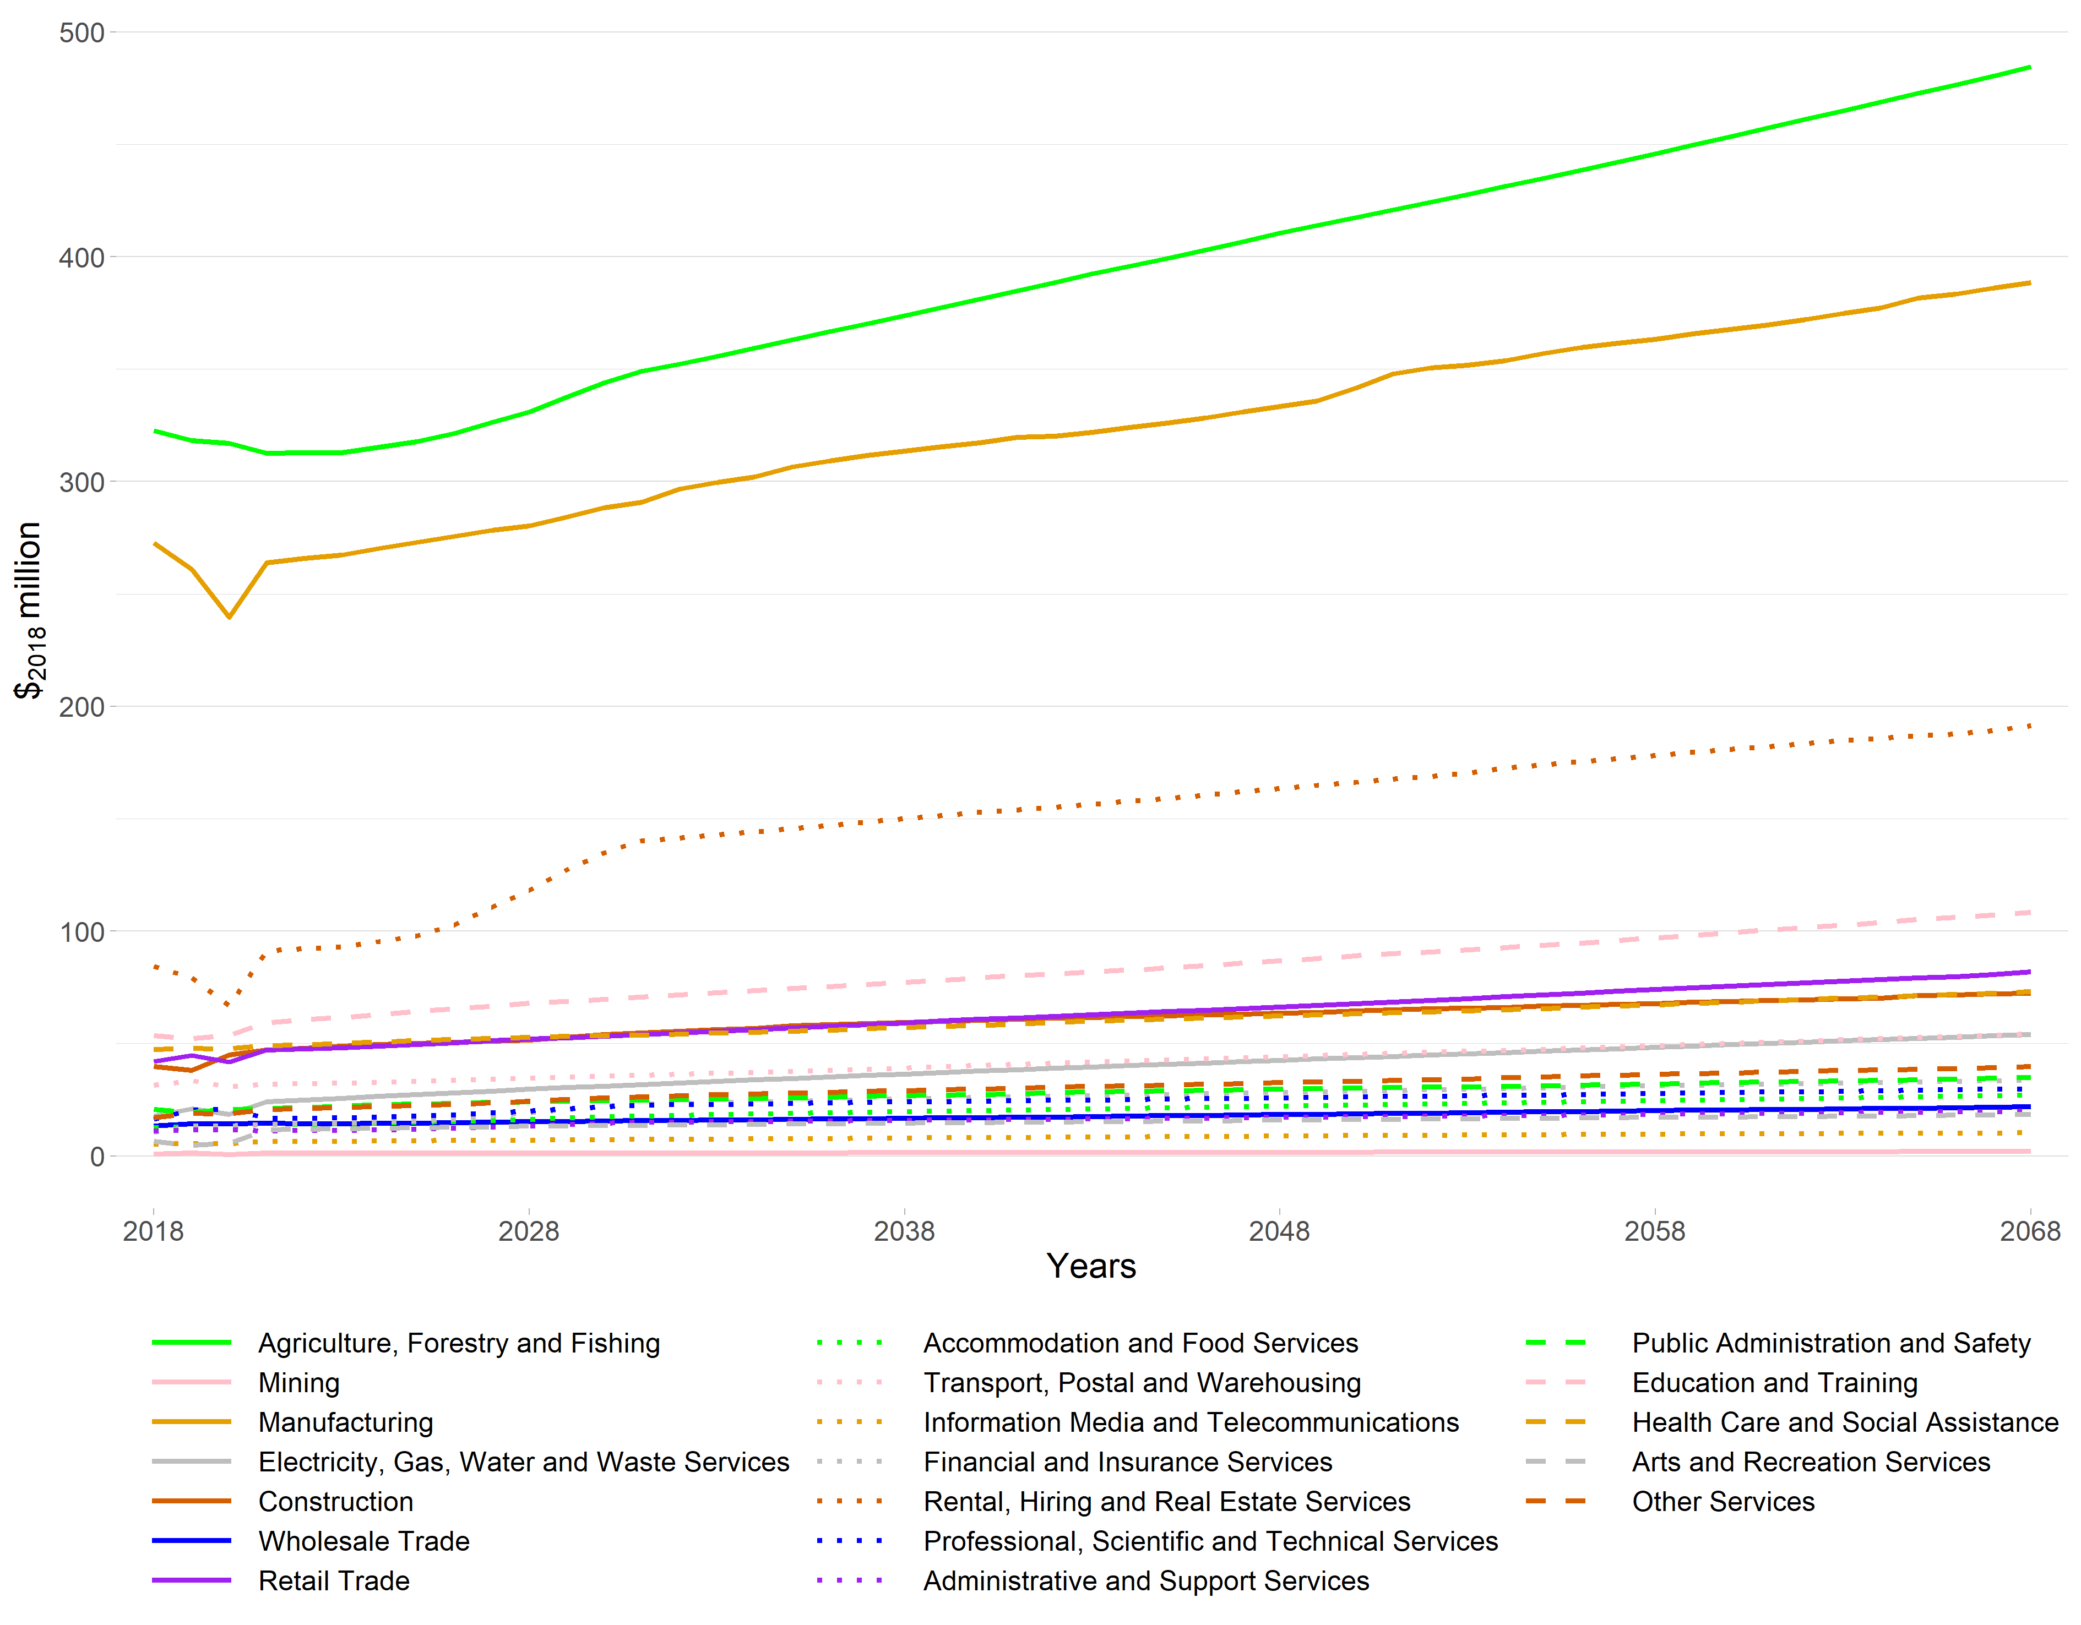Note: The value added figures for 2018 to 2020 are estimates based on MEResearch’s multi-regional input-output table for the financial year ending March 2018 as derived from the latest available StatsNZ Inter-Industry Study of the New Zealand economy.

Hauraki District
The employment projections of each nineteen ANZSIC industries are presented in Figure 24. Hauraki District is currently heavily dependent on Agriculture, Forestry and Fishing, with 1,477 MECs in 2018, or just over one in five people employed in Agriculture, Forestry and Fishing. Agriculture, Forestry and Fishing is projected to remain the dominant employer by 2068 (Figure 24). Construction is the second largest industry in 2018 with 779 MECs and is projected to increase to 1,092 MECs by 2068. However, Construction does not remain the second largest in 2068 as Education and Training grows from 620 MECs to 1,314 MECs to be the second largest in 2068.
Figure 24 Hauraki District Employment under a High Growth Scenario, 2018 to 2068
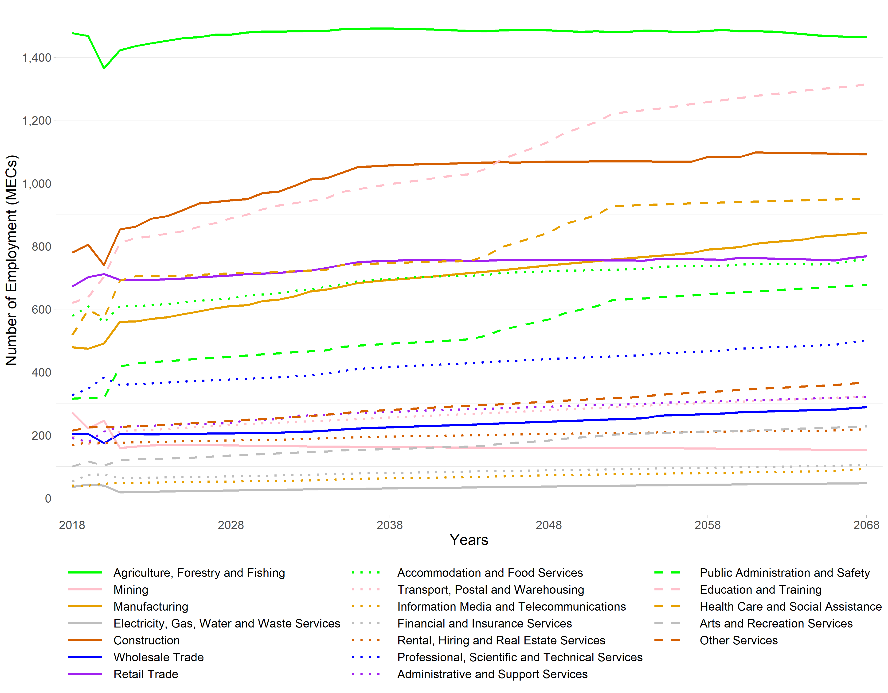Note: The employment figures for 2018 through to 2020 are actuals derived from StatsNZ’s 2020 Business Directory.
The value added projections of each nineteen ANZSIC industries are presented in Figure 25. In terms of value added contribution to the economy, the Agriculture, Forestry and Fishing is the largest, with $₂₀₁₈161 million in 2018, projected to increase to $₂₀₁₈227 million by 2068. The second largest contributor in value added terms is Mining with $₂₀₁₈70.4 million in 2018. By 2068, though, the second largest industry is Manufacturing growing from $₂₀₁₈64.5 million to $₂₀₁₈146 million in the 50-year period.

Figure 25 Hauraki District Value Added under a High Growth Scenario, 2018 to 2068
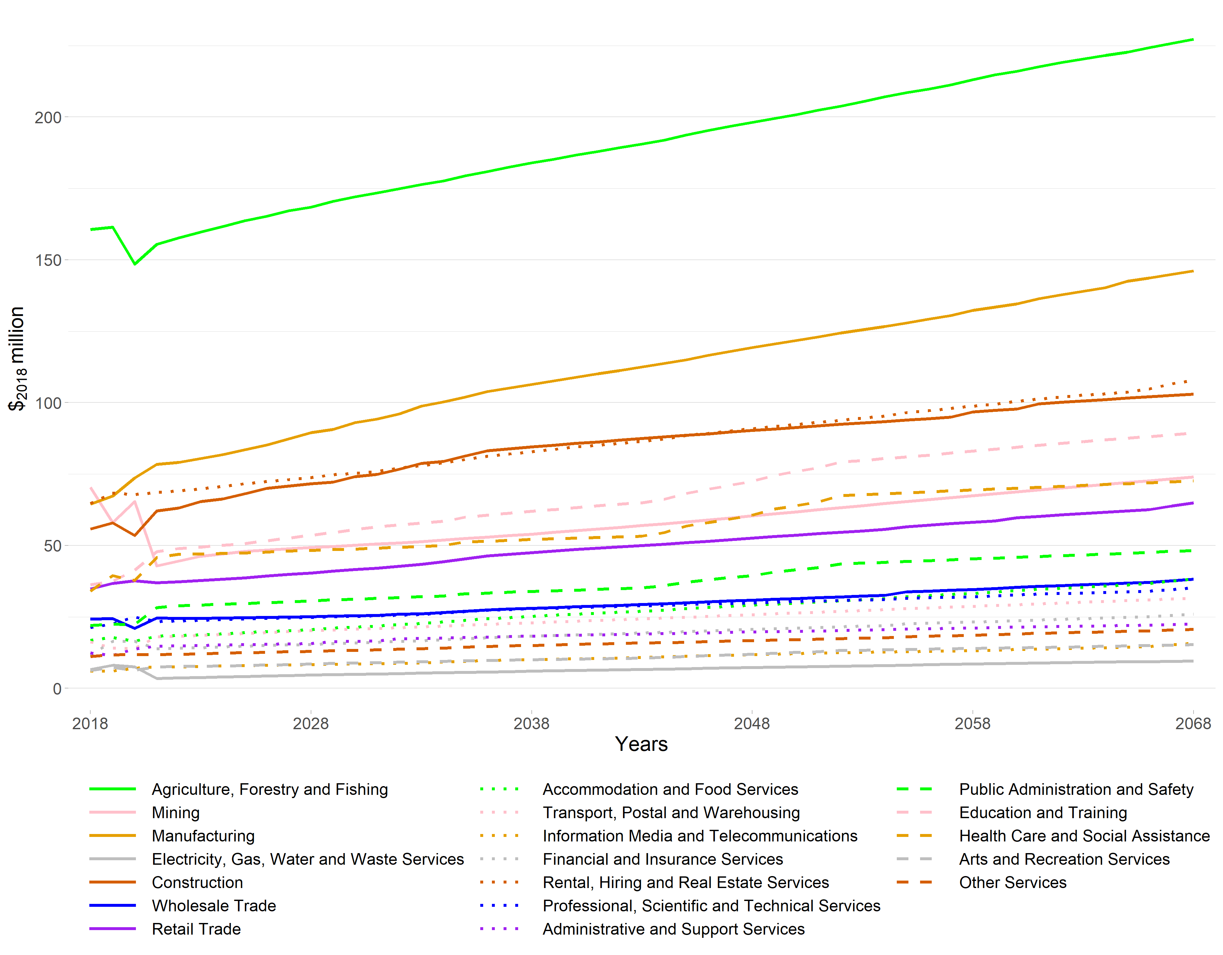Note: The value added figures for 2018 to 2020 are estimates based on MEResearch’s multi-regional input-output table for the financial year ending March 2018 as derived from the latest available StatsNZ Inter-Industry Study of the New Zealand economy.

Waitomo District
Waitomo District is one of the districts of which the economy is dominated by Agriculture, Forestry and Fishing.
The employment projections of each nineteen ANZSIC industries are presented in Figure 26. Agriculture, Forestry and Fishing is the dominant industry in Waitomo District, followed by Manufacturing. 1,387 people were employed in Agriculture, Forestry and Fishing in 2018, and is projected to increase to 1,773 MECs by 2068. Manufacturing had 863 MECs in 2018 and is also projected to increase to 1004 MECs. Construction is the third largest in 2018, in terms of employment, with 422 MECs in 2018 increasing to 566 MECs.

Figure 26 Waitomo District Employment under a High Growth Scenario, 2018 to 2068
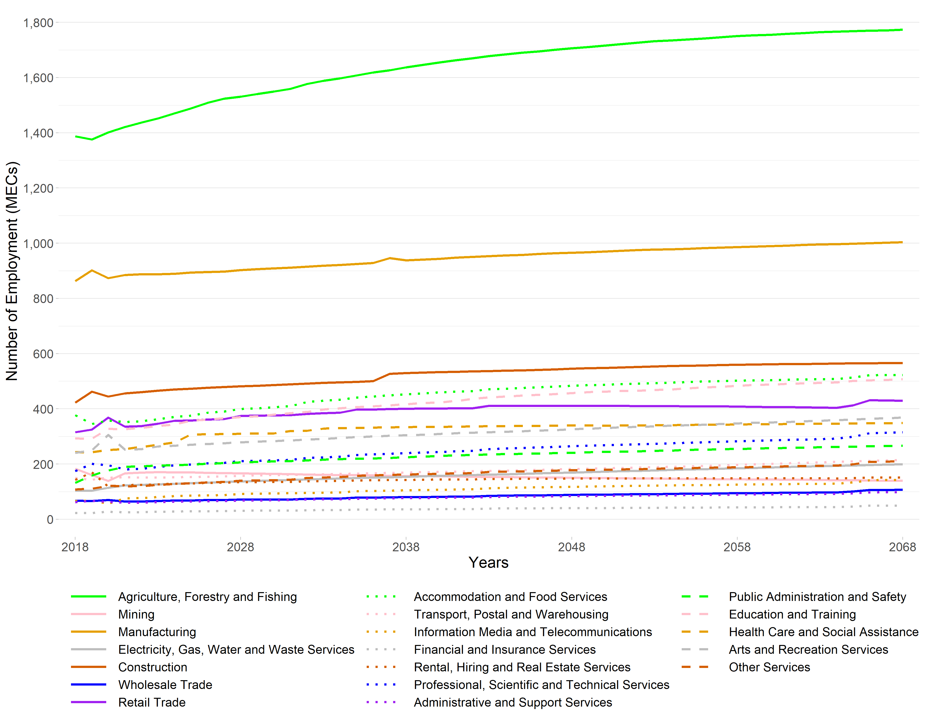Note: The employment figures for 2018 through to 2020 are actuals derived from StatsNZ’s 2020 Business Directory.
As an example of projected employment changes at SA2 level within Waitomo District, we extracted Herangi. The employment projections are presented in Figure 27. This is a SA2 particularly dependent on Agriculture, Forestry and Fishing.

Figure 27 Herangi District Employment under a High Growth Scenario, 2018 to 2068
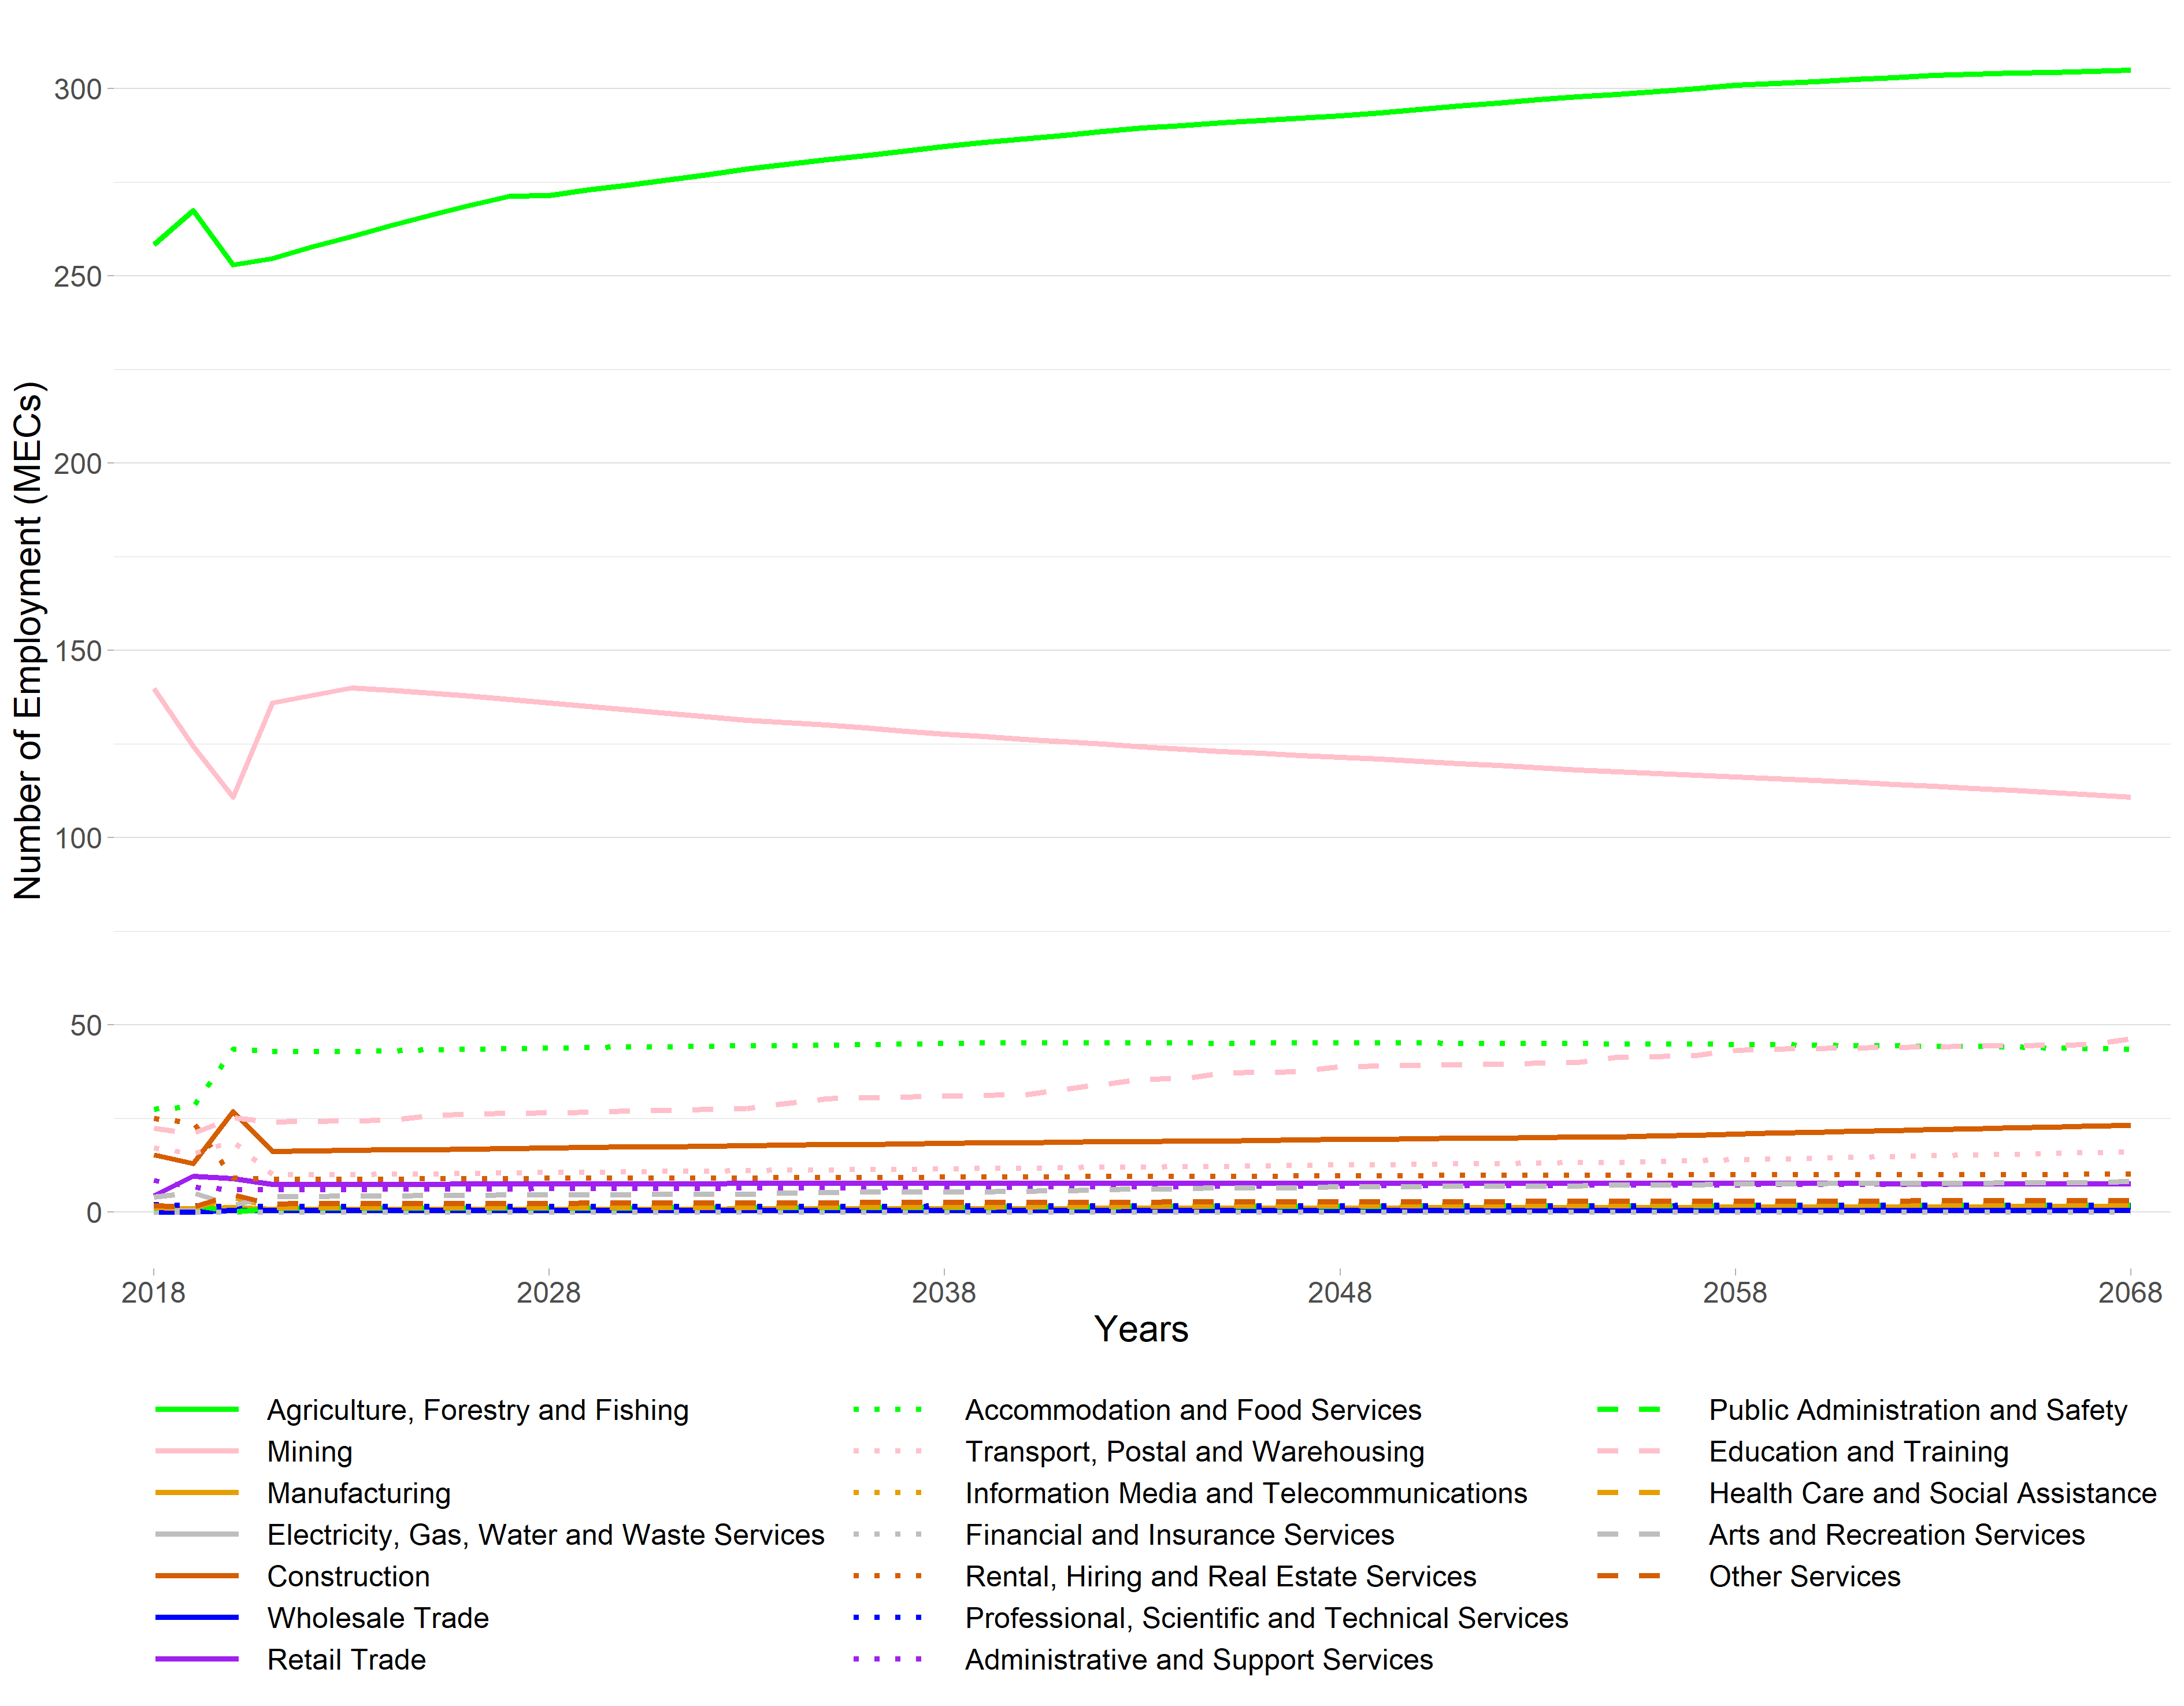Note: The employment figures for 2018 through to 2020 are actuals derived from StatsNZ’s 2020 Business Directory.
The value added projections of each nineteen ANZSIC industries are presented in Figure 28. Total value added for Waitomo District was $₂₀₁₈557 million in 2018 (excluding OODs). This is expected to rise to $₂₀₁₈995 million by 2068. Agriculture, Forestry and Fishing contributed $₂₀₁₈152 million of value added while Manufacturing contributed $₂₀₁₈52 million in 2018 and they are projected to increase to $₂₀₁₈268 million and $₂₀₁₈93.5 million, respectively. Financial and Insurance Services in the district increases considerably from $₂₀₁₈4.9 million to $₂₀₁₈12.1 million. The contribution of Accommodation and Food Services to the district’s economy is projected to increase significantly as well, from $₂₀₁₈10.9 million to $₂₀₁₈26.4 million.

Figure 28 Waitomo District Value Added under a High Growth Scenario, 2018 to 2068
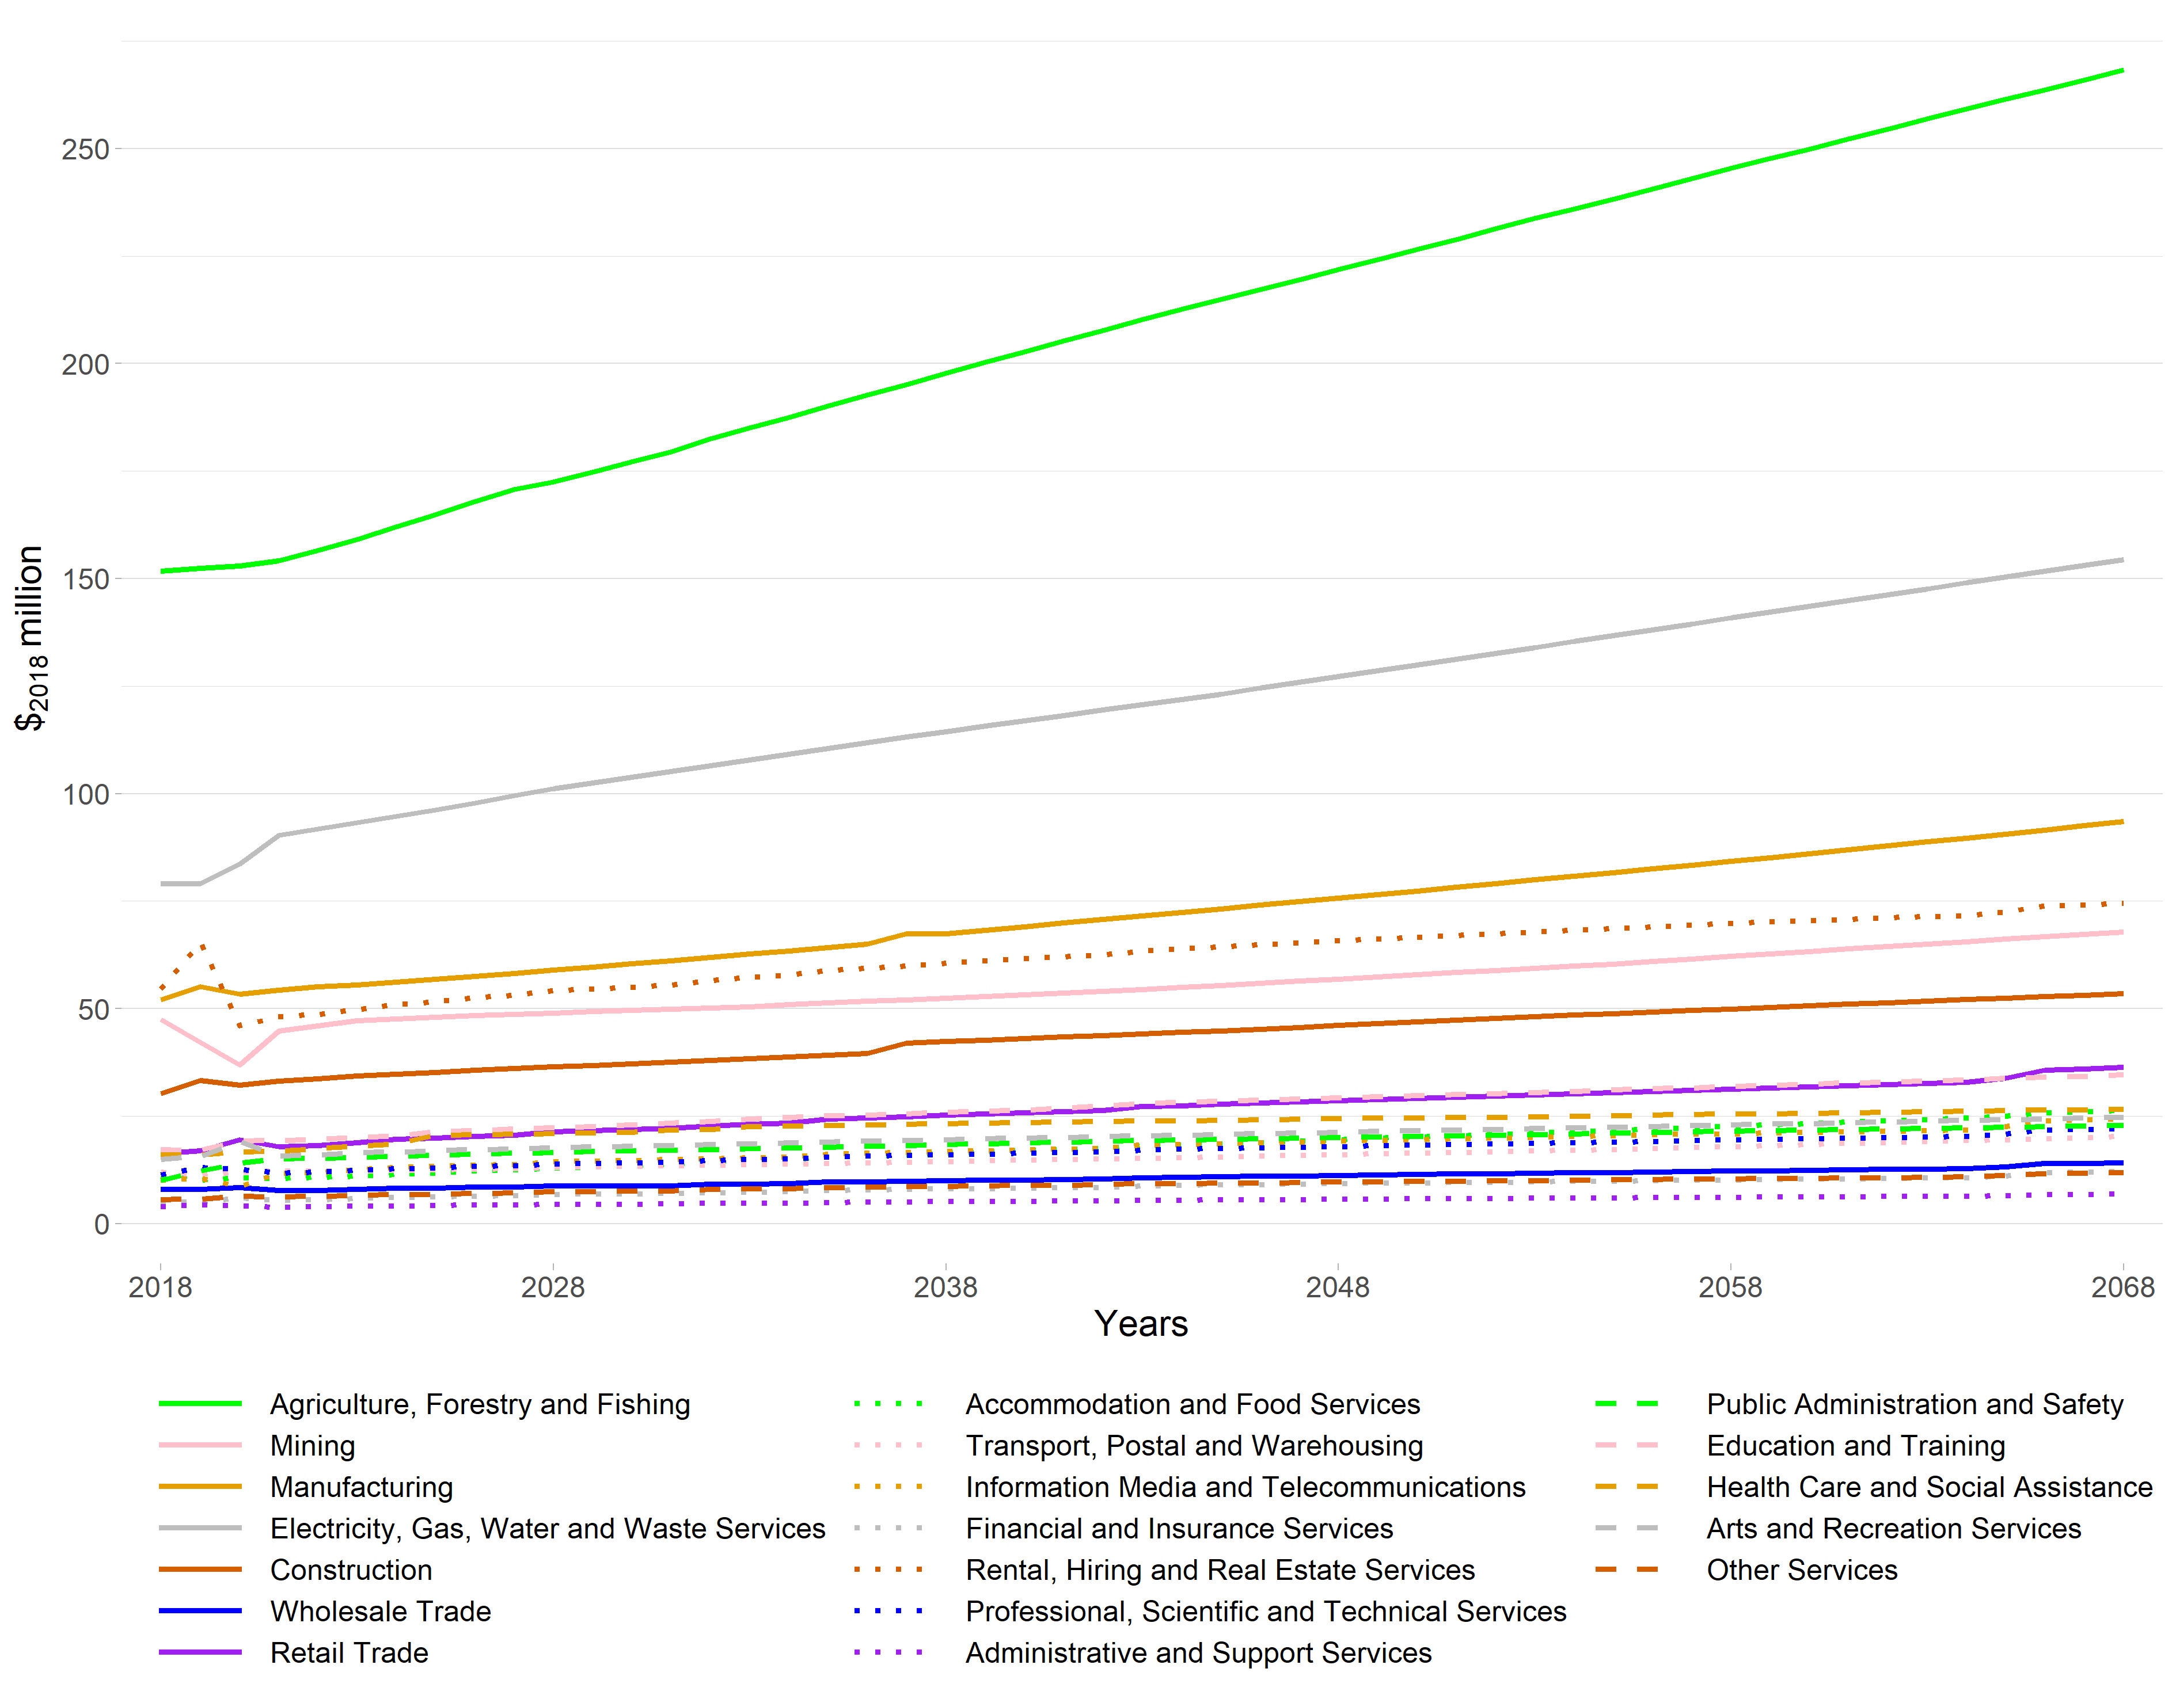Note: The value added figures for 2018 to 2020 are estimates based on MEResearch’s multi-regional input-output table for the financial year ending March 2018 as derived from the latest available StatsNZ Inter-Industry Study of the New Zealand economy.

Ōtorohanga District
Ōtorohanga District is the smallest district in Waikato Region in terms of economic activity (excluding the Rotorua District that is in Waikato Region).
The employment projections of each nineteen ANZSIC industries are presented in Figure 29. It is dominated by Agriculture, Forestry and Fishing. In 2018, 1,722 people (or 36.3% of the district’s MECs) were employed in the industry, out of a total of 4,739 MECs. Public Administration and Safety is the second largest industry by employment in 2018, with 426 MECs, followed by Manufacturing with 382 MECs. All other industries in the district employed less than 300 MECs in 2018.

Figure 29 Ōtorohanga District Employment under a High Growth Scenario, 2018 to 2068
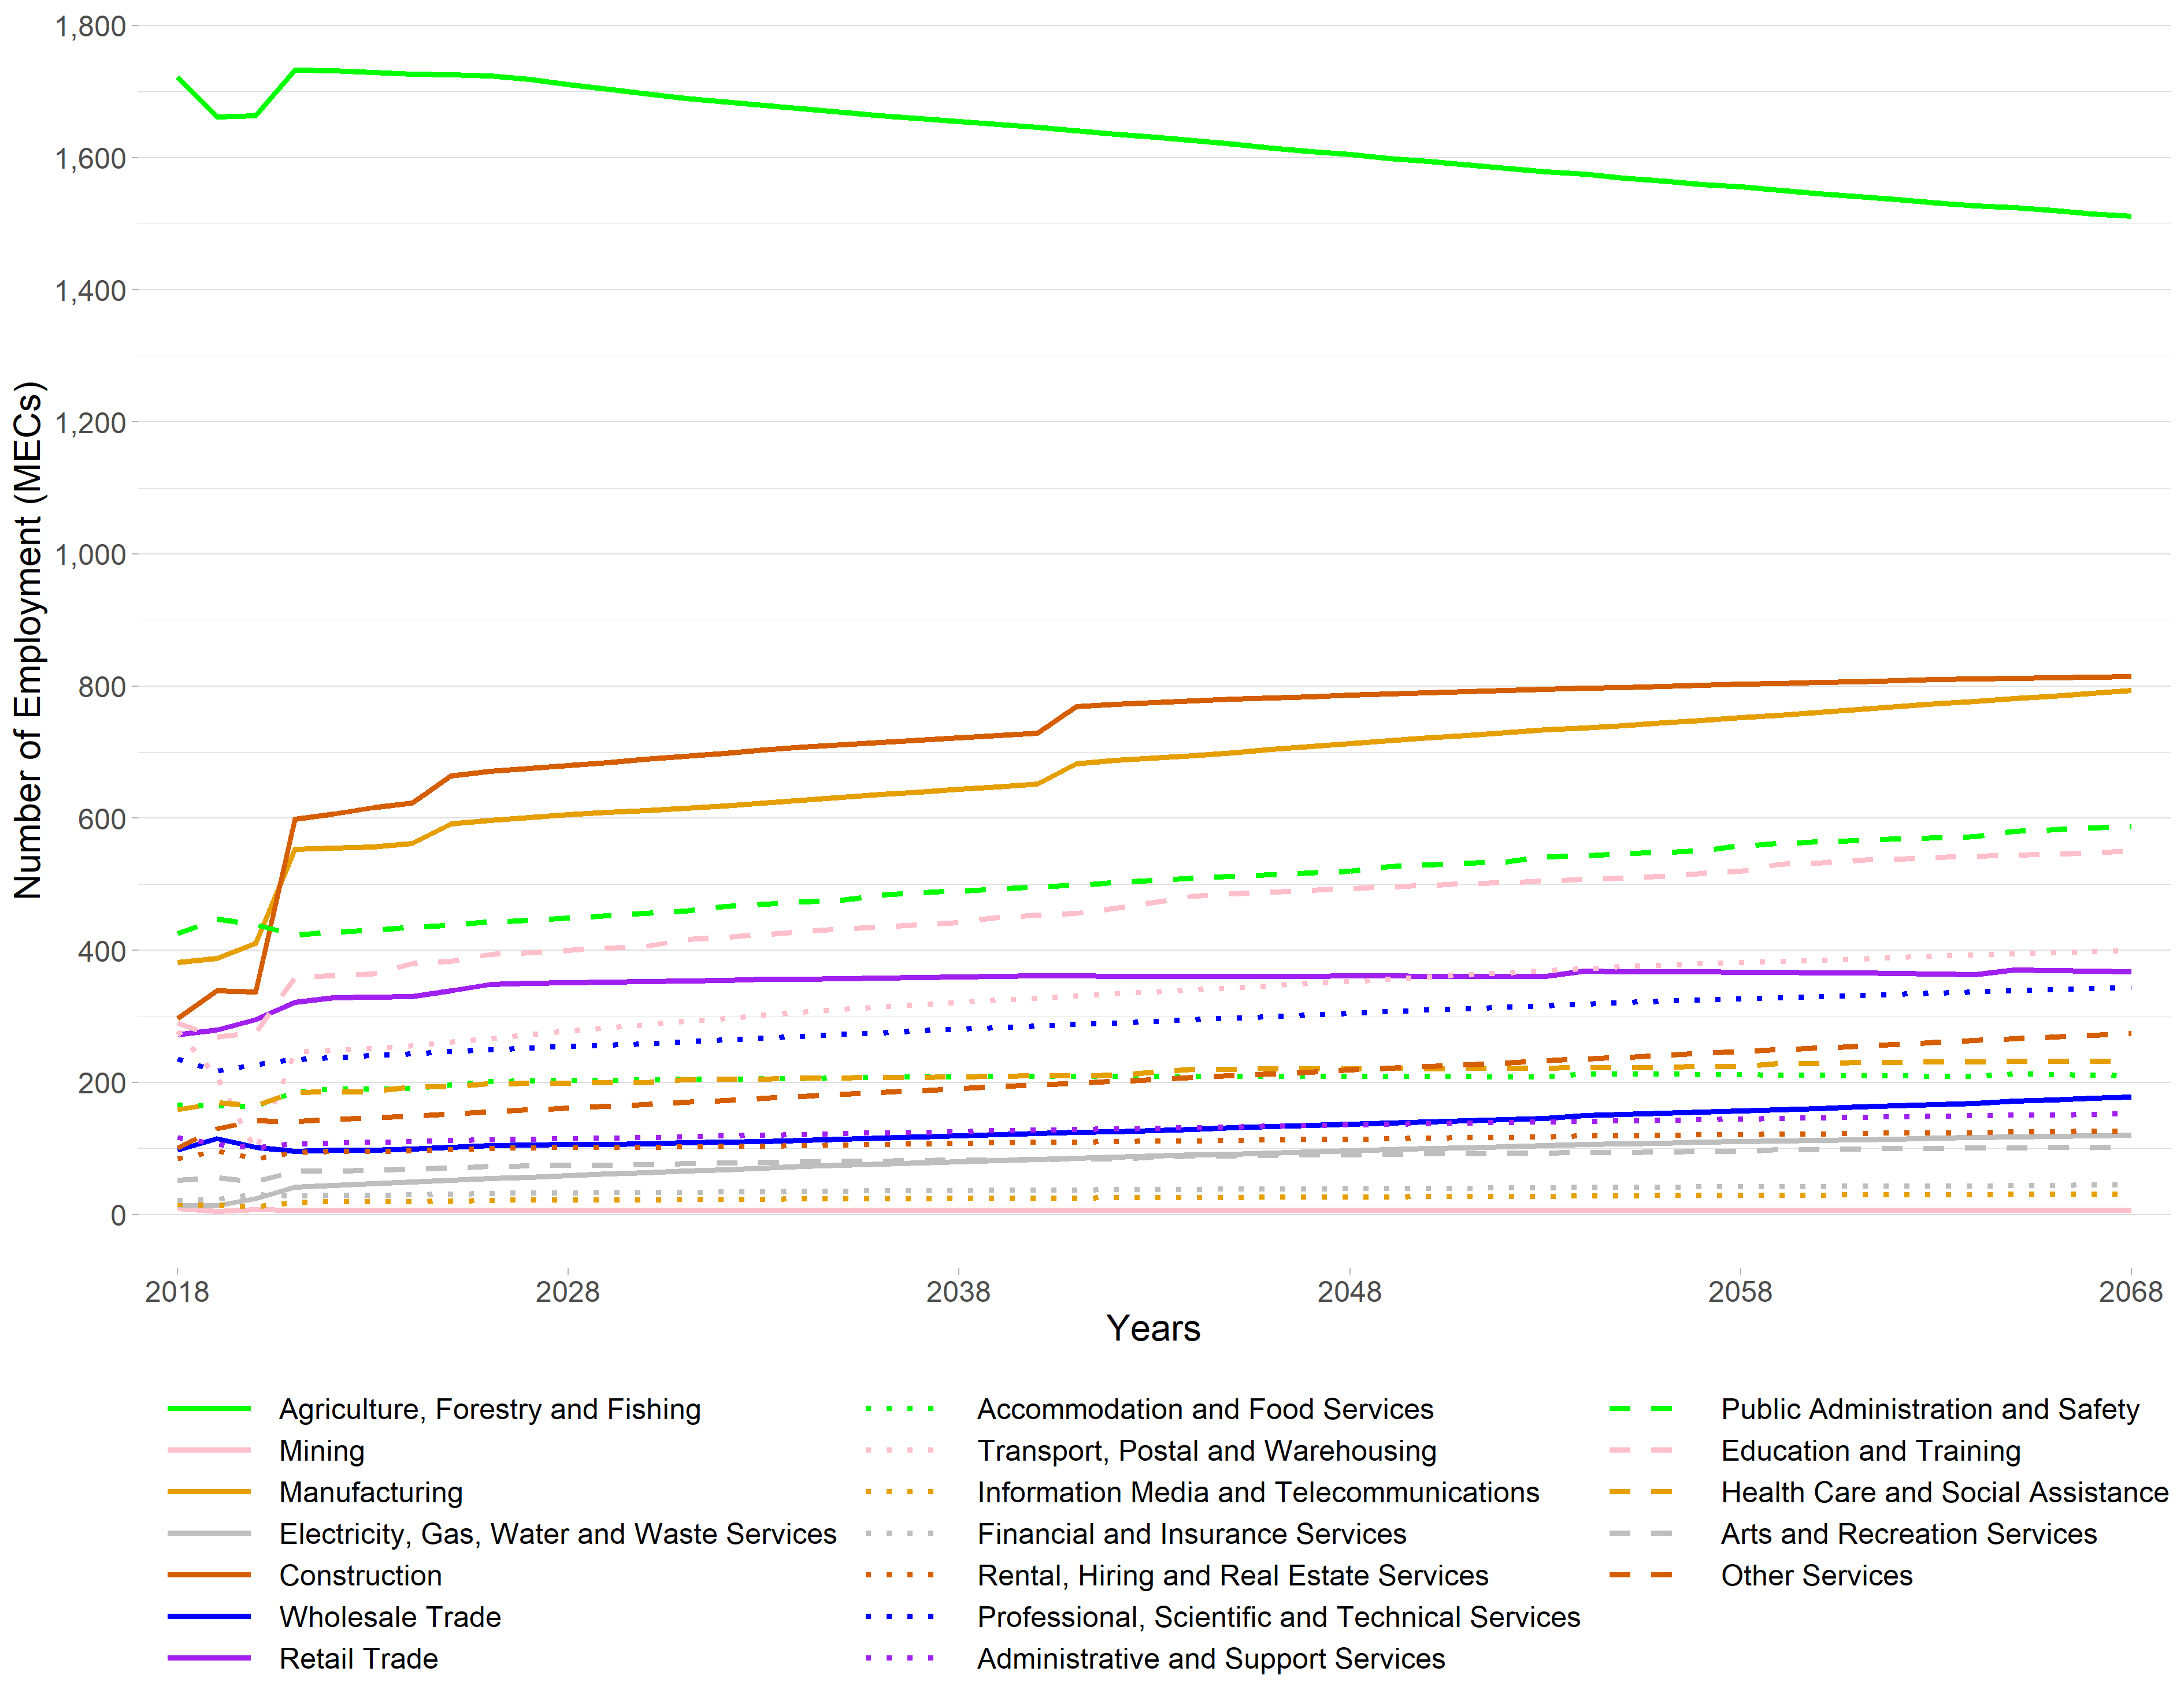Note: The employment figures for 2018 through to 2020 are actuals derived from StatsNZ’s 2020 Business Directory.
The value added projections of each nineteen ANZSIC industries are presented in Figure 30. Given the dominance of Agriculture, Forestry and Fishing, it is not surprising that it contributes the greatest amount of value added to the district. In 2018, the value added of Agriculture, Forestry and Fishing was $₂₀₁₈196 million, or 45.0% of the district’s total value added (excluding OODs) of $₂₀₁₈436 million. Agriculture, Forestry and Fishing is projected to increase to $₂₀₁₈265 million by 2068 in value added terms which would constitute 33.4% of the district’s value added (of $₂₀₁₈791 million, excluding OODs). Electricity, Gas, Water and Waste services grows considerably from $₂₀₁₈2.66 million to $₂₀₁₈24.4 million in the 50-year period. Other industries that are projected to grow significantly over the next 50 years include: Construction, Other Services, and Manufacturing.

Figure 30 Ōtorohanga District Value Added under a High Growth Scenario, 2018 to 2068
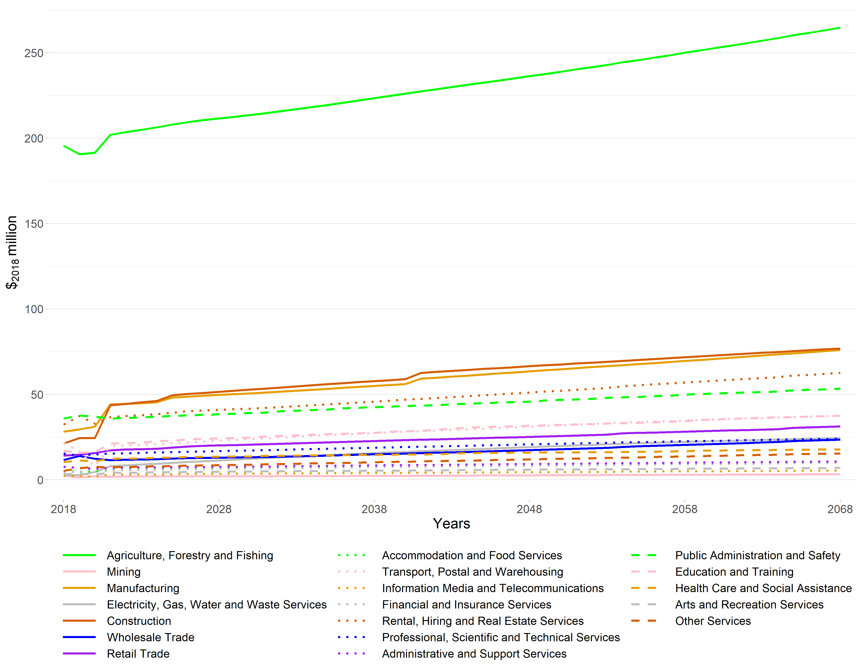Note: The employment figures for 2018 through to 2020 are actuals derived from StatsNZ’s 2020 Business Directory.

Projections within each Statistical Area 2
As we analyse over 240 SA2s in Waikato Region, it is impractical to go over every SA2 projection in this document. However, we wish to direct readers to the level of economic detail that is now available for use, for planning and decision making. For illustrative purposes, we have already reported on selected SA2s in the above sections on projected changes to TAs.
Caution is warranted in using the reported projections. These results are indicative of how the SA2s could transition into the future but are in no way indicative of what will transpire. A decision to either relocate an industry or locate a new/emerging industry in a particular area can have transformative effects on that locality, and we are certain that such decisions will be taken, and hence the accuracy of the projections at SA2 level are called into question. The Statistical Area projections can be seen to be accurate in as much as the SA2s follow recent trends, given the land use constraints that were identified through the WISE modelling.
We have undertaken a cursory analysis of the trends in the projected SA2 data. For example, in terms of concentration of employment, five SA2s within Waikato Region have significant proportions of the region’s employees, all within Hamilton City. By 2068, Frankton Junction is projected to have the highest share of 6.65% of total MECs. This is followed by Te Rapa North with 6.36%, Te Rapa South with 5.45%, Hamilton Central with 5.31%, and Hamilton West with 3.15%. These five SA2s make up 26.9% of Waikato Region total. By 2068, six SA2s have more than 2% of the region’s MECs, and eleven SA2s have between 1-2%, 221 SA2s have less than 1% of the region’s MECs in 2068. Unsurprisingly, this reinforces the overall dominance of employment within Hamilton City.
Although there is overall growth in employment in Waikato Region, some TAs and SA2s are projected to experience a decline in employment between 2018 and 2068. These are shown in Table 3.
Further analysis of the changes within each SA2 is required, to enable an understanding of the industries which are projected to lose employees. The spatial modelling enables an analysis by SA2 level. Although it is too detailed to present each SA2 in this report, it is worth noting that the projected changes by industry can be explored at the SA2 level, giving a valuable insight into how industry is likely or could change within TAs. We stress that this is only one projected pathway, and there are an infinite number of alternative pathways.

Table 3 SA2 Areas with Projected Decline in Employment under a High Growth Scenario, 2018 to 2068.
Statistical Area | Territorial Authority | Actual MECs in 2018 | Projected MECs in 2038 | Compounded Annual Growth Rate (2018 - 2038) | Projected MECs in 2068 | Compounded Annual Growth Rate (2018 - 2068)
Hillcrest East (Hamilton City) | Hamilton City | 1,155 | 668 | -2.70% | 788 | -0.76%
Islands Thames-Coromandel District | Thames-Coromandel District | 13.9 | 10 | -1.61% | 10 | -0.65%
Ngakuru | Rotorua District | 788 | 691 | -0.66% | 691 | -0.26%
Hauraki Plains North | Hauraki District | 459 | 382 | -0.91% | 406 | -0.24%
Marotiri | Taupō District | 1,175 | 1,187 | 0.05% | 1,128 | -0.08%
Maihiihi | Ōtorohanga District | 827 | 835 | 0.05% | 797 | -0.07%

Conclusion
This modelling exercise has projected changes in key economic indicators of employment and value added within the Waikato Region, at a very detailed spatial and industry level. Specifically, employment and value added for over 240 SA2s and 19 industries has been generated. This provides unprecedented information for exploration of economic futures for Waikato Region. Patterns of industry and spatial change can be investigated across the whole region, as well as changes in economic structure within the SA2s themselves. Although the modelling generally forecasts growth across the region, there are some areas that will face contraction of specific industries. There are also some significant changes projected for the structure of economies at a local level.

Employment is measured by Modified Employee Counts (MECs). A MEC job year is the employment of one person, measured as one Modified Employment Count, for one year. StatsNZ, under the Business Frame (which matches businesses almost exactly with their employees), collect annual data on employment by SA1 at the 6-digit ANZSIC industry level, one employee is termed an ‘EC’ or Employee Count. ECs are head counts of people employed in an industry. Thus, if a person is employed in more than one industry then they are counted twice. ECs also do not account for self-employed, business proprietors. For this reason, Market Economics Ltd has created modified employment counts (MECs) based on the EC data, which includes estimates of the numbers of working proprietors for each industry type. Overall, MECs when compared with alternative employment measures, such as the Census of Population and Dwellings, will over count employment, probably in the order of 10 to 15 percent. It must however be noted that the Census of Population and Dwellings which is typically a five yearly survey, dependent upon recipient response, and in the case of employment information has a high no-respondent rate. Neither dataset is therefore completely adequate in measuring employment.
All value added figures are presented in constant NZ$₂₀₁₈ million dollars.
WISE simulates demographic, economic, land-use, and environmental change across space (for a 100m x 100m spatial grid) and through time (yearly time steps for 2018 to 2068) for Waikato Region. It was developed through a policy-science collaboration under New Zealand Government Foundation of Research, Science and Technology (FRST) funding. Full documentation of the underlying integrated models and how they interact is available in the WISE Technical Specification available from http://www.creatingfutures.org.nz/resources/publications.
Also known as the Economic Futures Model.
Excludes Rotorua District (part in Waikato Region).
Excludes Rotorua District (part in Waikato Region).

