Update email to Waikato Projections Group – 15 July 2020

From: Beat Huser <Beat.Huser@waikatoregion.govt.nz>
Sent: Wednesday, 15 July 2020 5:46 pm
To: Waikato Projections Group
Subject: RE: Update on 2018 Census and the Waikato Projections

Hi All

The news we have been waiting for since months/years… Statistics NZ has advised us today that the 2018-base Estimated Resident Population (ERP) census data will be released on 23 Sept 2020 (refer email below). This means we can finally start our planned population, household and economic Waikato projection work.

In my last email update (23 April 2020) we assumed an earlier release date of July 2020 for the Stats data, and we have now updated the timeline and tasks accordingly (see below). We aim to release all the projection deliverables, both at TA and SA2 level, by end Feb/early March 2021.

The deliverables remain the same as agreed previously by the working group and contracts with the model/data providers (Alchemists Ltd, UoW/NIDEA, Market Economics) have been confirmed:

- By Territorial Authority Boundary (yearly time steps):
o Land Use (by WISE land use class)
o Population (by gender/age cohorts)
o Households (by household type)
o Labour force
o Employment (as Modified Employee Counts, MEC’s)
o Value Added ($m)

- By SA2 (new Census Area Units) boundary (modelled time steps 2018, 2023, 2033, 2043, 2053, 2063, with yearly extrapolations in between):
o Land Use (by WISE land use class)
o Population (total)
o Households (total)
o Labour force
o Employment (as MEC’s)
o Value Added ($m)

Apologies for the long and frustrating delays that required us to use alternative and out-dated information for our LTPs and other planning projects.

I will provide further updates as we progress the above work. Please contact me if you have any questions, or refer to the website: www.creatingfutures.org.nz/waikato-projections-demographic-and-economic/.

Cheers
Beat
Beat Huser​ | | | PRINCIPAL STRATEGIC ADVISOR | | | Strategy, Science and Strategy

WAIKATO REGIONAL COUNCIL | Te Kaunihera ā Rohe o Waikato

P: +6478590854
M: +6421368954
F: facebook.com/waikatoregion
Private Bag 3038, Waikato Mail Centre, Hamilton, 3240

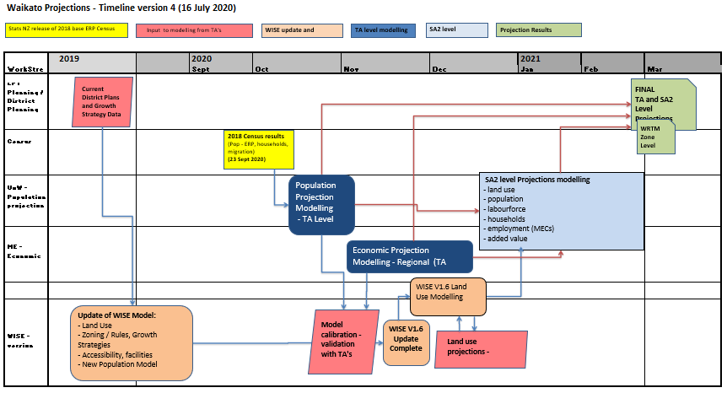

Stats NZ – confirmation of release of the 2018 post-enumeration survey (PES) and the 2018-base estimated resident population (ERP)

From: Brooke Theyers <brooke.theyers@stats.govt.nz>
Sent: Wednesday, 15 July 2020 12:05 pm
Cc: Michelle Feyen <michelle.feyen@stats.govt.nz>; Joel Watkins <joel.watkins@stats.govt.nz>; Lindsay Davis <lindsay.davis@stats.govt.nz>; Kim Dunstan <kim.dunstan@stats.govt.nz>
Subject: 2018 Post-Enumeration Survey and 2018-base Estimated Resident Population Release Date Confirmed

Kia ora,

Following on from our discussions and updates over the past few months, Stats NZ can confirm that results from the 2018 post-enumeration survey (PES) and the 2018-base estimated resident population (ERP) will be published on 23 September 2020. This release will include revisions to national, subnational, and Māori population estimates for 2014-2019.

This follows remediation work on the PES as a result of needing to further modify the methodology, to address the complication of the admin enumerations used to enhance the 2018 Census dataset, and to address an issue with how dwellings were selected to be surveyed by the PES. The net undercount estimate from the PES flows through to create the 2018-base ERP, so it has been essential to ensure this estimate is valid prior to producing the ERP itself, to provide accurate estimates of the population based on 2018 Census data.

We are aware the delayed publishing of these results has impacted some customers’ needs, and we appreciate the information and input you have provided to us in our conversations about the delay, as well as your patience and understanding. We understand that these estimates are an important input for your work; this delay was needed in order to ensure we provide robust data that is fit for purpose.

Prior to the release, we will be working to prepare the outputs, methodology papers and complete peer review of the methodology and model used in the PES. We will continue to work closely with you ahead of the release to keep you informed of progress and will communicate early if any issues arise.

The first demographic projections produced will be national population projections, which will be released in late 2020. These will be followed by subnational population projections at territorial authority and Auckland local board area level in early 2021. We will also be scheduling updates to period life tables based on the 2018-base ERP. We expect to update the Stats NZ release calendar with these release dates by August 2020.

Please let us know if you would like any further information or discussion about the release of PES results and ERP, or if any of your needs have changed due to Covid-19, by emailing demography@stats.govt.nz.

Regards
Brooke

Brooke Theyers
Senior Manager – Population Insights | Kaiwhakahaere Matua – Ngā Māramatanga Taupori
Social and Population Insights | Ngā Mātau Pāpori me te Taupori
Stats NZ Tatauranga Aotearoa
DDI +64 3 964 8331 | M +64 21 589 466 | stats.govt.nz

