Memo
File No: | 41 10 22
Date: | 4 June 20195 June 2019
To: | Michelle While (FP TIG) and Dawn Inglis (WRTM User Group)
From: | Beat Huser, Principal Strategic Advisor, Strategy, WRC
Subject: | Update: 2018 Census based Waikato Population & Economic Projections

Purpose
The purpose of this Memo is to provide an update on the Waikato population and economic projections (based on 2018 Census), for the WRTM User group (Dawn Inglis) and the FP TIG (Michelle White). The feedback of the two meetings will then be incorporated into the consultation with the Waikato Projections Working Group to confirm the modified timeline for the delivery of the projection data.

Background
Stats NZ has now confirmed that the data (population and migration) we need for the population projection work will be released in March 2020. No date has been confirmed yet for the release of household data (usually the last dataset to be released, probably towards the end of 2020).

Our original aim to provide the required projection data (population, household, employment by TA and SA2) by Feb 2020 will now be delayed by about 6 months, with population and economic/employment projections completed by Oct/Nov 2020 (and for households early 2021?). The revised timeline is appended.

Projections data for the LTP 2021-2031
The original delivery date of Feb 2020 was intended to meet the needs for the LTP 2021-2031 process. The above modified timeline does not provide projection data until Oct/Nov 2010 (Household data even later). We have therefore explored alternative options with the providers of the population and economic projections data (UoW/NIDEA and Market Economics).

From all the options discussed we recommend the following approach for your consideration. The key principle is that we did not want to repeat a staged process using preliminary Stats NZ data. This caused a lot of confusion, distraction and unnecessary costs last time (2013 Census data), because the final Census data released were markedly different from preliminary data released by Stats NZ (and as a result the final projection results also changed considerably from the preliminary projections).

Suggested approach for 2018 Census based projections:
- Wait for the release by Stats NZ of the final population data, and follow the process and timeline as outlined in the diagram above (this follows the process the Waikato Projection Working Group, FP and WRTM User Group agreed to last year, but now with a delayed delivery date of about 6 months, see Appendix).
- Use the current projections (based on the 2013 Census) for the LTP 2021-2031 initially and then update when the new 2018 Census based projections become available (Oct/Nov 2020).
- For most councils the current projections are likely to be similar to those that will be based on the 2018 Census data, at least at the district/city level.
- However, for the ‘growth councils’ (Hamilton, Waipa, Matamata-Piako and especially for Waikato) current projections are probably an underestimate (continuing high migration).

Alternative approach for ‘growth councils’ (adapted to each Council’s specific need).
- The main issue and likely differences between the current and 2018-based projections will be at the SA2/SA1 level, especially where zoning, planned (aspirational) development and/or the timing of development has undergone recent changes (compared to assumptions made for the Census 2013 based projections).
- For those councils/sub-district areas we therefore propose to use the currently available projections in conjunction with additional information and assessments to support the best possible data to support the LTP 2021-2031 process. This may include:
- Compare the current 2013-based Waikato projection results for 2018 against Stats NZ 2018 population estimates (note: these estimates are based on 2013 Census data, and are available) to assess if current medium or high Waikato projections are most appropriate.
- Use the appropriate current projections dataset (likely to be either medium or high) based on assessment in point 1.
- Use additional data (e.g. WISE updated 2018 land use layer, TA growth/development spatial information, consent data) to assess where growth has occurred. Then compare these results with projected land use data from WISE.
- This information could then be used to inform any adjustments in expected growth at a sub-district level.
- Other suggestions?

The Table below summarises the pros and cons of the suggested approaches. The first column (left hand) summarises the process shown in the above diagram, i.e. original process with delayed delivery of the projection results, by Oct/Nov 2020. The other two columns describe the two approaches for providing projection results by Feb 2020 (as input into the LTP 2021-2031), i.e. use of current 2013 Census based projections with and without further work.

Table 1 Comparison of proposed approaches
Wait for 2018 Census data (as per diagram and timeline above).  - Population/employment – Oct/Nov 2020  - Household - end 2020/early 2021(?) | Use current projections for LTP 2021-2031 and:  - Update LTP with new 2018-based projections when available. | Use current projections and:  - Adjust using additional data/information  - Update with new 2018-based projections when available.
Benefits:  - Cost effective – as process and modelling will only need to be undertaken once.  - Will represent up to date projections based on best available data. | Benefits:  - Cost effective – as process and modelling will only need to be undertaken once.  - Timely data input for LTP 2021-2031 (by Feb). | Benefits:  - Gives TA’s some additional and up-to-date information to move forward with.  - Complements current projections with current land use, additional development information and check against Stats NZ 2018 estimates.  - Timely data input for LTP 2021-2031 (by Feb).
Risks:  - Projection results provided (too) late in the planning cycle for LTP 2021-2031  - There could be further slippage on Stats NZ release dates. | Risks:  - Use of currently available projections may be inaccurate in some locations, especially for small local growth areas.  - Different projections included in LTP (first 2013 based and then 2018 Census based). | Risks:  - Different TA’s might choose to use different data.  - Could be differences between these projections/assessments and final results.  - The additional costs and efforts may not justify the benefits achieved.
Caveats:  - Assumes that proposed timelines for census data releases are met. | Caveats:  - Assumes that no major changes in zoning/development localities and/or timing has occurred in last 3-4 years. | Caveats:  - ?

Appendix Proposed timeline for 2018 Census based Waikato projections
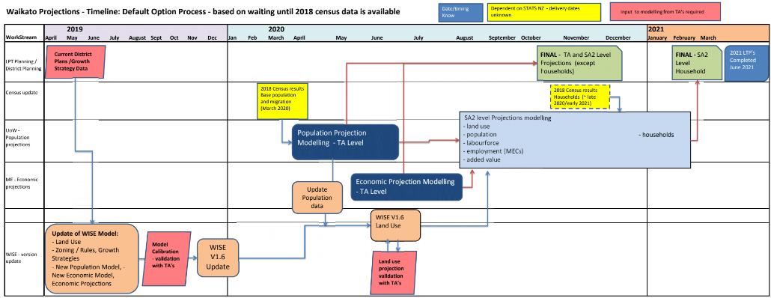

Refer to meeting notes 31 July 2018: www.creatingfutures.org.nz/waikato-projections-demographic-and-economic/projections-working-group/

