**Email update on Waikato Projections - From Dr Beat Huser, Waikato Regional Council**

**23rd April 2020**

Hi All

Hope you are in good health and spirits.  This email informs you about:

1. The expected delivery of Waikato population and economic projections.
2. A comparison between our 2013-based projections with various Stats NZ data sets
3. LTP 2021-2031 assumptions

**Update on delivery of Waikato projections**

It has been a while since our last update (see below) about the Waikato population and economic projections originally planned to be delivered by Feb 2020. This assumed that the Census data required to start our regional/local population and economic modelling (sub-national Estimated Resident Population (ERP), would be available by last Oct 2019…  This was then re-scheduled to 30 March 2020, which we have assumed so far for our planning and delivery, **as per email below from Stats NZ**. However, Stats NZ advised last week that they need more time, and are not even prepared to announce an expected release date (**see email below**).

We have re-scheduled our timeline and list of tasks assuming a best guess of ERP data release by Stats NZ on July 2020, which would allow us **delivering all Waikato projections by Dec 2020**, **see diagram below**.  This means we aim to deliver all land use, population, household, labour force and economic (employment, value-added) projections 2018-2068 at TA and SA2 level, as specified in my previous email, Sept 2019, see below.

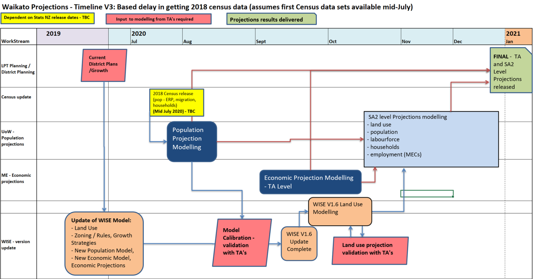

**Stats NZ 2018 Census releases**

Stats NZ have already released a lot of Census 2018 data, so why are we waiting for the Estimated Resident Population, ERP data?

Population estimates include a number of important adjustments to Census night counts, including:

* residents missed by census (net census undercount)
* residents temporarily overseas on census night
* births, deaths, and net migration since census night.

Some of these adjustments are from what’s called  the ‘Post-enumeration survey’ (PES) undertaken after each census. This has not been included in any of the population data released so far, and unfortunately is causing some headache for Stats NZ, mainly due to the mix of census responses and administrative data the 2018 Census is using, see email from Stats NZ below.  Feel free to get in touch with Stats NZ directly, if you have any questions:

Joel Watkins

Manager – Census Coverage | Kaiwhakahaere – Hōkai Tatauranga, Population Insights Ngā Māramatanga Taupori

**DDI** +64 3 964 8807 | **Mobile** +64 21 824 947 | [stats.govt.nz](http://www.stats.govt.nz/)

**Comparison of Waikato and Stats NZ data**

Michael Cameron (University of Waikato) has produced a comparison of the current (2013 census based) Waikato population projections with Stats NZ projections for the Waikato TAs, as well as with a couple of other population data sets released by Stats NZ in 2019 (**see attachment**).

**LTP assumptions**

The original delivery date of Feb 2020 was intended to meet the needs for the LTP 2021-2031 process, e.g. providing the best and most-up-to-date assumptions. The first modified timeline (Oct 2020) does not meet the timeline for the LTP process, and this has now been pushed back another couple of months to December 2020). We have explored alternative options with the providers of the population and economic projections data (UoW/NIDEA and Market Economics), and decided the approach outlined below. The key principle is that we did not want to repeat a staged process using preliminary Stats NZ data. This caused a lot of confusion, distraction and unnecessary costs last time (2013 Census data), because the final Census data released were markedly different from preliminary data released by Stats NZ (and as a result the final projection results also changed considerably from the preliminary projections).

**Suggested approach for LTP assumptions:**

•       Use the current projections (based on the 2013 Census) for the LTP 2021-2031 initially, then update when 2018 Census based projections become available (Dec 2020).

•       For most councils the current projections are likely to be similar to those that will be based on the 2018 Census data, particularly at the district level.

•       However, for the ‘growth councils’ (Hamilton, Waipa and Waikato) current projections are likely an underestimate due to continuing high migration (although COVID-19 will change the migration assumptions again, at least in the short to medium term).

**Note** that the results of the current projections 2013-2063 and working group documents, meeting notes and presentations are available from here: [www.creatingfutures.org.nz/waikato-projections-demographic-and-economic/](http://www.creatingfutures.org.nz/waikato-projections-demographic-and-economic/)

Please forward this email to any other staff that might be interested in the population and economic projections.  Also, let me know if you wish to unsubscribe from this list.

Contact me if you have any questions or feedback.

Many thanks.

Kia kaha

Beat

|  |  |  |  |  |  |  |  |  |  |  |  |  |  |  |  |
| --- | --- | --- | --- | --- | --- | --- | --- | --- | --- | --- | --- | --- | --- | --- | --- |
| |  |  |  |  |  |  |  |  |  |  |  |  |  |  |  | | --- | --- | --- | --- | --- | --- | --- | --- | --- | --- | --- | --- | --- | --- | --- | | |  |  |  |  |  |  |  |  |  | | --- | --- | --- | --- | --- | --- | --- | --- | --- | | |  |  |  |  |  |  | | --- | --- | --- | --- | --- | --- | | |  |  |  |  |  | | --- | --- | --- | --- | --- | | **Beat Huser​** | | | PRINCIPAL STRATEGIC ADVISOR | | | Strategy, Science and Strategy | | | WAIKATO REGIONAL COUNCIL | Te Kaunihera ā Rohe o Waikato | | [**Take a look at the work we do**](https://www.waikatoregion.govt.nz/community/whats-happening/video-hub/) | | | |  | | --- | | P: [**+6478590854**](tel:+6478590854) | | M: [**+6421368954**](tel:+6421368954) | | F: [**facebook.com/waikatoregion**](https://www.facebook.com/waikatoregion) | | Private Bag 3038, Waikato Mail Centre, Hamilton, 3240 | | | |